Module Code | IY4113
Group | B
Module Title | Practical assignment part 2: Java Fundamentals
Assessment Type | Report
Module Tutor Name | Jonathan Shore
Student ID Number | P486024
Assessment Window | Final submission: 17/03/2026- 19/04/2026

I confirm that this assignment is my own work. Where I have referred to academic sources, I have provided in-text citations and included the sources in the final reference list.

Where I have used AI, I have cited and referenced appropriately.

Table of contents:
Final submission:

Written report:
Introduction: ………………………………………………………………………………………....3
Analysis:………………………………………………………………………………………………3Algorithm designs:…………………………………………………………………………………..8
Testing:………………………………………………………………………………………………44
Evaluation:…………………………………………………………………………………………..64
Code listing:………………………………………………………………………………………...65
References:………………………………………………………………………………………...98
Appendices:……………………………………………………………………………………...…98

Milestone 1:

Program purpose:………………………………………………………………………………….98
IPO table:…………………………………………………………………………………………...100
Gantt chart:…………………………………………………………………………………………126
The algorithm:……………………………………………………………………………………...102
The class diagram:………………………………………………………………………………...123
The research:………………………………………………………………………………………124
Diary entries:……………………………………………………………………………………….127

Milestone 2:

The program code:……………………………………………………………………………….133
The research:……………………………………………………………………………………..129
The updated gantt chart:…………………………………………………………………………173
Diary entries:……………………………………………………………………………………….173

The github link of my repository:
https://github.com/T0486024Ali/T0486024_Final_Submission_4113_Part_2

Introduction:
This report presents the implementation of an extension to the CityRide Lite application developed in Part 1, with the aim of creating a more realistic and fully featured transport fare companion app. The extension builds upon the core functionality of the original program by introducing rider profiles, persistent data storage, and support for multiple user roles. The system allows riders to save and load profiles using JSON files and to import and export journey data using CSV files, enabling journey data to persist between sessions. In addition, an administrator role is included, providing access to a secure administration menu for managing fare rules, discounts, daily caps, and peak time windows. The report is structured to cover system analysis, algorithm design, testing, evaluation, and the final implementation.

Analysis:

The major requirements of the program:
First of all, the program should provide a simple, menu-driven interface that allows users to track daily journeys and import or export journey data using CSV files. This menu represents the functional requirements of the program and includes options such as adding a journey, listing journeys, and filtering journeys based on journey details such as passenger type. In addition, the menu includes extended functionality for the CityRide Lite application, including importing journeys from a CSV file and exporting journeys to a CSV file. One of the key functional requirements is that the system must allow the user to select a role when the program launches, which can be either a rider or an administrator.
Each user role within the program is restricted to a specific set of functions. Only one role can be active during a single program session. For example, when the rider role is selected, the system allows users to create and load personal profiles from a JSON file, edit and delete journeys, and view running totals and summaries for any day. In contrast, when the administrator role is selected, the user must log in using a password to access a separate administration menu. This menu allows the administrator to view and manage the active system configuration, including adding, updating, and deleting base fare rules, discounts, daily caps, and peak time windows.
Another functional requirement is that the program should allow users to view per journey costs, including base fares, discounts applied, and the final charged fare after discounts and caps. The system should also allow users to view running totals for each passenger type, indicating whether a daily cap has been reached. In addition, the program must be able to export an end-of-day summary as a CSV report and a human readable text summary that includes the rider’s name and the date. As a result, each rider profile must store a name and a default payment method. If all of these requirements are implemented, the program can be considered fully functional.
In addition to these functional requirements, the program must satisfy several non-functional requirements to ensure reliability and stability. These include robust error handling and input validation for all user inputs. Each input value, regardless of its data type, must be validated, and clear error messages should be displayed when invalid data is entered. The system must allow users to re-enter incorrect values without terminating the program. All prompts should clearly state the expected input format, and no invalid data should be saved under any circumstances.
Furthermore, the system must reliably save and load data using JSON files and should initialise safe default values if required files are missing. Saved data must remain readable and reusable across multiple program sessions. The program should calculate fares, totals, and summaries within a short time after user input to ensure acceptable performance. Finally, the program must follow the NTIC guide to good programming practices, including adherence to the Single Responsibility Principle and consistent Java naming conventions, such as using Upper Camel Case for class names.

IPO table:
Feature / Task. | Inputs. | Processing (what the system does). | Outputs.
Add user’s rider profiles | Profiles list that includes the name, default payment method of each profile in it. | This profiles list reads all the details of all the profiles from the user. For example, it takes the name and default payment method of each profile from the user, as each profile needs to have that | The output is knowing the name and default payment method of each profile in this profiles list by inputting them by the user.
The user’s profile name | name | The system of the program takes the name of the profile from the user | The output is knowing the name of the profile by getting it from the user.
The user’s profile default payment method | defaultPayment | The system of the program reads the default payment method of the profile from the user. | The output is knowing the default payment method of the profile by entering it by the user.
The user’s admin username | userName | The system of the program reads the username of ethe admin from the user. | The output is knowing the admin’s username by getting it from the user.
The user’s admin password | password | The program gets the admin password from the user | The output is identifying the admin password by entering it by the user.
The user’s admin username | inputUserName | The program checks if the admin’s username inputted by the user is correct by checking if it equals the correct admin’s username to allow the admin to log in to the system to access the separate administration menu which will enable the admin to view the active system configuration to add, update, or delete any base fare rules, discounts, daily caps, and peak time windows. | The output is knowing the admin’s username that might allow him to log in to the system.
The user’s admin password | inputPassword | The program checks if the admin’s password inputted by the user is correct by checking if it equals the correct admin’s password to allow the admin to log in to the system to access the separate administration menu which will enable the admin to view the active system configuration to add, update, or delete any base fare rules, discounts, daily caps, and peak time windows. | The output is knowing the admin’s password that might allow him to log in to the system.
The program’s user role | userRole | The program gets the user role from the user. It might be either a rider or an admin. This user role determines what the program can or should exactly do. | The output is knowing the user role whether it is a rider or an admin.
The program’s user role | userRole | The program reads the user’s role again to make it equal 1 or 2, as it was not like that in the first time the program took this input from the user. When the user’s role is 1, the program’s user is a rider, and when the user’s role is 2, the program’s user is an admin. | The output is knowing the user role of the program to identify if the program’s user is a rider or an admin.
Display main menu & route choice. | choice (0,7). | The choice which will allow the program to do one function from the functions that it can do in the simple menu of choices that the program has is inputted by the user. | The output is the choice that is inputted by the user which will identify the option that the program will go through in this CityRide Lite app.
Add journey. | Journey list that includes the date, starting zone, destination zone, passenger type, and the type of trip if it is peak or off-peak. | The system reads the values of all the journey list variables from the user. | The output is knowing the date, starting zone, destination zone, passenger type, and the type of trip if it is peak or off-peak. This helps in adding the journey to the journey list.
The journey id | journeyId | The system reads the value of the journeyId variable from the user | The output is knowing the journeyId of each journey, and of course, it needs to be unique because it is used if we wanted to remove a journey and it is one of the program requirements as well.
The journey id | journeyId | The system reads the value of the journeyId variable from the user to remove a journey by it. | The output is knowing the journeyId of each journey, and of course, it needs to be unique because it is used to remove a journey and it is one of the program requirements as well.
The starting zone | fromZone | The system reads the value of the fromZone variable from the user | The output is knowing the starting zone which is the value of the fromZone variable of each journey to help in adding the journey.
The starting zone | fromZone | The system reads the value of the fromZone variable from the user to help the program filter all the journeys recorded using it. | The output is knowing the starting zone which is the value of the fromZone variable of each journey to help the program filter all the journeys recorded using it.
The starting zone | fromZone | The system reads the value of the fromZone variable again from the user to check if it equals any number from 0 to 5, as it was not like that in the first time the program took this input from the user. | The output is knowing the starting zone which is the value of the fromZone variable of each journey to help in adding the journey.
The starting zone | fromZone | The system reads the value of the fromZone variable again from the user to check if it equals any number from 0 to 5, as it was not like that in the first time the program took this input from the user. It also does that to help the program filter all the journeys recorded using it. | The output is knowing the starting zone which is the value of the fromZone variable of each journey to help the program filter all the journeys recorded using it.
The destination zone | toZone | The system reads the value of the toZone variable from the user | The output is knowing the destination zone which is the value of the fromZone variable of each journey to help in adding the journey.
The destination zone | toZone | The system reads the value of the toZone variable again from the user to check if it equals any number from 0 to 5, as it was not like that in the first time the program took this input from the user. | The output is knowing the destination zone which is the value of the fromZone variable of each journey to help in adding the journey.
The destination zone | toZone | The system reads the value of the toZone variable from the user to help the program filter all the journeys recorded using it. | The output is knowing the destination zone which is the value of the fromZone variable of each journey user to help the program filter all the journeys recorded using it.
The destination zone | toZone | The system reads the value of the toZone variable again from the user to check if it equals any number from 0 to 5, as it was not like that in the first time the program took this input from the user. It also does that to help the program filter all the journeys recorded using it. | The output is knowing the destination zone which is the value of the fromZone variable of each journey user to help the program filter all the journeys recorded using it.
The time band | timeBand | The system reads the value of the time band from the user | The output is knowing time band which is the value of the timeBand variable of each journey to help in adding the journey.
The time band | timeBand | The system reads the value of the time band again from the user to check if it equals peak or off-peak regardless of the case, as it was not like that in the first time the program took this input from the user. | The output is knowing time band which is the value of the timeBand variable of each journey to help in adding the journey.
The passenger type | passengerType | The system reads the value of the passenger type from the user | The output is knowing the passenger type which is the value of the passengerType variable of each journey to help in adding the journey.
The passenger type | passengerType | The system reads the value of the passenger type variable again from the user to check if it equals adult, student, child, or senior citizen regardless of the case, as it was not like that in the first time the program took this input from the user. | The output is knowing the passenger type which is the value of the passengerType variable of each journey to help in adding the journey.
The journey date | dateInput | The system reads the value of the journeyDate variable from the user | The output is knowing the journey date which is the value of the journeyDate variable of each journey to help in adding the journey.
The journey date | dateInput | The system reads the value of the journey date that we should filter all the journeys by. This means the system does that to print all the journeys that has this date. | The output is knowing the date that the program will filter the journeys by. This date is entered by the user.
Exit (21). | choice (21). | Terminate main loop. | The Program ends.
Algorithm designs:
The flowchart:
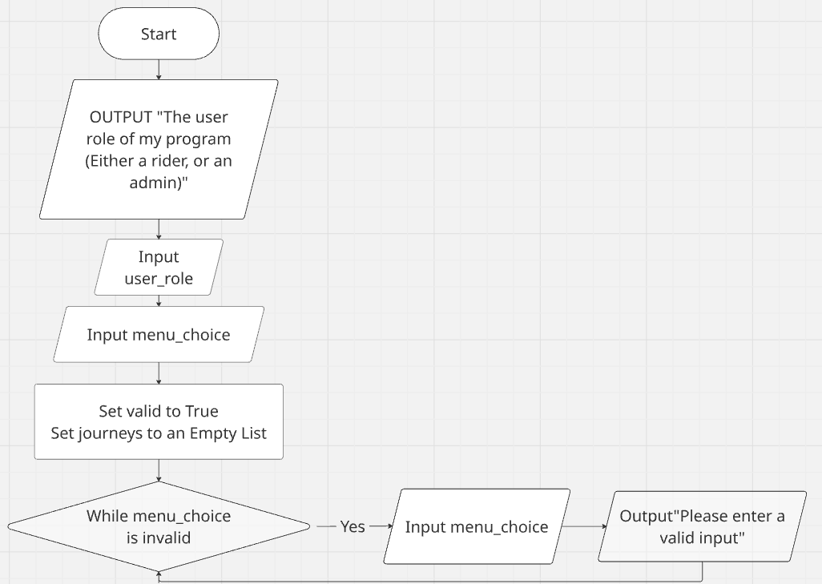

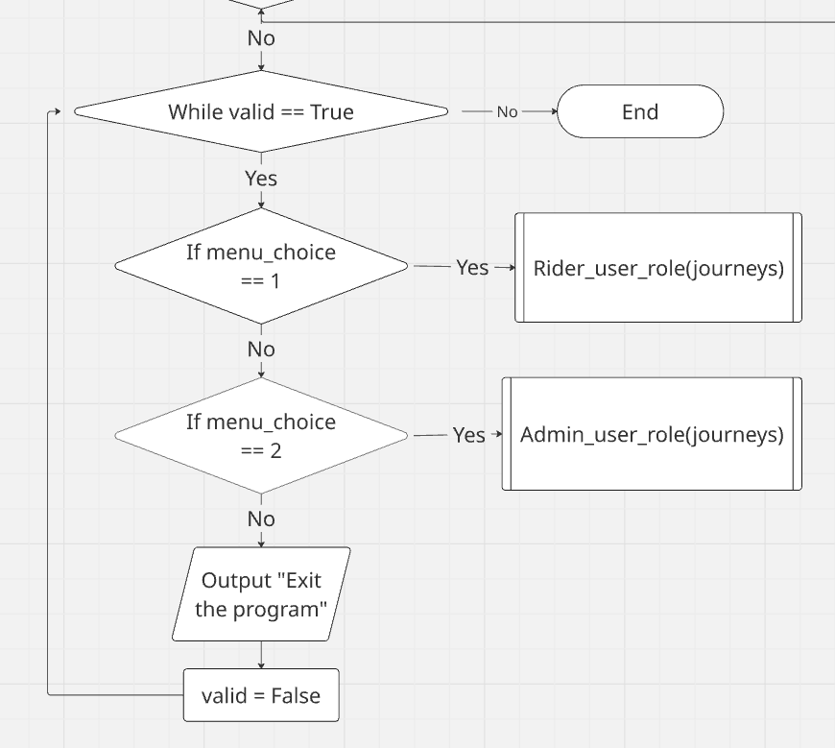

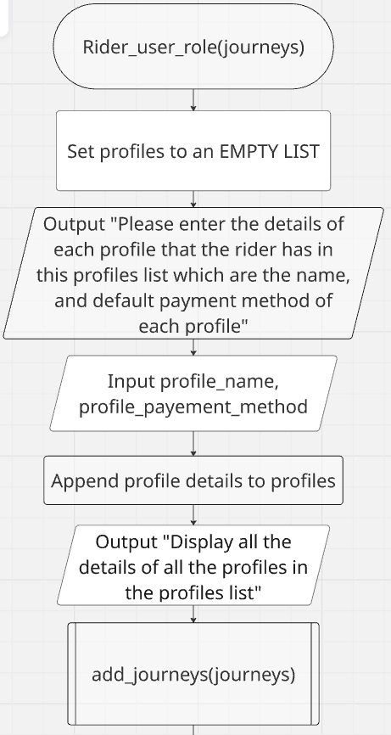
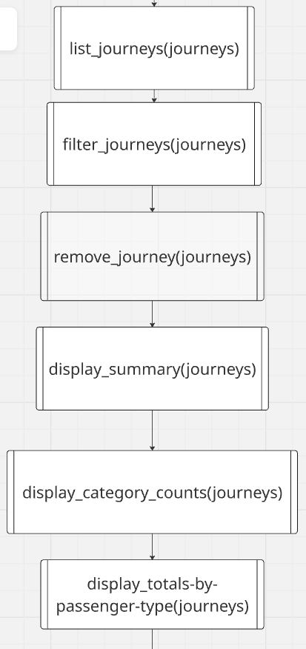

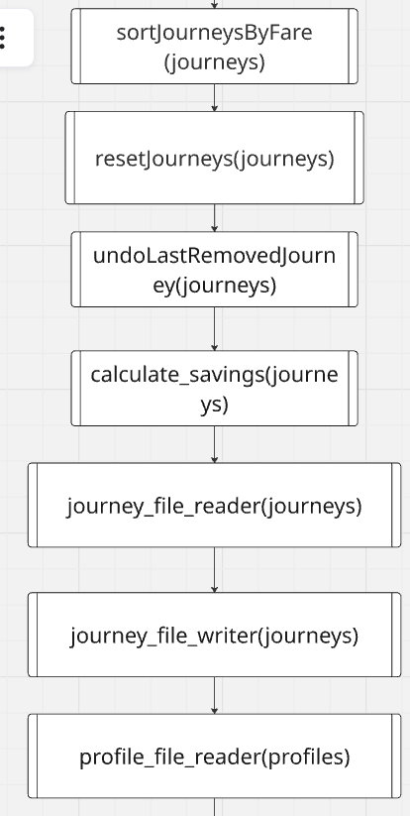

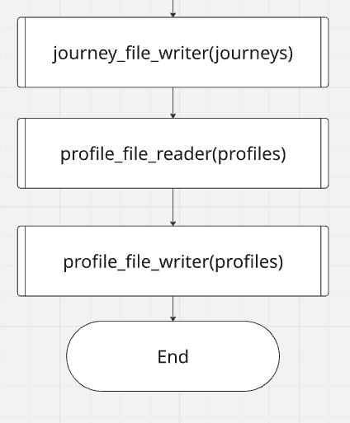

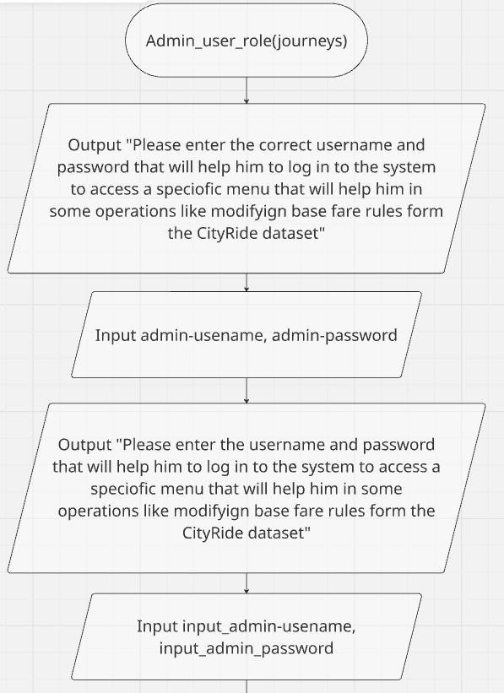

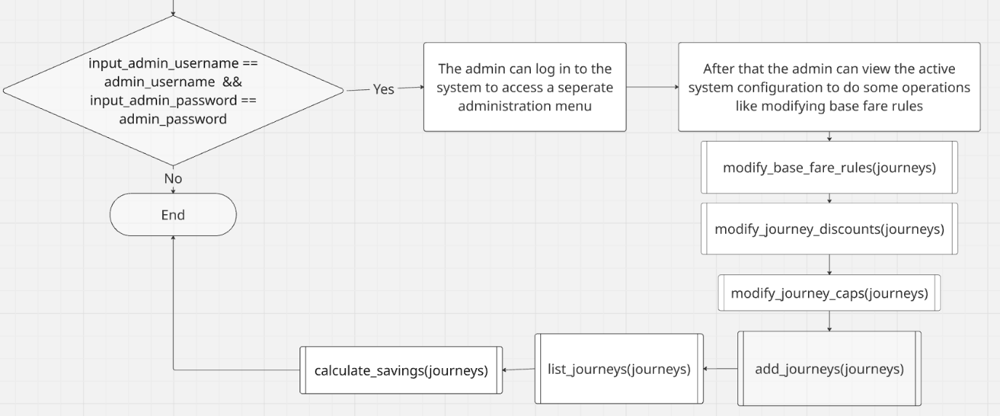

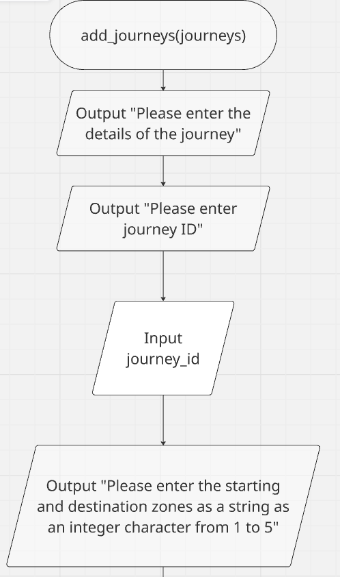

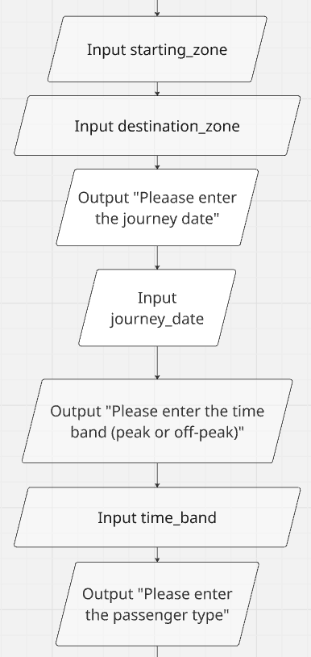

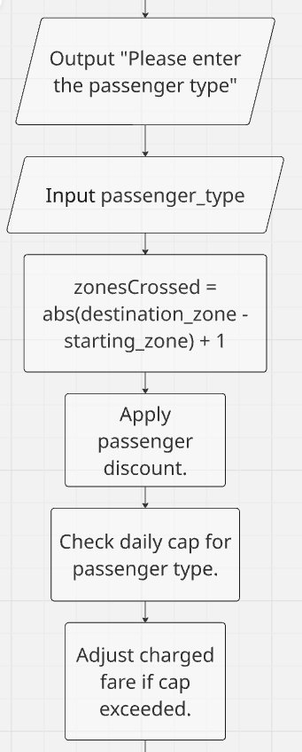

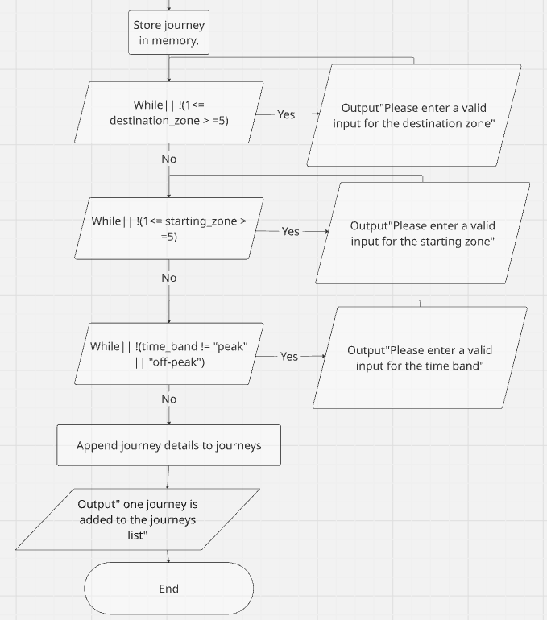

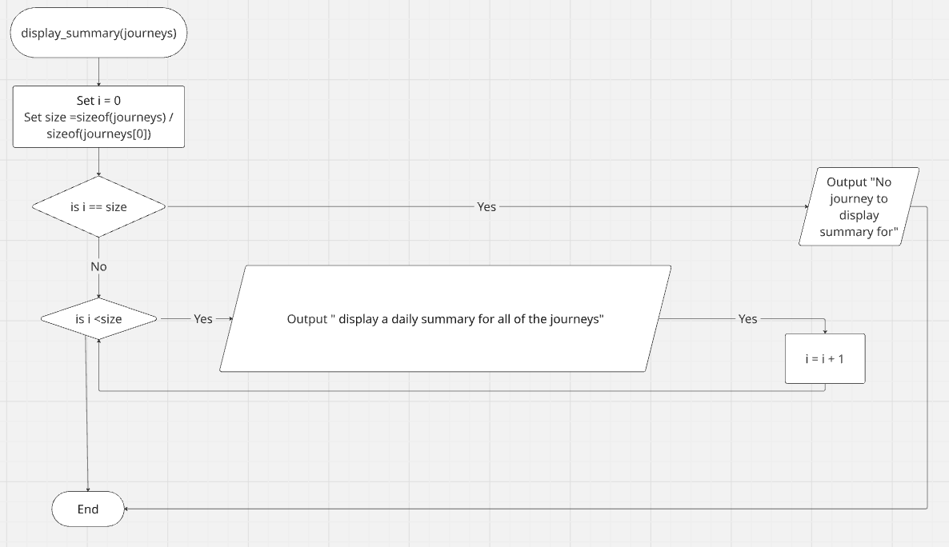

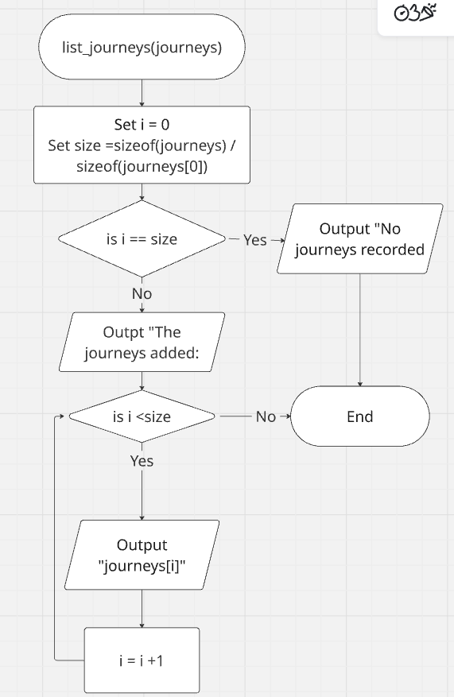

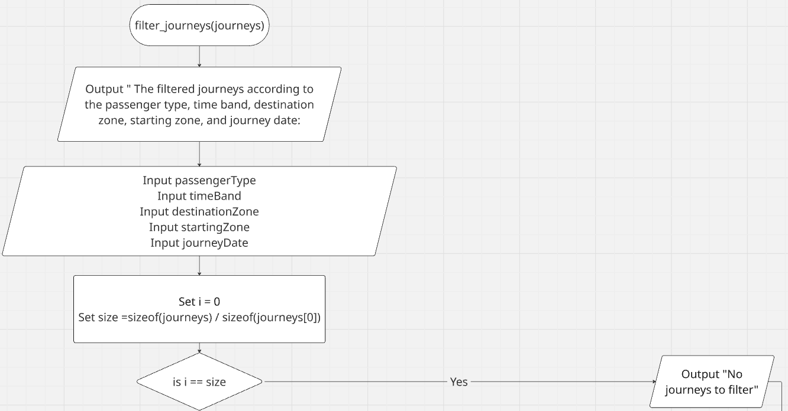

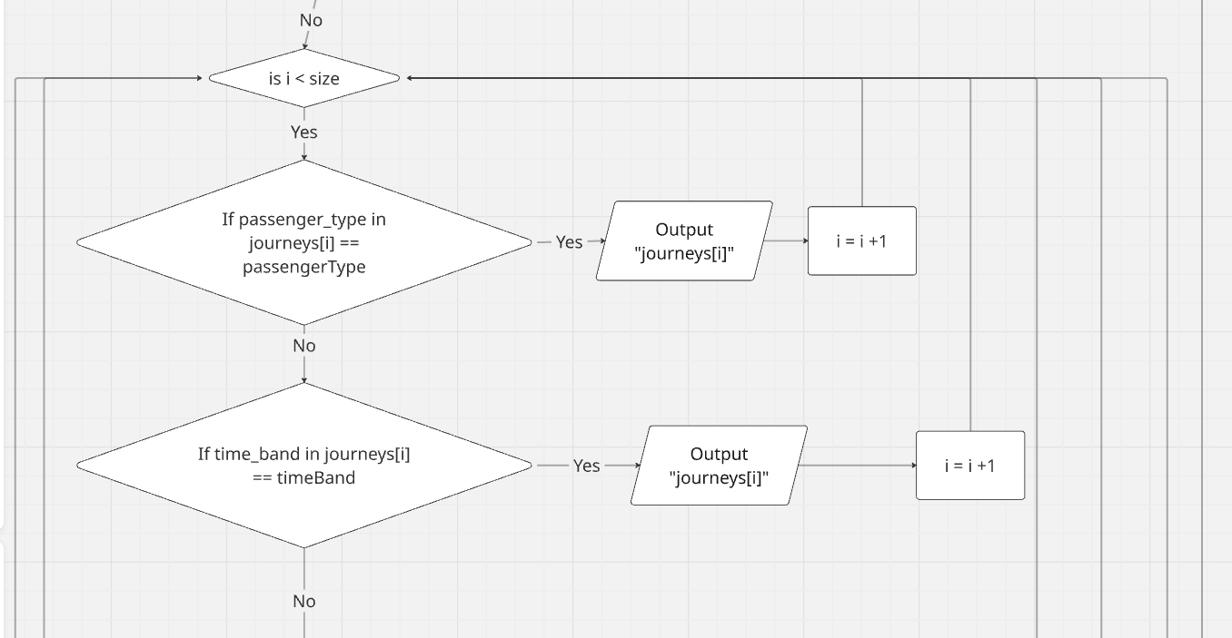

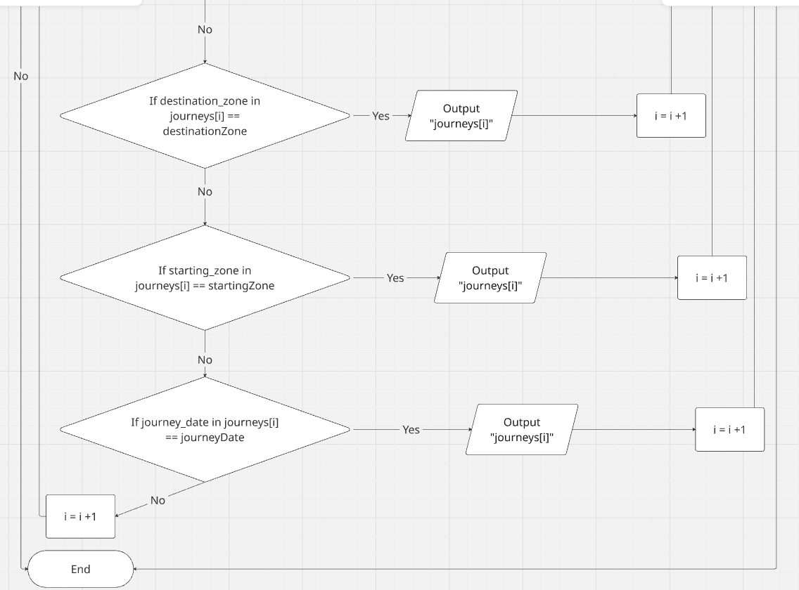

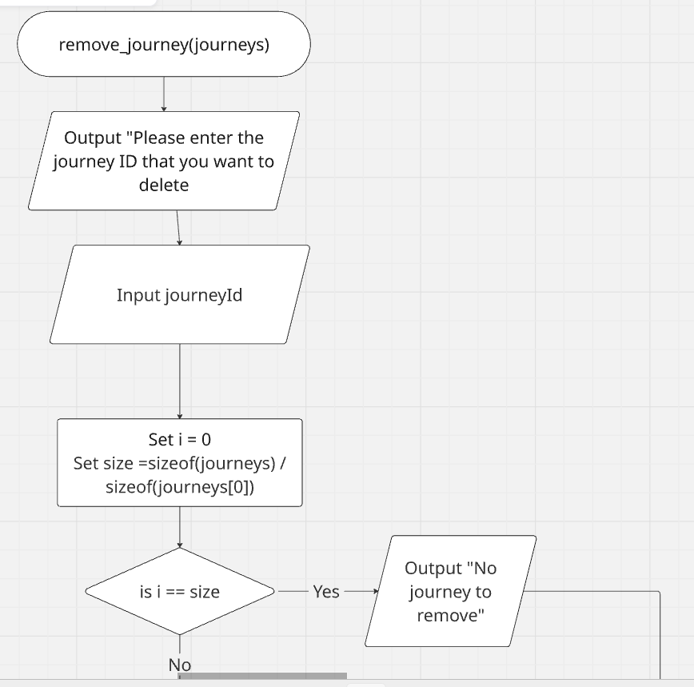

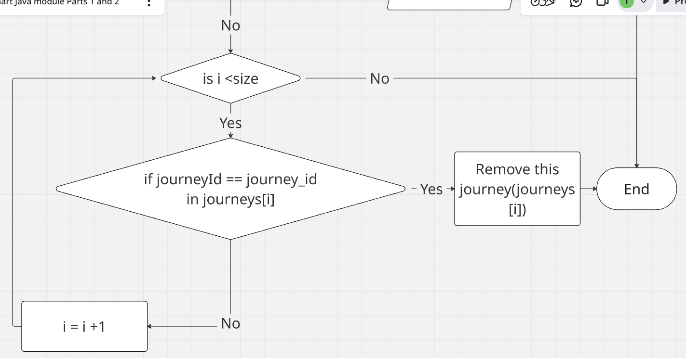

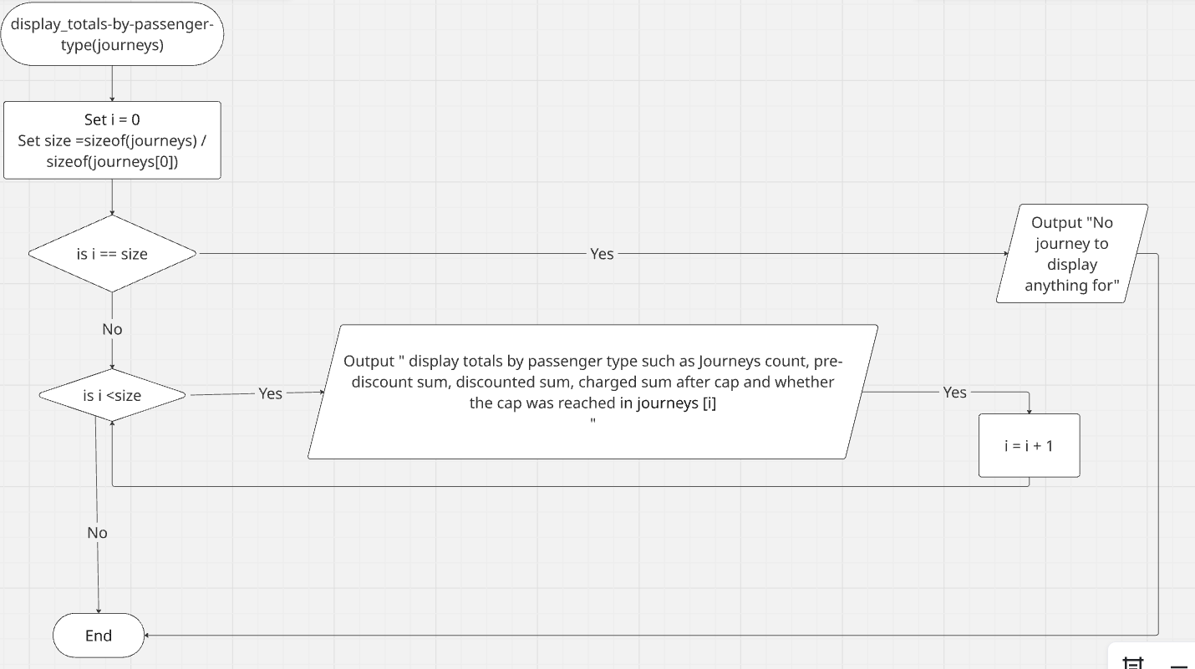

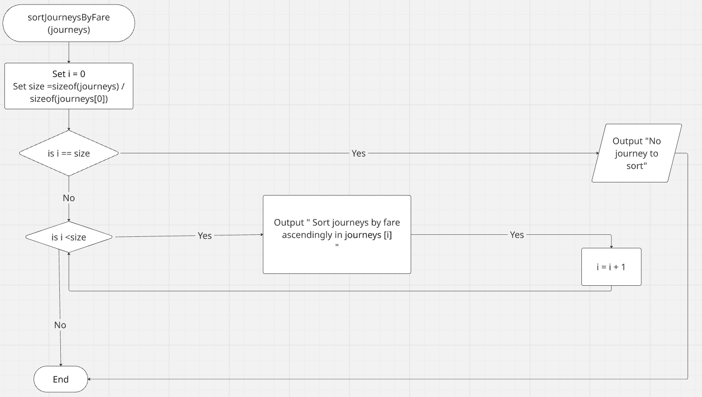

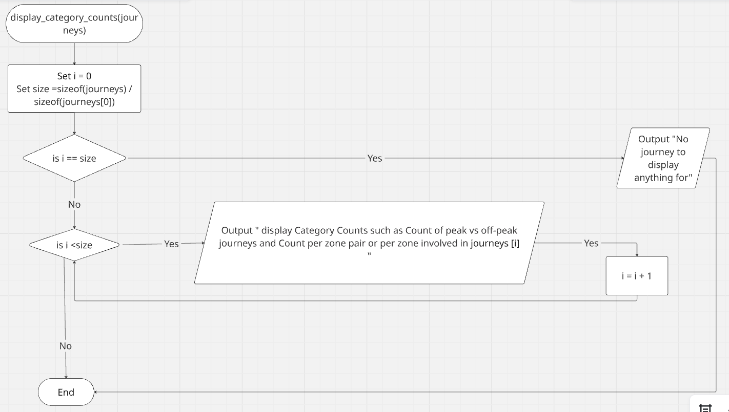

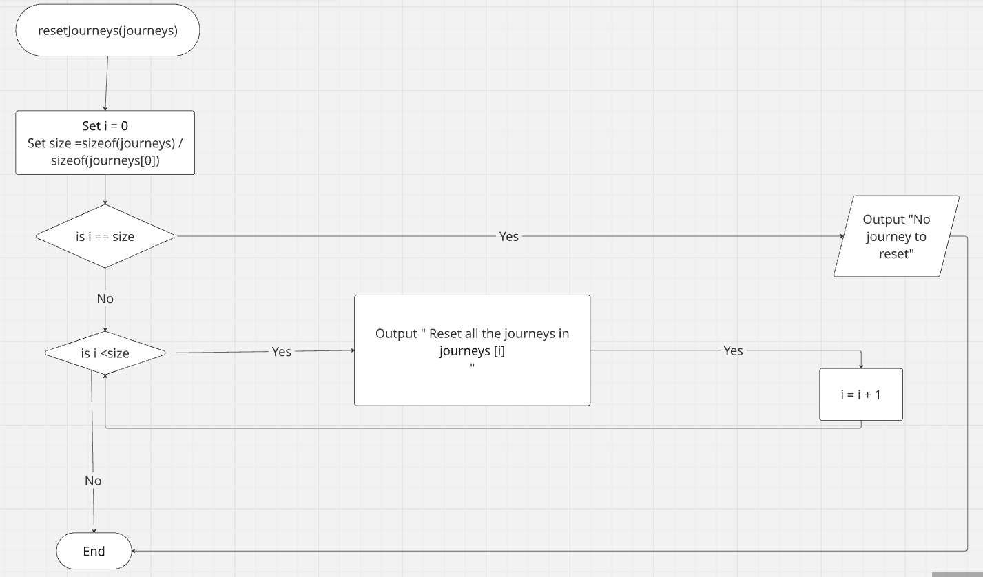

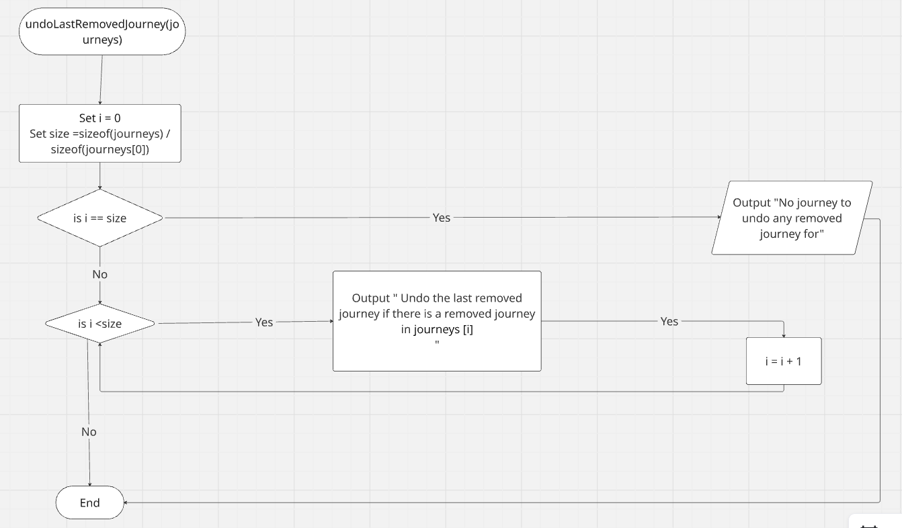

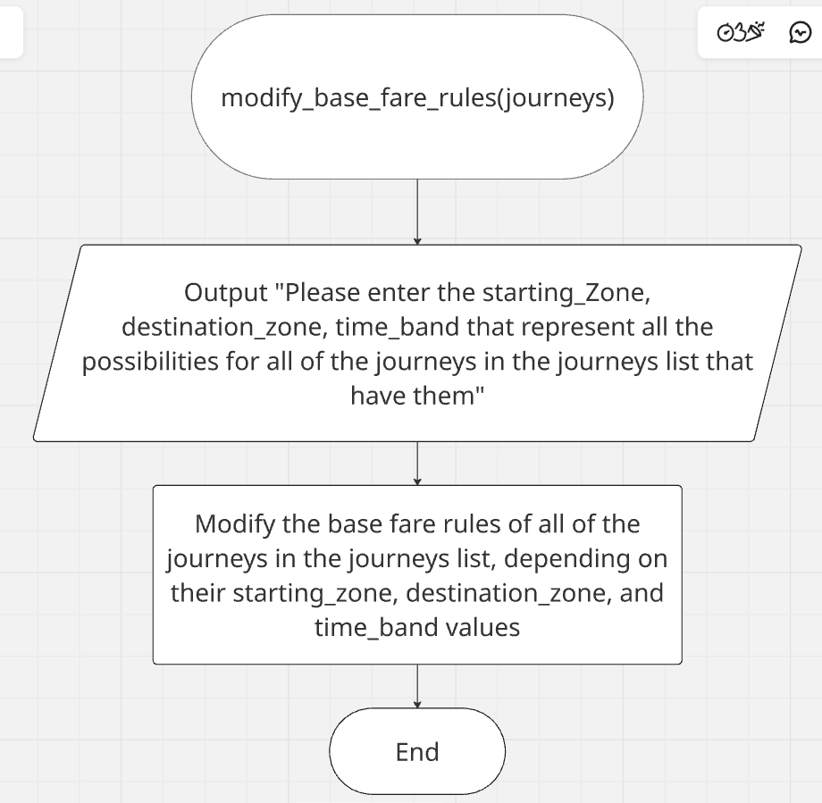

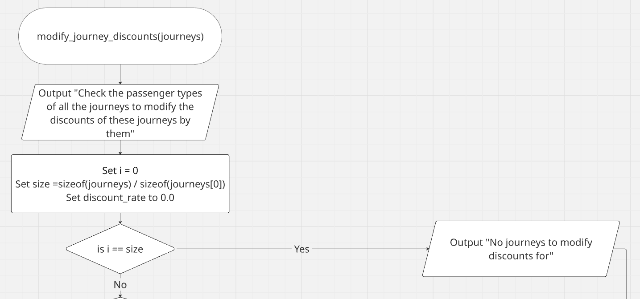

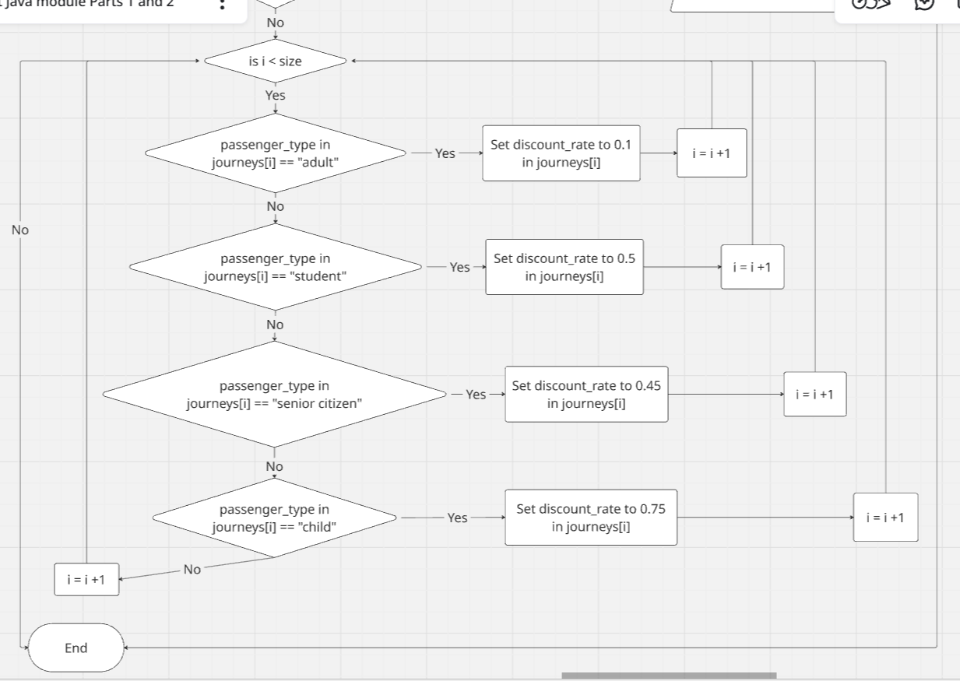

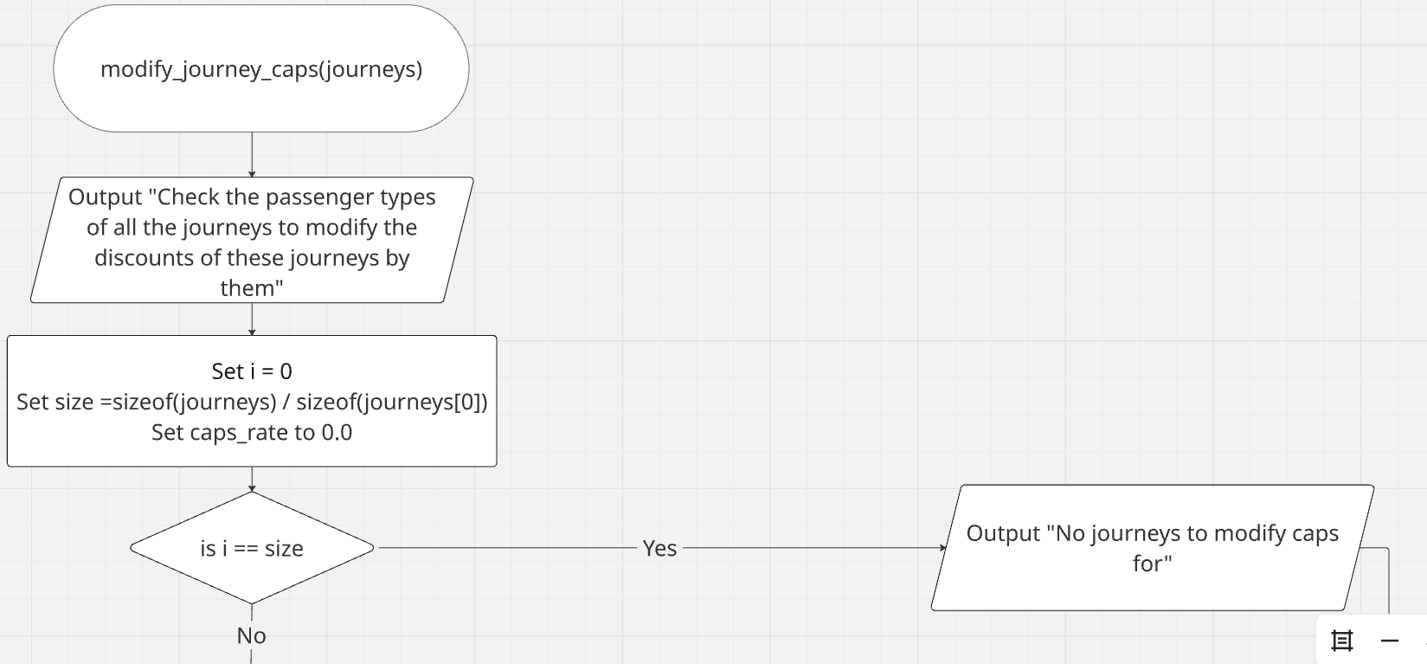

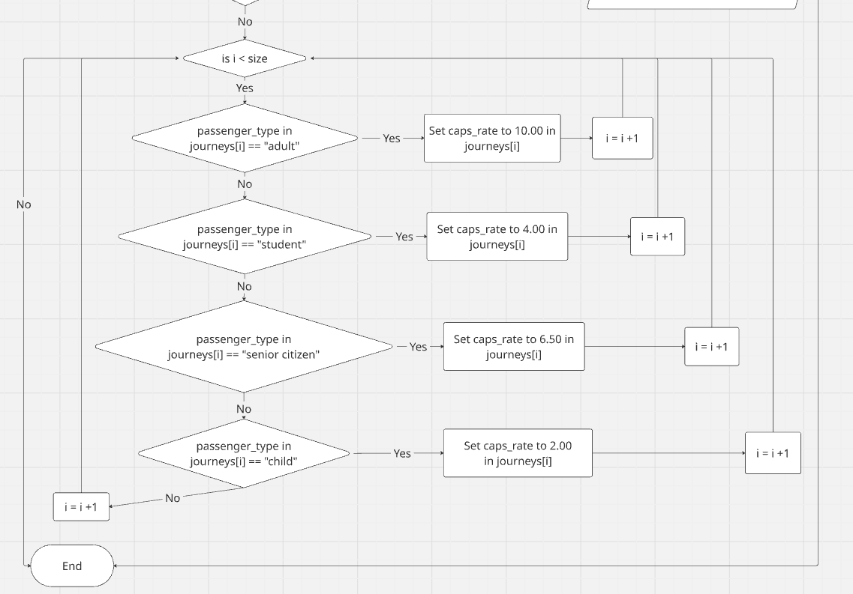

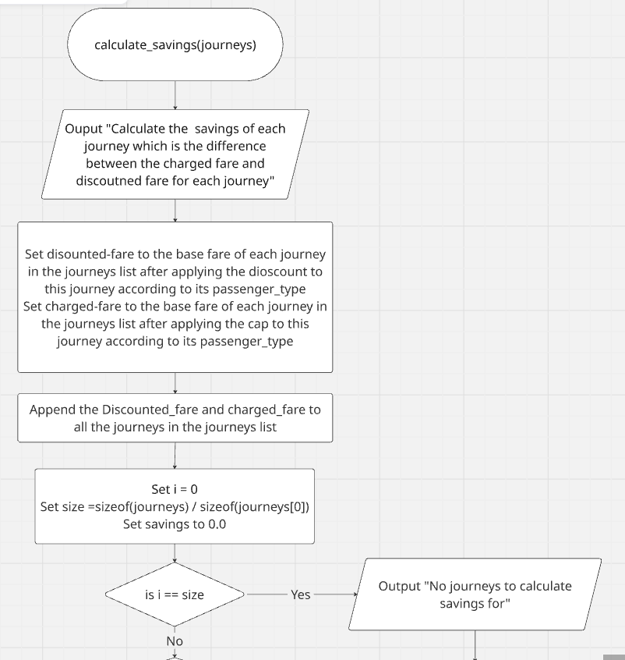

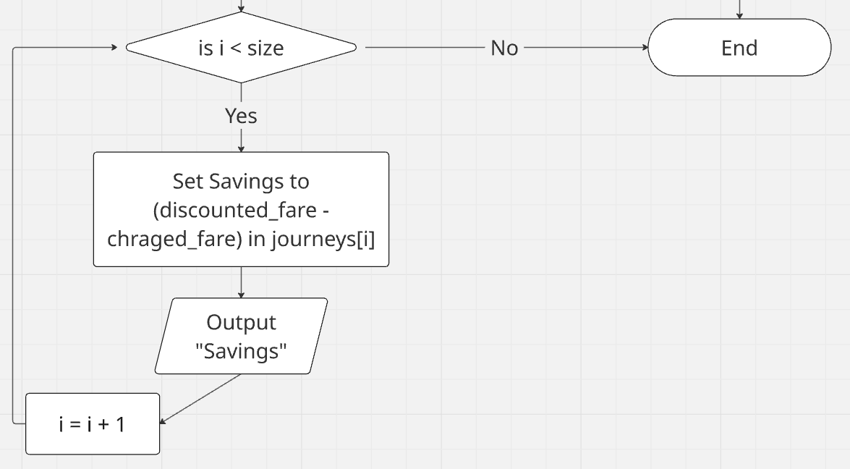

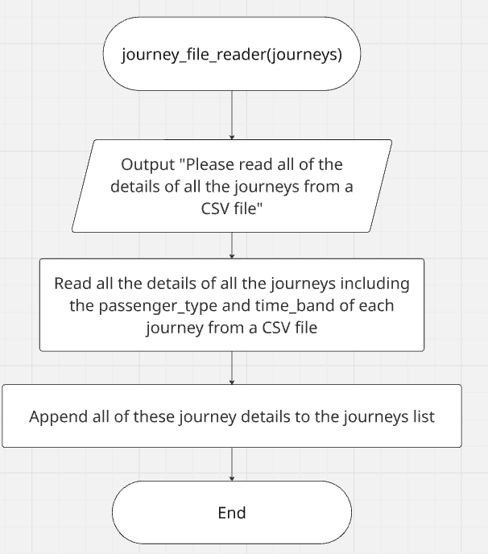

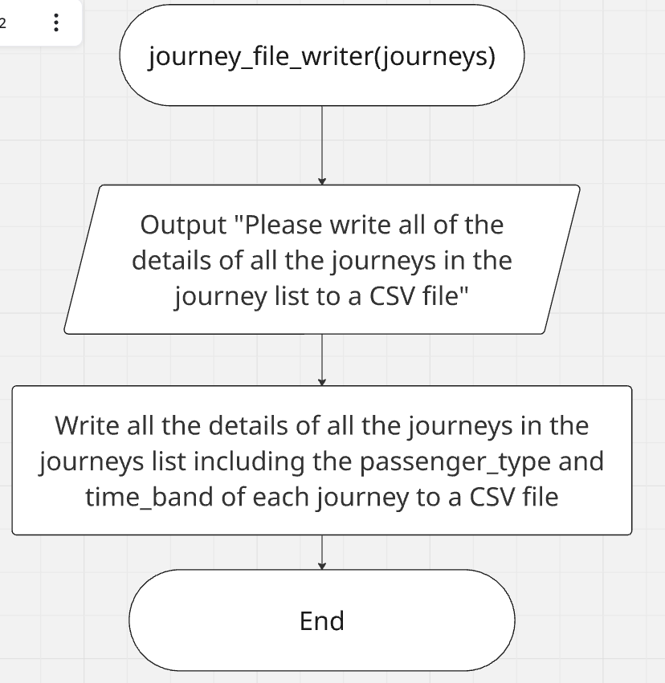

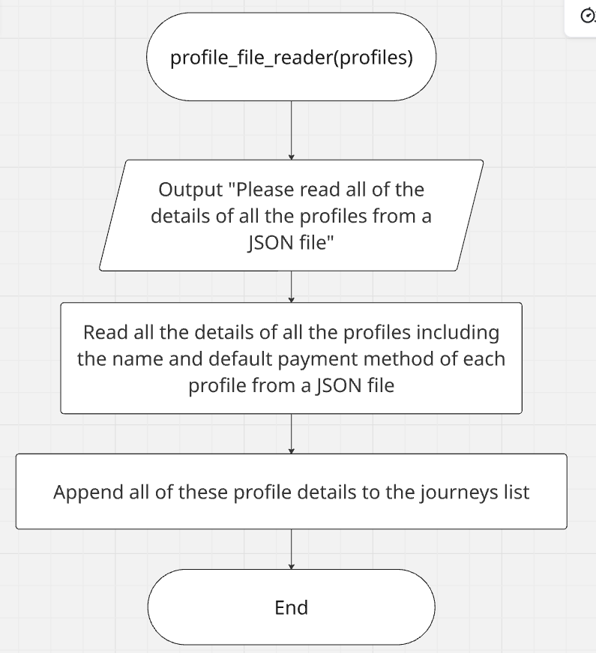

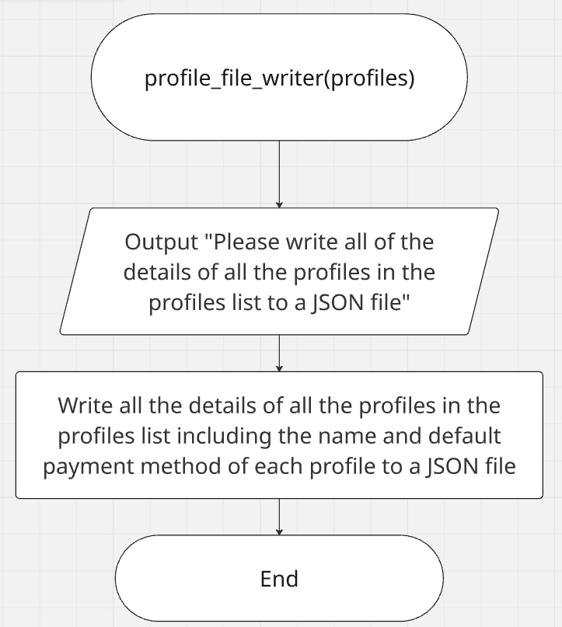

The class diagram:
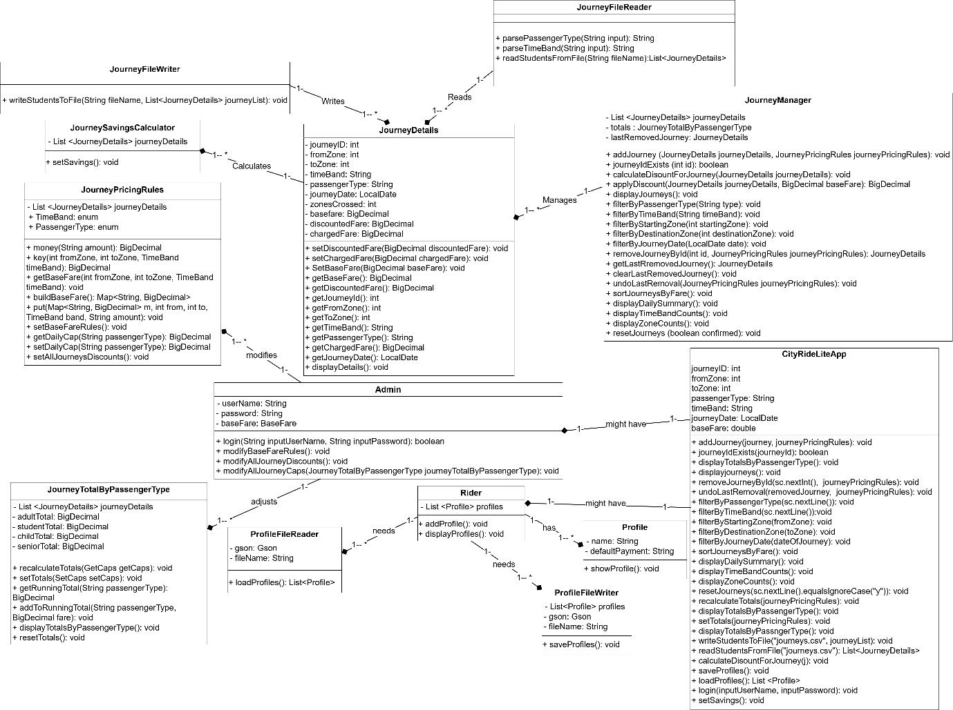
Note: The updated and clear class diagram is uploaded to GitHub as a PDF, so can you review it there because the image uploaded for it here is not very clear, and thanks.

Testing:
Test number | Test | Test description | Test data | Expected output | Actual output | Comments
1 | name | Valid test | “Ahmed” (String) | Program should continue as expected. | Program continues as expected. | Test passes.
2 | name | Invalid test | 100  (integer) | Program should respond with an error message and re-prompt. | Program continues as expected without any errors. | Test fails.
3 | name | Extreme valid test (length test <=11) | “Ali Mohamed” | Program should continue as expected. | Program continues as expected. | Test passes.
4 | name | Extreme invalid test (input = integer) | 115  (integer) | Program should respond with an error message- too long, and re-prompt. | Program continues as expected without any errors. | Test fails.
5 | name | Error test (carriage return) | Carriage return | Program should respond with an error message and re-prompt. | Program responds with an error message and re-prompt. | Test passes.
6 | defaultPayment | Valid test | “Visa” (String) | Program should continue as expected. | Program continues as expected. | Test passes.
7 | defaultPayment | Invalid test | 300  (integer) | Program should respond with an error message and re-prompt. | Program continues as expected without any errors. | Test fails.
8 | defaultPayment | Extreme valid test (length test <=11) | “Credit Card” | Program should continue as expected. | Program continues as expected. | Test passes.
9 | defaultPayment | Extreme invalid test (input = integer) | 310  (integer) | Program should respond with an error message- too long, and re-prompt. | Program continues as expected without any errors. | Test fails.
10 | defaultPayment | Error test (carriage return) | Carriage return | Program should respond with an error message and re-prompt. | Program responds with an error message and re-prompt. | Test passes.
11 | userName | Valid test | “Aly” (String) | Program should continue as expected. | Program continues as expected. | Test passes.
12 | userName | Invalid test | 150  (integer) | Program should respond with an error message and re-prompt. | Program continues as expected without any errors. | Test fails.
13 | userName | Extreme valid test (length test <=9) | “Ali Ahmed” | Program should continue as expected. | Program continues as expected. | Test passes.
14 | userName | Extreme invalid test (input = integer) | 210  (integer) | Program should respond with an error message- too long, and re-prompt. | Program continues as expected without any errors. | Test fails.
15 | userName | Error test (carriage return) | Carriage return | Program should respond with an error message and re-prompt. | Program responds with an error message and re-prompt. | Test passes.
16 | password | Valid test | “Ali80” (String) | Program should continue as expected. | Program continues as expected. | Test passes.
17 | password | Invalid test | 220  (integer) | Program should respond with an error message and re-prompt. | Program continues as expected without any errors. | Test fails.
18 | password | Extreme valid test (length test <=8) | “Aliali80” | Program should continue as expected. | Program continues as expected. | Test passes.
19 | password | Extreme invalid test (input = integer) | 190  (integer) | Program should respond with an error message- too long, and re-prompt. | Program continues as expected without any errors. | Test fails.
20 | password | Error test (carriage return) | Carriage return | Program should respond with an error message and re-prompt. | Program responds with an error message and re-prompt. | Test passes.
21 | inputUserName | Valid test | “Amr” (String) | Program should continue as expected. | Program continues as expected. | Test passes.
22 | inputUserName | Invalid test | 130  (integer) | Program should respond with an error message and re-prompt. | Program continues as expected without any errors. | Test fails.
23 | inputUserName | Extreme valid test (length test <=8) | “Ali Diab” | Program should continue as expected. | Program continues as expected. | Test passes.
24 | inputUserName | Extreme invalid test (input = integer) | 180  (integer) | Program should respond with an error message- too long, and re-prompt. | Program continues as expected without any errors. | Test fails.
25 | inputUserName | Error test (carriage return) | Carriage return | Program should respond with an error message and re-prompt. | Program responds with an error message and re-prompt. | Test passes.
26 | inputPassword | Valid test | “Visa” (String) | Program should continue as expected. | Program continues as expected. | Test passes.
27 | inputPassword | Invalid test | 200  (integer) | Program should respond with an error message and re-prompt. | Program continues as expected without any errors. | Test fails.
28 | inputPassword | Extreme valid test (length test <=10) | “Aliali@800” | Program should continue as expected. | Program continues as expected. | Test passes.
29 | inputPassword | Extreme invalid test (input = integer) | 260  (integer) | Program should respond with an error message- too long, and re-prompt. | Program continues as expected without any errors. | Test fails.
30 | inputPassword | Error test (carriage return) | Carriage return | Program should respond with an error message and re-prompt. | Program responds with an error message and re-prompt. | Test passes.
31 | userRole | Valid test | 1- integer | Program should continue as expected. | Program continues as expected. | Test passes.
32 | userRole | Invalid test | “D”  (String) | Program should respond with an error message and re-prompt. | Program responds with an error message and re-prompt. | Test passes.
33 | userRole | Extreme valid test (userRole<=2) | 2 (integer) | Program should continue as expected. | Program continues as expected. | Test passes.
34 | userRole | Extreme invalid test (userRole == "H” ) | “H”  “string” | Program should flag as an error and re-prompt. | Program flags value and asks user to re-enter | Test passes.
35 | userRole | Erroneous (string) | “C”- String | Program should flag as an error and re-prompt. | Program flags value and asks user to re-enter. | Test passes.
36 | userRole | Valid test | 1- integer | Program should continue as expected. | Program continues as expected. | Test passes.
37 | userRole | Invalid test | “Y”  (String) | Program should respond with an error message and re-prompt. | Program responds with an error message and re-prompt. | Test passes.
38 | userRole | Extreme valid test (userRole<=2) | 2 (integer) | Program should continue as expected. | Program continues as expected. | Test passes.
39 | userRole | Extreme invalid test (userRole == "G” ) | “G”  “string” | Program should flag as an error and re-prompt. | Program flags value and asks user to re-enter | Test passes.
40 | userRole | Erroneous (string) | “E”- String | Program should flag as an error and re-prompt. | Program flags value and asks user to re-enter. | Test passes.
41 | choice | Valid test | 12- integer | Program should continue as expected. | Program continues as expected. | Test passes.
42 | choice | Invalid test | “J”  (String) | Program should respond with an error message and re-prompt. | Program responds with an error message and re-prompt. | Test passes.
43 | choice | Extreme valid test (choice<=200) | 132  (integer) | Program should continue as expected. | Program continues as expected. | Test passes.
44 | choice | Extreme invalid test (choice== "N” ) | “N”  “string” | Program should flag as an error and re-prompt. | Program flags value and asks user to re-enter | Test passes.
45 | choice | Erroneous (string) | “K”- String | Program should flag as an error and re-prompt. | Program flags value and asks user to re-enter. | Test passes.
46 | journeyId | Valid test | 1- integer | Program should continue as expected. | Program continues as expected. | Test passes.
47 | journeyId | Invalid test | “H”  (String) | Program should respond with an error message and re-prompt. | Program responds with an error message and re-prompt. | Test passes.
48 | journeyId | Extreme valid test (journeyId <=500) | 500 (integer) | Program should continue as expected. | Program continues as expected. | Test passes.
49 | journeyId | Extreme invalid test (journeyId == "I” ) | “I”  “string” | Program should flag as an error and re-prompt. | Program flags value and asks user to re-enter | Test passes.
50 | journeyId | Erroneous (string) | “B”- String | Program should flag as an error and re-prompt. | Program flags value and asks user to re-enter. | Test passes.
51 | fromZone | Valid test | 3- integer | Program should continue as expected. | Program continues as expected. | Test passes.
52 | fromZone | Invalid test | -2 (negative integer) | Program should flag the value with an error message and re-prompt. | Program flags value and asks user to re-enter. | Test passes.
53 | fromZone | Extreme valid test (fromZone<=5) | 5 - integer | Program should continue as expected. | Program continues as expected. | Test passes.
54 | fromZone | Extreme invalid test (fromZone == “A”) | “A” (String) | Program should flag as an error and re-prompt. | Program flags value and asks user to re-enter | Test passes  .
55 | fromZone | Erroneous (string) | “E”- String | Program should flag as an error and re-prompt. | Program flags value and asks user to re-enter. | Test passes.
56 | fromZone | Valid test | 4- integer | Program should continue as expected. | Program continues as expected. | Test passes.
57 | fromZone | Invalid test | -6  (negative integer) | Program should flag the value with an error message and re-prompt. | Program flags value and asks user to re-enter. | Test passes.
58 | fromZone | Extreme valid test (fromZone<=5) | 5 - integer | Program should continue as expected. | Program continues as expected. | Test passes.
59 | fromZone | Extreme invalid test (fromZone == “G”) | “G” (String) | Program should flag as an error and re-prompt. | Program flags value and asks user to re-enter | Test passes  .
60 | fromZone | Erroneous (string) | “B”- String | Program should flag as an error and re-prompt. | Program flags value and asks user to re-enter. | Test passes.
61 | toZone | Valid test | 3- integer | Program should continue as expected. | Program continues as expected. | Test passes.
62 | toZone | Invalid test | -4 (negative integer) | Program should flag the value with an error message and re-prompt. | Program flags value and asks user to re-enter. | Test passes.
63 | toZone | Extreme valid test (toZone<=5) | 5- integer | Program should continue as expected. | Program continues as expected. | Test passes.
64 | toZone | Extreme invalid test (toZone == “F”) | “F” | Program should flag as an error and re-prompt. | Program flags value and asks user to re-enter | Test passes.
65 | toZone | Erroneous (string) | “C”- string | Program should flag as an error and re-prompt. | Program flags value and asks user to re-enter. | Test passes.
66 | toZone | Valid test | 4- integer | Program should continue as expected. | Program continues as expected. | Test passes.
67 | toZone | Invalid test | -7  (negative integer) | Program should flag the value with an error message and re-prompt. | Program flags value and asks user to re-enter. | Test passes.
68 | toZone | Extreme valid test (toZone<=5) | 5- integer | Program should continue as expected. | Program continues as expected. | Test passes.
69 | toZone | Extreme invalid test (toZone == “F”) | “F” | Program should flag as an error and re-prompt. | Program flags value and asks user to re-enter/program continues as expected | Test passes.
70 | toZone | Erroneous (string) | “M”- string | Program should flag as an error and re-prompt. | Program flags value and asks user to re-enter. | Test passes.
71 | passengerType | Valid test | “Adult” (String) | Program should continue as expected. | Program continues as expected. | Test passes.
72 | passengerType | Invalid test | “Senior”  (String) | Program should respond with an error message and re-prompt. | Program responds with an error message and re-prompt. | Test passes.
73 | passengerType | Extreme valid test (length test <=14) | “Senior Citizen” | Program should continue as expected. | Program continues as expected. | Test passes.
74 | passengerType | Extreme invalid test (length test >= 15) | “Senior citizen and student” | Program should respond with an error message- too long, and re-prompt. | Program responds with an error message and re-prompt. | Test passes.
75 | passengerType | Error test (carriage return) | Carriage return | Program should respond with an error message and re-prompt. | Program responds with an error message and re-prompt. | Test passes.
76 | passengerType | Valid test | “Student” (String) | Program should continue as expected. | Program continues as expected. | Test passes.
77 | passengerType | Invalid test | “Senior C”  (String) | Program should respond with an error message and re-prompt. | Program responds with an error message and re-prompt. | Test passes.
78 | passengerType | Extreme valid test (length test <=14) | “Senior Citizen” | Program should continue as expected. | Program continues as expected. | Test passes.
79 | passengerType | Extreme invalid test (length test >= 15) | “Senior citizen and adult” | Program should respond with an error message- too long, and re-prompt. | Program responds with an error message and re-prompt. | Test passes.
80 | passengerType | Error test (carriage return) | Carriage return | Program should respond with an error message and re-prompt. | Program responds with an error message and re-prompt. | Test passes.
81 | timeBand | Valid test | “Peak” (String) | Program should continue as expected. | Program continues as expected. | Test passes.
82 | timeBand | Invalid test | “peak and not off-peak” (String) | Program should respond with an error message and re-prompt. | Program responds with an error message and re-prompt. | Test passes.
83 | timeBand | Extreme valid test (length test <=8) | “Off-peak”  (String) | Program should continue as expected. | Program continues as expected. | Test passes.
84 | timeBand | Extreme invalid test (length test >= 9) | “not off-peak” (String) | Program should respond with an error message- too long, and re-prompt. | Program responds with an error message and re-prompt. | Test passes.
85 | timeBand | Error test (carriage return) | Carriage return | Program should respond with an error message and re-prompt. | Program responds with an error message and re-prompt. | Test passes.
86 | timeBand | Valid test | “peak” (String) | Program should continue as expected. | Program continues as expected. | Test passes.
87 | timeBand | Invalid test | “peak and off-peak” (String) | Program should respond with an error message and re-prompt. | Program responds with an error message and re-prompt. | Test passes.
88 | timeBand | Extreme valid test (length test <=8) | “Off-peak”  (String) | Program should continue as expected. | Program continues as expected. | Test passes.
89 | timeBand | Extreme invalid test (length test >= 9) | “not off-Peak” (String) | Program should respond with an error message- too long, and re-prompt. | Program responds with an error message and re-prompt. | Test passes.
90 | timeBand | Error test (carriage return) | Carriage return | Program should respond with an error message and re-prompt. | Program responds with an error message and re-prompt. | Test passes.
91 | dateInput | Valid test | “2026-02-11” (LocalDate) | Program should continue as expected. | Program continues as expected. | Test passes.
92 | dateInput | Invalid test | “2026-02-1”  (LocalDate) | Program should respond with an error message and re-prompt. | Program responds with an error message and re-prompt. | Test passes.
93 | dateInput | Extreme valid test (length test <= 10) | “2026-02-09” (LocalDate) | Program should continue as expected. | Program continues as expected. | Test passes.
94 | dateInput | Extreme invalid test (length test >= 11) | “2026-02-099” (LocalDate) | Program should respond with an error message- too long, and re-prompt. | Program responds with an error message and re-prompt. | Test passes.
95 | dateInput | Error test (carriage return) | Carriage return | Program should respond with an error message and re-prompt. | Program responds with an error message and re-prompt. | Test passes.
96 | fromZone | Valid test | 3- integer | Program should continue as expected. | Program continues as expected. | Test passes.
97 | fromZone | Invalid test | -9  (negative integer) | Program should flag the value with an error message and re-prompt. | Program flags value and asks user to re-enter. | Test passes.
98 | fromZone | Extreme valid test (fromZone<=5) | 5 - integer | Program should continue as expected. | Program continues as expected. | Test passes.
99 | fromZone | Extreme invalid test (fromZone == “F”) | “F” (String) | Program should flag as an error and re-prompt. | Program flags value and asks user to re-enter. | Test passes  .
100 | fromZone | Erroneous (string) | “O”- String | Program should flag as an error and re-prompt. | Program flags value and asks user to re-enter. | Test passes.
101 | fromZone | Valid test | 4- integer | Program should continue as expected. | Program continues as expected. | Test passes.
102 | fromZone | Invalid test | -10 (negative integer) | Program should flag the value with an error message and re-prompt. | Program flags value and asks user to re-enter. | Test passes.
103 | fromZone | Extreme valid test (fromZone<=5) | 5 - integer | Program should continue as expected. | Program continues as expected. | Test passes.
104 | fromZone | Extreme invalid test (fromZone == “J”) | “J” (String) | Program should flag as an error and re-prompt. | Program flags value and asks user to re-enter. | Test passes  .
105 | fromZone | Erroneous (string) | “P”- String | Program should flag as an error and re-prompt. | Program flags value and asks user to re-enter. | Test passes.
106 | toZone | Valid test | 3- integer | Program should continue as expected. | Program continues as expected. | Test passes.
107 | toZone | Invalid test | -11 (negative integer) | Program should flag the value with an error message and re-prompt. | Program flags value and asks user to re-enter. | Test passes.
108 | toZone | Extreme valid test (toZone<=5) | 5- integer | Program should continue as expected. | Program continues as expected. | Test passes.
109 | toZone | Extreme invalid test (toZone == “G”) | “G” | Program should flag as an error and re-prompt. | Program flags value and asks user to re-enter | Test passes.
110 | toZone | Erroneous (string) | “Q”- string | Program should flag as an error and re-prompt. | Program flags value and asks user to re-enter. | Test passes.
111 | toZone | Valid test | 4- integer | Program should continue as expected. | Program continues as expected. | Test passes.
112 | toZone | Invalid test | -12 (negative integer) | Program should flag the value with an error message and re-prompt. | Program flags value and asks user to re-enter. | Test passes.
113 | toZone | Extreme valid test (toZone<=5) | 5- integer | Program should continue as expected. | Program continues as expected. | Test passes.
114 | toZone | Extreme invalid test (toZone == “R”) | “R” | Program should flag as an error and re-prompt. | Program flags value and asks user to re-enter. | Test passes.
115 | toZone | Erroneous (string) | “S”- string | Program should flag as an error and re-prompt. | Program flags value and asks user to re-enter. | Test passes.
116 | dateInput | Valid test | “2026-02-10” (LocalDate) | Program should continue as expected. | Program continues as expected. | Test passes.
117 | dateInput | Invalid test | “2026-02-2”  (LocalDate) | Program should respond with an error message and re-prompt. | Program responds with an error message and re-prompt. | Test passes.
118 | dateInput | Extreme valid test (length test <= 10) | “2026-02-08” (LocalDate) | Program should continue as expected. | Program continues as expected. | Test passes.
119 | dateInput | Extreme invalid test (length test >= 11) | “2026-02-091” (LocalDate) | Program should respond with an error message- too long, and re-prompt. | Program responds with an error message and re-prompt. | Test passes.
120 | dateInput | Error test (carriage return) | Carriage return | Program should respond with an error message and re-prompt. | Program responds with an error message and re-prompt. | Test passes.
121 | journeyId | Valid test | 6- integer | Program should continue as expected. | Program continues as expected. | Test passes.
122 | journeyId | Invalid test | “T”  (String) | Program should respond with an error message and re-prompt. | Program responds with an error message and re-prompt. | Test passes.
123 | journeyId | Extreme valid test (journeyId <=102) | 102  (integer) | Program should continue as expected. | Program continues as expected. | Test passes.
124 | journeyId | Extreme invalid test (journeyId == "U” ) | “U”  “string” | Program should flag as an error and re-prompt. | Program flags value and asks user to re-enter | Test passes.
125 | journeyId | Erroneous (string) | “V”- String | Program should flag as an error and re-prompt. | Program flags value and asks user to re-enter. | Test passes.

Evaluation:
Firstly, I believe that the program I did for the extension of the CityRide Lite app is very effective and efficient. As I feel that I have met most of the requirements needed for implementing that app and making it more real and creative. This is because the app can now add journeys, filter journeys, list journeys, add users’ rider profiles, read, write the rider profiles to a JSON file, read, and write all the journeys recorded to a CSV file. I also made the program choose the correct user once it launches which is either a rider or an admin. In addition, I adjusted the role or purpose of each user. For example, I made the rider do the purpose of reading or writing journeys to a CSV file. Another example is that I made the admin do the function of modifying the base fare rules of the CityRide dataset if he accessed the menu required by the correct password. But I feel that some requirements are not met, as it is said that the program needs to export a summary as a CSV report with line items and human readable text summary, saved in reports with the date and the name of the rider. That happened because I failed to know how to implement this requirement. In conclusion, the Program is overall excellent from my own point of view, but just some requirements need to be refined or implemented.
There are many strengths that my program includes. One strength of my program is the efficient use of object-oriented programming. This is because I decomposed my program into many classes and methods to make it do at least most of the requirements needed with an excellent performance. In addition, all of my program code follows the NTIC guide to good programming because all the classes and methods follow SRP which means single responsibility principle. This means that each class, for example, does just 1 thing or purpose. All the classes, methods, and non-constant fields also follow the consistent naming convention of this guide which makes the program much better. Additionally, I think that the program has the best error handling and input validation for all of the variables inputted by the user. Therefore, the program responds to any error that it might face because of any user input by appropriate error messages and re-prompting the user to input that variable again until the input becomes valid. Another strength of my program is that all the rider and admin user profiles perform the required functions in the program. For instance, the rider has the ability to edit, delete journeys, and view running totals. The admin also has the ability to modify all the base fare rules that are in the city ride dataset, the discounts, and the daily caps of all the journeys, regardless of the passenger type in them.
There are many weaknesses that my program includes. Some weaknesses are related to the requirements because some of them are partially met or not met at all. For example, the requirement that needs the program to view the pre-journey costs, running totals, and whether the cap was reached or applied or not is partially met in my program. This is because my program does everything in it except that it views the per-journey costs of a specific passenger type in specific journeys. That happened because my program just calculates and views the per-journey costs which are the base fare of all journeys in order, regardless of the passenger type. Another weakness of the program is that it is not able to export a summary as a CSV report with line items and human readable text summary that includes the rider's name. This is because I do not know the line items that the program needs to generate, and I do not know how to make a human readable summary from any program code. The last weakness that I think needs to be addressed is to make the program much better and more effective is that the simple menu of options that the program has is not password protected. This means that there is no password implemented for it, so the program needs you to enter it to open the menu. I did not do that because I do not know its way.
There are many areas of improvement that could make the program the best program ever. The first improvement is to always make the program have a number of user profiles that equals exactly the number of journeys recorded, regardless of any change that might happen to this number. Although this is not mentioned in the requirements, I think that it is a good approach to do so to show that each journey has a specific profile. This can make the program more efficient and effective. I am saying that because my program has just 10 profiles, regardless of the number of journeys recorded in the program. Another improvement I think will be helpful to have in the program is to make the program offer to save all the users’ rider profiles and journeys to the required files in the exit option in the program’s simple menu. As the program just does that when the user presses their option from the menu. Therefore, I think that if I thought about the way of doing that, maybe by an if condition, that would be better. The last area of improvement that could make the program much better is to make the simple menu of options that the program needs to do any operation password protected. This means that when running the program, the correct password must be inserted in order to access the menu and perform any operation on the journeys or users’ rider profiles to enhance the program to make it more effective and creative.
Through implementing the program, I learned many lessons. These lessons include the importance of implementing an object-oriented program to create any complicated app, like the one I did, which is the CityRide Lite app. This type of program is important for that because it decomposes all the requirements of that app into small parts that can be done separately without any confusion. The program does that decomposition by making each purpose or requirement in a class, and this class has one method or multiple methods to do that purpose. Another important lesson I learnt after finishing this program that created the CityRide Lite app is that the clear layout, performance, instructions, and feedback, which includes appropriate error messages when doing error handling or input validation for any variable in the program, are essential to make the program appealing and easy to use. Another lesson I learnt is that the error handling or input validation for all the variables of the program helps the program to work and run effectively without any crashes or errors. The last lesson I learnt is that testing any program is very quintessential, as it ensures that the program behaves correctly and all the errors that you might face in any user input to any variable are validated and handled correctly.

Code listing:
The completed program code (the code runs):
import com.google.gson.Gson;
import com.google.gson.GsonBuilder;
import com.google.gson.reflect.TypeToken;
import java.io.*;
import java.lang.reflect.Type;
import java.util.*;
import java.time.LocalDate;
import java.math.BigDecimal;
import java.math.RoundingMode;
import java.util.HashMap;
import java.util.Map;
// A class that holds data for a single journey.
class JourneyDetails {
private int journeyId;
private int fromZone;
private int toZone;
private String timeBand;
private String passengerType;
private LocalDate journeyDate;
private int zonesCrossed;
private BigDecimal baseFare;
private BigDecimal discountedFare;
private BigDecimal chargedFare;
// Constructor only takes raw journey input.
public JourneyDetails(int journeyId, int fromZone, int toZone,
String timeBand, String passengerType, BigDecimal baseFare, LocalDate journeyDate) {
this.journeyId = journeyId;
this.fromZone = fromZone;
this.toZone = toZone;
this.timeBand = timeBand;
this.passengerType = passengerType;
this.baseFare = baseFare;
this.journeyDate = journeyDate;
this.zonesCrossed = Math.abs(toZone - fromZone) + 1;
}
public JourneyDetails() {
this.journeyId = 0;
this.fromZone = 1;
this.toZone = 1;
this.timeBand = "off-peak";
this.passengerType = "adult";
this.baseFare = BigDecimal.ZERO;;
this.journeyDate = LocalDate.now();
}
// Setters used internally by the Journey class.
public void setDiscountedFare(BigDecimal discountedFare) {
this.discountedFare = discountedFare;
}
public void setChargedFare(BigDecimal chargedFare) {
this.chargedFare = chargedFare;
}
public void setBaseFare(BigDecimal baseFare) {
this.baseFare = baseFare;
}
// Getters.
public BigDecimal getBaseFare() {
return baseFare;
}
public BigDecimal getDiscountedFare() {
return discountedFare;
}
public int getJourneyId() {
return journeyId;
}
public int getFromZone() {
return fromZone;
}
public int getToZone() {
return toZone;
}
public String getTimeBand() {
return timeBand;
}
public String getPassengerType() {
return passengerType;
}
public BigDecimal getChargedFare() {
return chargedFare;
}
public LocalDate getJourneyDate() {
return journeyDate;
}
// A method that helps us in writing
public String toCSV() {
return journeyId + "," + fromZone + "," + toZone + "," + timeBand + "," + passengerType + "," + baseFare + "," + journeyDate;
}
// Displays full journey details.
public void displayDetails() {
System.out.println("Journey ID: " + journeyId + " " +
"Starting zone: " + fromZone + " " +
"Destination zone: " + toZone + " " +
"Time band: " + timeBand + " " +
"Passenger type: " + passengerType + " " +
"Zones crossed: " + zonesCrossed + " " +
"Base fare: £" + String.format("%.2f",baseFare) + " " +
"Discounted fare: £" + String.format("%.2f",discountedFare) + " " +
"Charged fare: £" + String.format("%.2f",chargedFare) + " " +
"Journey date: " + journeyDate);
}
}
// A class that manages all the journeys.
class JourneyManager {
private final List<JourneyDetails> journeyList;
private final JourneyTotalByPassengerType totals;
private JourneyDetails lastRemovedJourney = null;
/* A constructor in this class that passes the journey list that has all the journeys and
the totals object of the DisplayTotalByPassengerType class */
public JourneyManager(List<JourneyDetails> journeyList, JourneyTotalByPassengerType totals) {
this.journeyList = journeyList;
this.totals = totals;
}
// Adds a journey object and computes all fares internally.
public void addJourney(JourneyDetails journeyDetails, JourneyPricingRules journeyPricingRules) {
calculateDiscountForJourney(journeyDetails);
journeyList.add(journeyDetails);
totals.recalculateTotals(journeyPricingRules);
System.out.println("Journey added successfully.");
}
// Calculates the discount for each journey added.
public void calculateDiscountForJourney(JourneyDetails journeyDetails) {
BigDecimal discounted = applyDiscount(journeyDetails, journeyDetails.getBaseFare());
journeyDetails.setDiscountedFare(discounted);
}
// Ensures journey IDs are unique to avoid ambiguity when adding, removing or undoing journeys.
public boolean journeyIdExists(int id) {
for (JourneyDetails journey : journeyList) {
if (journey.getJourneyId() == id) {
return true;
}
}
return false;
}
// Applies discount based on the passenger type of each journey.
public BigDecimal applyDiscount(JourneyDetails journeyDetails, BigDecimal baseFare) {
BigDecimal discountRate = BigDecimal.ZERO;
if (journeyDetails.getPassengerType().equalsIgnoreCase("student")) {
discountRate = new BigDecimal("0.25");
} else if (journeyDetails.getPassengerType().equalsIgnoreCase("child")) {
discountRate = new BigDecimal("0.5");
} else if (journeyDetails.getPassengerType().equalsIgnoreCase("senior citizen")) {
discountRate = new BigDecimal("0.3");
} else if (journeyDetails.getPassengerType().equalsIgnoreCase("adult")) {
discountRate = BigDecimal.ZERO;
} else {
System.out.println("Invalid passenger type");
}
BigDecimal discount = baseFare.multiply(discountRate);
return baseFare.subtract(discount);
}
// Displays all the journeys.
public void displayJourneys() {
if (journeyList.isEmpty()) {
System.out.println("No journeys recorded.");
return;
}
for (JourneyDetails journey : journeyList) {
journey.displayDetails();
}
}
// Filters journeys by the passenger type.
public void filterByPassengerType(String type) {
for (JourneyDetails journeyDetails : journeyList) {
if (journeyDetails.getPassengerType().equalsIgnoreCase(type)) {
journeyDetails.displayDetails();
}
}
}
// Filters journeys by the time band.
public void filterByTimeBand(String timeBand) {
for (JourneyDetails journeyDetails : journeyList) {
if (journeyDetails.getTimeBand().equalsIgnoreCase(timeBand)) {
journeyDetails.displayDetails();
}
}
}
// Filters journeys by the starting zone.
public void filterByStartingZone(int startingZone) {
for (JourneyDetails journeyDetails : journeyList) {
if (journeyDetails.getFromZone() == startingZone) {
journeyDetails.displayDetails();
}
}
}
// Filters journeys by the destination zone.
public void filterByDestinationZone(int destinationZone) {
for (JourneyDetails journeyDetails : journeyList) {
if (journeyDetails.getToZone() == destinationZone) {
journeyDetails.displayDetails();
}
}
}
// Filters journeys by the journey date.
public void filterByJourneyDate(LocalDate date) {
for (JourneyDetails journeyDetails : journeyList) {
if (journeyDetails.getJourneyDate().equals(date)) {
journeyDetails.displayDetails();
}
}
}
(ChatGPT,2026)
// A method that removes a journey by its id.
public JourneyDetails removeJourneyById(int id, JourneyPricingRules journeyPricingRules) {
for (int i = 0; i < journeyList.size(); i++) {
if (journeyList.get(i).getJourneyId() == id) {
lastRemovedJourney = journeyList.get(i);
journeyList.remove(i);
// recalculate totals after removing
totals.recalculateTotals(journeyPricingRules);
System.out.println("Journey removed successfully.");
return lastRemovedJourney;
}
}
System.out.println("No journey found with that ID.");
lastRemovedJourney = null;
return null;
}
// A method to get the last removed journey in order to help in undoing this journey later in the UndoJourney class.
public JourneyDetails getLastRemovedJourney() {
return lastRemovedJourney;
}
/* A method that clears the last removed journey to avoid undoing the same journey in the UndoJourney class
twice if the user pressed the choice of undoing this journey two times after each other. */
public void clearLastRemovedJourney() {
lastRemovedJourney = null;
}
(ChatGPT,2026)
// A method that undoes any last removed journey
public void undoLastRemoval(JourneyPricingRules journeyPricingRules) {
JourneyDetails journey = getLastRemovedJourney();
if (journey == null) {
System.out.println("Nothing to undo.");
return;
}
journeyList.add(journey);
clearLastRemovedJourney();
// A method that recalculates all the passenger types’ totals after restoring a journey.
totals.recalculateTotals(journeyPricingRules);
System.out.println("Last removed journey has been restored.");
}
(Goodrich et al. , 2014)
// A method that sorts all the journeys manually by their base fares.
public void sortJourneysByFare() {
for (int i = 0; i < journeyList.size() - 1; i++) {
for (int j = i + 1; j < journeyList.size(); j++) {
JourneyDetails FirstJourney = journeyList.get(i);
JourneyDetails SecondJourney = journeyList.get(j);
if (FirstJourney.getChargedFare()
.compareTo(SecondJourney.getChargedFare()) > 0) {
journeyList.set(i, SecondJourney);
journeyList.set(j, FirstJourney);
}
}
}
System.out.println("Journeys sorted by fare (lowest to highest).");
}
// A class that displays a daily summary for all the journeys.
public void displayDailySummary() {
if (journeyList.isEmpty()) {
System.out.println("No journeys recorded today.");
return;
}
BigDecimal totalJourneys = BigDecimal.valueOf(journeyList.size());
BigDecimal totalCost = BigDecimal.ZERO;
JourneyDetails mostExpensive = journeyList.get(0);
for (JourneyDetails journey : journeyList) {
totalCost = totalCost.add(journey.getChargedFare());
if (journey.getChargedFare().compareTo(mostExpensive.getChargedFare()) > 0) {
mostExpensive = journey;
}
}
System.out.println("----- Daily Summary -----");
System.out.println("Total journeys: " + totalJourneys);
System.out.println("Total cost charged: £" + String.format("%.2f",totalCost));
System.out.println("Average cost per journey: £" + String.format("%.2f",(totalCost.divide(totalJourneys, RoundingMode.HALF_UP))));
System.out.println("Most expensive journey ID: " +
mostExpensive.getJourneyId() +
" (£" + String.format("%.2f",mostExpensive.getChargedFare()) + ")");
}
// A method that displays peak and off-peak counts for all the journeys.
public void displayTimeBandCounts() {
int peak = 0;
int offPeak = 0;
for (JourneyDetails Journey : journeyList) {
if (Journey.getTimeBand().equalsIgnoreCase("peak")) {
peak++;
} else {
offPeak++;
}
}
System.out.println("Peak journeys: " + peak);
System.out.println("Off-peak journeys: " + offPeak);
}
(Goodrich et al. , 2014)
// A method that displays how many journeys involved each zone (zones 1–5 only).
public void displayZoneCounts() {
int[] zoneCounts = new int[6]; // Index 1–5 represent zones.
for (JourneyDetails Journey : journeyList) {
zoneCounts[Journey.getFromZone()]++;
zoneCounts[Journey.getToZone()]++;
}
System.out.println("Zone involvement counts:");
for (int zone = 1; zone <= 5; zone++) {
if (zoneCounts[zone] > 0) {
System.out.println("Zone " + zone + ": " + zoneCounts[zone]);
}
}
}
// Resets all the journeys.
public void resetJourneys(boolean Confirmed) {
if (!Confirmed) {
System.out.println("Reset cancelled.");
return;
}
totals.resetTotals();
journeyList.clear();
System.out.println("All journeys have been reset.");
}
}
// A class that gets and sets all the pricing rules of all the journeys by the admin.
class JourneyPricingRules {
private final List<JourneyDetails> journeyList;
(ChatGPT,2026)
// A constructor that passes the journey list to this class.
public JourneyPricingRules(List<JourneyDetails> journeyList) {
this.journeyList = journeyList;
}
private enum TimeBand {
PEAK,
OFF_PEAK
}
private enum PassengerType {
ADULT,
STUDENT,
CHILD,
SENIOR_CITIZEN
}
public static BigDecimal money(String amount) {
return new BigDecimal(amount).setScale(2, RoundingMode.HALF_UP);
}
public static String key(int fromZone, int toZone, TimeBand timeBand) {
return fromZone + "-" + toZone + "-" + timeBand.name();
}
public static final Map<String, BigDecimal> BASE_FARE = buildBaseFare();
// A method that helps us to get the updated base fares according to the updated rules done by the admin.
public static BigDecimal getBaseFare(int fromZone, int toZone, TimeBand timeBand) {
return BASE_FARE.get(key(fromZone, toZone, timeBand));
}
// A method that helps us to modify the default base fare rules by the admin.
public static Map<String, BigDecimal> buildBaseFare(){
Map<String, BigDecimal> m = new HashMap<>();
// Peak fares
put(m,1,1, TimeBand.PEAK,"3.50"); put(m,1,2, TimeBand.PEAK,"2.20");
put(m,1,3, TimeBand.PEAK,"1.50"); put(m,1,4, TimeBand.PEAK,"5.40");
put(m,1,5, TimeBand.PEAK,"8.00");
put(m,2,1, TimeBand.PEAK,"5.20"); put(m,2,2, TimeBand.PEAK,"3.30");
put(m,2,3, TimeBand.PEAK,"2.10"); put(m,2,4,TimeBand.PEAK,"4.80");
put(m,2,5, TimeBand.PEAK,"5.50");
put(m,3,1, TimeBand.PEAK,"6.80"); put(m,3,2, TimeBand.PEAK,"4.10");
put(m,3,3, TimeBand.PEAK,"7.10"); put(m,3,4, TimeBand.PEAK,"9.00");
put(m,3,5, TimeBand.PEAK,"8.70");
put(m,4,1, TimeBand.PEAK,"6.40"); put(m,4,2, TimeBand.PEAK,"4.50");
put(m,4,3, TimeBand.PEAK,"7.00"); put(m,4,4, TimeBand.PEAK,"5.00");
put(m,4,5, TimeBand.PEAK,"8.00");
put(m,5,1, TimeBand.PEAK,"6.10"); put(m,5,2, TimeBand.PEAK,"7.50");
put(m,5,3, TimeBand.PEAK,"4.60"); put(m,5,4, TimeBand.PEAK,"2.50");
put(m,5,5, TimeBand.PEAK,"1.50");
// Off-peak fares
put(m,1,1, TimeBand.OFF_PEAK,"6.00"); put(m,1,2, TimeBand.OFF_PEAK,"7.50");
put(m,1,3, TimeBand.OFF_PEAK,"5.30"); put(m,1,4, TimeBand.OFF_PEAK,"5.50");
put(m,1,5, TimeBand.OFF_PEAK,"5.20");
put(m,2,1, TimeBand.OFF_PEAK,"5.50"); put(m,2,2, TimeBand.OFF_PEAK,"5.80");
put(m,2,3, TimeBand.OFF_PEAK,"6.50"); put(m,2,4, TimeBand.OFF_PEAK,"5.90");
put(m,2,5, TimeBand.OFF_PEAK,"6.50");
put(m,3,1, TimeBand.OFF_PEAK,"1.20"); put(m,3,2, TimeBand.OFF_PEAK,"4.60");
put(m,3,3, TimeBand.OFF_PEAK,"1.80"); put(m,3,4, TimeBand.OFF_PEAK,"5.50");
put(m,3,5, TimeBand.OFF_PEAK,"8.00");
put(m,4,1, TimeBand.OFF_PEAK,"5.70"); put(m,4,2, TimeBand.OFF_PEAK,"7.20");
put(m,4,3, TimeBand.OFF_PEAK,"5.50"); put(m,4,4, TimeBand.OFF_PEAK,"2.60");
put(m,4,5, TimeBand.OFF_PEAK,"4.40");
put(m,5,1, TimeBand.OFF_PEAK,"5.20"); put(m,5,2, TimeBand.OFF_PEAK,"2.80");
put(m,5,3, TimeBand.OFF_PEAK,"2.10"); put(m,5,4, TimeBand.OFF_PEAK,"4.40");
put(m,5,5, TimeBand.OFF_PEAK,"6.50");
return Map.copyOf(m);
}
public static void put(Map<String, BigDecimal> m, int from, int to, TimeBand band, String amount) {
m.put(key(from, to, band), money(amount));
}
// A method that modifies the default base fare rules by the admin.
public void setBaseFareRules () {
BigDecimal baseFare = BigDecimal.ZERO;
if (journeyList.isEmpty()) {
System.out.println("No Journeys found to modify the base fare for them by the admin!");
return;
}
for (JourneyDetails journeyDetails : journeyList) {
TimeBand band;
if (journeyDetails.getTimeBand().equalsIgnoreCase("peak")) {
band = TimeBand.PEAK;
} else {
band = TimeBand.OFF_PEAK;
}
// update the base fare rules by the admin
baseFare = getBaseFare(journeyDetails.getFromZone(), journeyDetails.getToZone(), band);
journeyDetails.setBaseFare(baseFare);
}
}
// A method that helps us to get all the daily caps of all the passenger types for all the journeys.
public BigDecimal getDailyCap(String passengerType) {
switch(passengerType.toLowerCase()) {
case "student": return new BigDecimal("6.00");
case "child": return new BigDecimal("4.00");
case "senior citizen": return new BigDecimal("7.00");
case "adult": return new BigDecimal("8.00");
default: return BigDecimal.ZERO;
}
}
/* A method that helps us modify all the daily caps of all the passenger types of all the journeys by the
admin. */
public BigDecimal setDailyCap(String passengerType) {
switch(passengerType.toLowerCase()) {
case "student": return new BigDecimal("4.00");
case "child": return new BigDecimal("2.00");
case "senior citizen": return new BigDecimal("6.50");
case "adult": return new BigDecimal("10.00");
default: return BigDecimal.ZERO;
}
}
// A method that sets all the discounted fares for all the journeys by the admin
public void setAllJourneysDiscounts () {
for (JourneyDetails journeyDetails : journeyList){
BigDecimal discountRate = BigDecimal.ZERO;
BigDecimal baseFare = BigDecimal.ZERO;
if (journeyDetails.getPassengerType().equalsIgnoreCase("student")) {
discountRate = new BigDecimal("0.5");
} else if (journeyDetails.getPassengerType().equalsIgnoreCase("child")) {
discountRate = new BigDecimal("0.75");
} else if (journeyDetails.getPassengerType().equalsIgnoreCase("senior citizen")) {
discountRate = new BigDecimal("0.45");
} else if (journeyDetails.getPassengerType().equalsIgnoreCase("adult")) {
discountRate = new BigDecimal("0.1");
} else {
System.out.println("Invalid passenger type");
}
BigDecimal discount = journeyDetails.getBaseFare().multiply(discountRate);
baseFare = journeyDetails.getBaseFare().subtract(discount);
journeyDetails.setDiscountedFare(baseFare);
}
}
}
// A class that gets and sets all the totals of all the passenger types of all the journeys.
class JourneyTotalByPassengerType {
private final List<JourneyDetails> journeyList;
// Running totals per passenger type (for daily cap logic)
private BigDecimal adultTotal = BigDecimal.ZERO;
private BigDecimal studentTotal = BigDecimal.ZERO;
private BigDecimal childTotal = BigDecimal.ZERO;
private BigDecimal seniorTotal = BigDecimal.ZERO;
// A constructor that passes the journey list to this class.
public JourneyTotalByPassengerType(List<JourneyDetails> journeyList) {
this.journeyList = journeyList;
}
/* A method that get the total of all the passenger types of all the journeys by recalculating it
after any change. */
public void recalculateTotals(JourneyPricingRules journeyPricingRules) {
// Resets the totals before recalculation
adultTotal = studentTotal = childTotal = seniorTotal = BigDecimal.ZERO;
// Loops through each journey in order
for (JourneyDetails journey : journeyList) {
BigDecimal discountedFare = journey.getDiscountedFare(); // Already calculated per journey
BigDecimal remainingCap = journeyPricingRules.getDailyCap(journey.getPassengerType()).
subtract(getRunningTotal(journey.getPassengerType()));
// Charged fare = min(discountedFare, remaining cap left)
BigDecimal chargedFare = discountedFare.min(remainingCap);
// Set the journey's charged fare
journey.setChargedFare(chargedFare);
// Add to the running total
addToRunningTotal(journey.getPassengerType(), chargedFare);
}
}
/* A method that sets all the totals of all the passenger types of all the journeys after
changing the pricing rules by the admin */
public void setTotals(JourneyPricingRules journeyPricingRules) {
// Reset totals before recalculation
adultTotal = studentTotal = childTotal = seniorTotal = BigDecimal.ZERO;
// Loop through each journey in order
for (JourneyDetails journey : journeyList) {
BigDecimal discountedFare = journey.getDiscountedFare(); // Already calculated per journey
BigDecimal remainingCap = journeyPricingRules.setDailyCap(journey.getPassengerType()).
subtract(getRunningTotal(journey.getPassengerType()));
// Charged fare = min(discountedFare, remaining cap left)
BigDecimal chargedFare = discountedFare.min(remainingCap);
// Set the journey's charged fare
journey.setChargedFare(chargedFare);
// Add to the running total
addToRunningTotal(journey.getPassengerType(), chargedFare);
}
}
// A method that gets the running total for a passenger type
public BigDecimal getRunningTotal(String passengerType) {
switch(passengerType.toLowerCase()) {
case "student": return studentTotal;
case "child": return childTotal;
case "senior citizen": return seniorTotal;
case "adult": return adultTotal;
default: return BigDecimal.ZERO;
}
}
// A method that adds the total of each student to the running total.
public void addToRunningTotal(String passengerType, BigDecimal fare) {
switch(passengerType.toLowerCase()) {
case "student": studentTotal = studentTotal.add(fare); break;
case "child": childTotal = childTotal.add(fare); break;
case "senior citizen": seniorTotal = seniorTotal.add(fare); break;
case "adult": adultTotal = adultTotal.add(fare); break;
}
}
// Displays the totals per passenger type
public void displayTotalsByPassengerType() {
System.out.println("Adult Total: £" + String.format("%.2f", adultTotal));
System.out.println("Student Total: £" + String.format("%.2f", studentTotal));
System.out.println("Child Total: £" + String.format("%.2f", childTotal));
System.out.println("Senior citizen Total: £" + String.format("%.2f", seniorTotal));
}
// Resets all the totals
public void resetTotals() {
adultTotal = studentTotal = childTotal = seniorTotal = BigDecimal.ZERO;
}
}
// A class that writes all the journeys to a CSV file.
class JourneyFileWriter {
// A method that does the class’s purpose of writing all the journeys to a CSV file.
public static void writeJourneysToFile(String fileName, List<JourneyDetails> journeyList) {
try {
PrintWriter writer = new PrintWriter(new FileWriter(fileName));
writer.println("journeyID,fromZone,toZone,timeBand,passengerType,baseFare,journeyDate");
for(JourneyDetails journeyDetails: journeyList){
writer.println(journeyDetails.toCSV());
}
writer.close();
System.out.println("journeys data successfully written to file");
}
catch (IOException e){
System.out.println("Error writing to file!");
}
}
}
// A class that reads all the journeys from a CSV file.
class JourneyFileReader {
/* A method that validates the input and handles all the errors for the passenger type variable of
all the recorded journeys */
public static String parsePassengerType(String input) {
String value = input.trim().toLowerCase();
if (value.equals("adult") ||
value.equals("student") ||
value.equals("child") ||
value.equals("senior citizen")) {
return value;
}
throw new IllegalArgumentException("Invalid passenger type: " + input);
}
/* A method that Validates the input and handles all the errors for the time band variable of all the
recorded journeys. */
public static String parseTimeBand(String input) {
String value = input.trim().toLowerCase();
if (value.equals("peak") || value.equals("off-peak")) {
return value;
}
throw new IllegalArgumentException("Invalid time band: " + input);
}
// A method that does the class’s purpose which is reading all the journeys from a CSV file.
public static List<JourneyDetails> readJourneysFromFile(String fileName) {
List<JourneyDetails> journeyList = new ArrayList<>();
try{
File file = new File(fileName);
Scanner scanner = new Scanner(file);
if (scanner.hasNextLine()){
scanner.nextLine();
}
while (scanner.hasNextLine()){
String line = scanner.nextLine();
String data[] = line.split(",");
int journeyId = Integer.parseInt(data[0]);
int fromZone = Integer.parseInt(data[1]);
int toZone = Integer.parseInt(data[2]);
String timeBand = parseTimeBand(data[3]);
String passengerType = parsePassengerType(data[4]);
BigDecimal baseFare = new BigDecimal(data[5]);
LocalDate journeyDate = LocalDate.parse(data[6]);
JourneyDetails journeyDetails = new JourneyDetails(
journeyId,
fromZone,
toZone,
timeBand,
passengerType,
baseFare,
journeyDate
);
journeyList.add(journeyDetails);
}
scanner.close();
}
catch (FileNotFoundException e){
System.out.println("Error -> file not found!");
}
catch (NumberFormatException e){
System.out.println("Error -> Invalid number in file!");
}
return journeyList;
}
}
// A class that writes all the user profiles to a JSON file
class ProfileFileReader {
private final Gson gson;
private String fileName;
// A default constructor
public ProfileFileReader() {
gson = new GsonBuilder().setPrettyPrinting().create();
fileName = "profiles.json";
}
// A method that does the class’s purpose of reading all the user profiles from a JSON file.
public List<Profile> loadProfiles() {
List<Profile> loadProfiles = new ArrayList<>();
try {
FileReader reader = new FileReader(fileName);
Type profileListType = new TypeToken<ArrayList<Profile>>() {}.getType();
loadProfiles = gson.fromJson(reader, profileListType);
reader.close();
if (loadProfiles == null) {
loadProfiles = new ArrayList<>();
}
}
catch (Exception e) {
System.err.println("No existing file found. Starting with empty list");
}
return loadProfiles;
}
}
// A class that reads all the user profiles from a JSON file.
class ProfileFileWriter {
private final List<Profile> profiles;
private final Gson gson;
private String fileName;
// A default constructor
public ProfileFileWriter(List<Profile> profiles) {
gson = new GsonBuilder().setPrettyPrinting().create();
this.profiles = profiles;
fileName = "profiles.json";
}
// A method that does the class’s purpose of writing all the user profiles to a JSON file.
public void saveProfiles() {
try {
FileWriter writer = new FileWriter(fileName);
gson.toJson(profiles, writer);
writer.close();
System.out.println("Profiles saved to file.");
}
catch (Exception e) {
System.err.println("Error saving to file");
e.printStackTrace();
}
}
}
// A class that sets the user profile for the rider user role.
class Profile {
private String name;
private String defaultPayment;
// A constructor that passes specific values to the private attributes of this class.
public Profile(String name, String defaultPayment) {
this.name = name;
this.defaultPayment = defaultPayment;
}
public Profile() {
name = "Ali";
defaultPayment = "Visa";
}
public void showProfile() {
System.out.println("Profile name: " + name);
System.out.println("Profile default payment method: " + defaultPayment);
}
}
/* A class that calculates the savings of each journey which is the remaining amount from the discounted fare after applying
the cap regardless of its passenger type */
class JourneySavingsCalculator {
private final List<JourneyDetails> journeyList;
// A constructor that passes the journey list to this class.
public JourneySavingsCalculator(List<JourneyDetails> journeyList) {
this.journeyList = journeyList;
}
public void setSavings() {
for (JourneyDetails journeyDetails : journeyList) {
/* Calculates savings which is the remaining amount from the discounted fare after applying the cap
on each journey regardless of its passenger type. */
BigDecimal Savings = journeyDetails.getDiscountedFare().subtract(journeyDetails.getChargedFare());
if (Savings.compareTo(BigDecimal.ZERO) > 0) {
System.out.println("The savings: " + Savings);
} else {
System.out.println("The savings might be 0 or lower");
}
}
}
}
// A class that identifies the rider user role.
class Rider {
private final List<Profile> profiles;
// A constructor that passes the profiles list to this class.
public Rider(List<Profile> profiles) {
this.profiles = profiles;
}
// A method that adds a profile to the profiles list.
public void addProfile(Profile profile){
profiles.add(profile);
}
// A method that displays all the profiles that are in the profiles list.
public void displayProfiles() {
if (profiles.isEmpty()) {
System.out.println("No profiles found!");
return;
}
for (Profile profile: profiles){
profile.showProfile();
}
}
}
// A class that identifies the admin user role.
class Admin {
private String userName;
private String password;
private JourneyPricingRules journeyPricingRules;
// The admin constructor
public Admin(String userName, String password, JourneyPricingRules journeyPricingRules) {
this.userName = userName;
this.password = password;
this.journeyPricingRules = journeyPricingRules;
}
/* A method that allows the admin to log in to the system with his correct username and password to access
a specific menu that allows him to add, update, or delete fare rules, discounts, daily caps
, and peak time windows */
public boolean login(String inputUserName, String inputPassword) {
return userName.equals(inputUserName) && password.equals(inputPassword);
}
// A method that modifies the base fare rules for all the journeys.
public void modifyBaseFareRules() {
journeyPricingRules.setBaseFareRules();
}
// A method that modifies the discounts rules in all the journeys of all the passenger types.
public void modifyAllJourneysDiscounts() {
journeyPricingRules.setAllJourneysDiscounts();
}
// A method that modifies the caps of all the journeys of all the passenger types.
public void modifyAllJourneysCaps(JourneyTotalByPassengerType journeyTotalByPassengerType) {
journeyTotalByPassengerType.setTotals(journeyPricingRules);
}
}
// Main application class.
public class CityRideLiteApp {
public static void main(String[] args) {
List<JourneyDetails> journeyList = new ArrayList<>();
List<Profile> profiles = new ArrayList<>();
Scanner sc = new Scanner(System.in);
Rider rider = new Rider(profiles);
int i = 0;
while (i < 10) {
String name = "";
boolean validName = false;
while (!validName) {
try {
System.out.println("Profile name: ");
name = sc.nextLine();
validName = true;
} catch (InputMismatchException e) {
System.out.println("Invalid input. Please enter a valid input for the profile name: ");
sc.nextLine();
}
}
String defaultPayment = "";
boolean validPaymentMethod = false;
while (!validPaymentMethod) {
try {
System.out.println("Profile payment method: ");
defaultPayment = sc.nextLine();
validPaymentMethod = true;
} catch (InputMismatchException e) {
System.out.println("Invalid input. Please enter a valid input for the profile payment method: ");
sc.nextLine();
}
}
i++;
Profile profile = new Profile(name, defaultPayment);
rider.addProfile(profile);
}
String userName = "";
boolean validUserName = false;
while (!validUserName) {
try {
System.out.println("Admin username: ");
userName = sc.nextLine();
validUserName = true;
} catch (InputMismatchException e) {
System.out.println("Invalid input. Please enter a valid input for the admin username: ");
sc.nextLine();
}
}
String password = "";
boolean validPassword = false;
while (!validPassword) {
try {
System.out.println("Admin password: ");
password = sc.nextLine();
validPassword = true;
} catch (InputMismatchException e) {
System.out.println("Invalid input. Please enter a valid input for the admin password: ");
sc.nextLine();
}
}
String inputUserName = "";
boolean inputValidUserName = false;
while (!inputValidUserName) {
try {
System.out.println("Admin input username: ");
inputUserName = sc.nextLine();
inputValidUserName = true;
} catch (InputMismatchException e) {
System.out.println("Invalid input. Please enter a valid input for the admin username: ");
sc.nextLine();
}
}
String inputPassword = "";
boolean inputValidPassword = false;
while (!inputValidPassword) {
try {
System.out.println("Admin input password: ");
inputPassword = sc.nextLine();
inputValidPassword = true;
} catch (InputMismatchException e) {
System.out.println("Invalid input. Please enter a valid input for the admin password: ");
sc.nextLine();
}
}
int userRole = 0;
boolean validUserRole = false;
while (!validUserRole) {
try {
System.out.println("The user role: ");
userRole = sc.nextInt();
while (!(userRole == 1) &&
!(userRole == 2)) {
System.out.println("Please enter a valid user role: ");
userRole = sc.nextInt();
}
sc.nextLine();
validUserRole = true;
} catch (InputMismatchException e) {
System.out.println("Invalid input. User role must be an integer.");
sc.nextLine();
}
}
if (userRole == 1) {
rider.displayProfiles();
} else if (userRole == 2) {
System.out.println("The user role of this program is admin");
}
JourneyPricingRules journeyPricingRules = new JourneyPricingRules(journeyList);
Admin admin = new Admin(userName, password, journeyPricingRules);
JourneyTotalByPassengerType totals = new JourneyTotalByPassengerType(journeyList);
JourneyManager journeyManager = new JourneyManager(journeyList,totals);
ProfileFileWriter profileFileWriter = new ProfileFileWriter(profiles);
ProfileFileReader profileFileReader = new ProfileFileReader();
JourneySavingsCalculator savings = new JourneySavingsCalculator(journeyList);
boolean running = true;
while (running) {
System.out.println("\n --- CityRide Lite ---");
System.out.println("1. Add journey");
System.out.println("2. List journeys");
System.out.println("3. Filter journeys by the passenger type");
System.out.println("4. Filter journeys by the starting zone");
System.out.println("5. Filter journeys by the destination zone");
System.out.println("6. Filter journeys by the journey date");
System.out.println("7. Filter journeys by the time band");
System.out.println("8. Remove a journey");
System.out.println("9. Undo the last removed journey");
System.out.println("10. Sort journeys by the fare");
System.out.println("11. Daily summary");
System.out.println("12. Category counts");
System.out.println("13. Reset day");
System.out.println("14. Display totals by passenger type");
System.out.println("15. write all the journeys to a CSV file");
System.out.println("16. read all the journeys from a CSV file");
System.out.println("17. write all the profiles to a JSON file");
System.out.println("18. Read all the profiles from a JSON file");
System.out.println("19. Modify the base fare rules, discounts, daily caps by the admin");
System.out.println("20. Print the savings which is the remaining amount from the discounted fare after " +
"applying the cap on each journey regardless of its passenger type.");
System.out.println("21.Exit.");
System.out.println("Choose option: ");
int choice = 0;
boolean validChoice = false;
while (!validChoice) {
try {
System.out.println("The choice:");
choice = sc.nextInt();
sc.nextLine();
validChoice = true;
} catch (InputMismatchException e) {
System.out.println("Invalid input. Choice must be an integer.");
sc.nextLine();
}
}
switch (choice) {
case 1:
if (userRole == 1 || userRole == 2) {
int journeyId = 0;
boolean validJourneyId = false;
while (!validJourneyId) {
try {
System.out.println("Journey ID:");
journeyId = sc.nextInt();
sc.nextLine();
if (journeyManager.journeyIdExists(journeyId)) {
System.out.println("This Journey ID already exists. Please enter a unique ID.");
} else {
validJourneyId = true;
}
} catch (InputMismatchException e) {
System.out.println("Invalid input. Journey ID must be an integer.");
sc.nextLine();
}
}
int fromZone = 0;
boolean validFromZone = false;
while (!validFromZone) {
try {
System.out.println("From zone (1–5):");
fromZone = sc.nextInt();
while (fromZone <= 0 || fromZone > 5) {
System.out.println("Please enter a valid input for the starting zone (1 to 5): ");
fromZone = sc.nextInt();
}
validFromZone = true;
} catch (InputMismatchException e) {
System.out.println("Invalid input. Please enter a number.");
sc.nextLine();
}
}
int toZone = 0;
boolean validToZone = false;
while (!validToZone) {
try {
System.out.println("To zone (1–5):");
toZone = sc.nextInt();
while (toZone <= 0 || toZone > 5) {
System.out.println("Please enter a valid input for the destination zone (1 to 5): ");
toZone = sc.nextInt();
}
sc.nextLine();
validToZone = true;
} catch (InputMismatchException e) {
System.out.println("Invalid input. Please enter a number.");
sc.nextLine();
}
}
String passengerType = "";
boolean validPassengerType = false;
while (!validPassengerType) {
try {
System.out.println("Passenger type (Adult / Student / Child / Senior Citizen):");
passengerType = sc.nextLine().trim().toLowerCase();
while (!passengerType.equalsIgnoreCase("adult") &&
!passengerType.equalsIgnoreCase("student") &&
!passengerType.equalsIgnoreCase("child") &&
!passengerType.equalsIgnoreCase("senior citizen")) {
System.out.println("Please enter a valid passenger type: ");
passengerType = sc.nextLine().trim().toLowerCase();
}
validPassengerType = true;
} catch (InputMismatchException e) {
System.out.println("Invalid input. Please enter a valid input for the passenger type: ");
sc.nextLine();
}
}
String timeBand = "";
boolean validTimeBand = false;
while (!validTimeBand) {
try {
System.out.println("Time band (Peak / Off-Peak):");
timeBand = sc.nextLine().trim().toLowerCase();
while (!timeBand.equalsIgnoreCase("peak") &&
!timeBand.equalsIgnoreCase("off-peak")) {
System.out.println("Please enter peak or off-peak: ");
timeBand = sc.nextLine().trim().toLowerCase();
}
validTimeBand = true;
} catch (InputMismatchException e) {
System.out.println("Invalid input. Please enter a valid time band: ");
sc.nextLine();
}
}
// Convert String → Enum
CityRideDataset.TimeBand band;
if (timeBand.equalsIgnoreCase("peak")) {
band = CityRideDataset.TimeBand.PEAK;
} else {
band = CityRideDataset.TimeBand.OFF_PEAK;
}
BigDecimal baseFare = CityRideDataset
.getBaseFare(fromZone, toZone, band);
LocalDate journeyDate = null;
boolean validDate = false;
while (!validDate) {
try {
System.out.println("Journey date (YYYY-MM-DD):");
String dateInput = sc.nextLine();
journeyDate = LocalDate.parse(dateInput);
validDate = true;
} catch (InputMismatchException e) {
System.out.println("Invalid input. Please enter a valid input for the date: ");
sc.nextLine();
} catch (Exception e) {
System.out.println("Invalid date format. Use YYYY-MM-DD.");
}
}
JourneyDetails journey = new JourneyDetails(
journeyId,
fromZone,
toZone,
timeBand,
passengerType,
baseFare,
journeyDate
);
journeyManager.addJourney(journey, journeyPricingRules);
}
break;
case 2:
if (userRole == 1 || userRole == 2) {
journeyManager.displayJourneys();
}
break;
case 3:
if (userRole == 1) {
System.out.println("Passenger type to filter: ");
journeyManager.filterByPassengerType(sc.nextLine());
}
else {
System.out.println("The program’s user is not a rider to filter all the journeys by the " +
"passenger type");
}
break;
case 4:
if (userRole == 1) {
System.out.println("Starting zone to filter: ");
int fromZone = 0;
boolean validFromZone = false;
while (!validFromZone) {
try {
System.out.println("From zone (1–5):");
fromZone = sc.nextInt();
while (fromZone <= 0 || fromZone > 5) {
System.out.println("Please enter a valid input for the starting zone (1 to 5): ");
fromZone = sc.nextInt();
}
sc.nextLine();
validFromZone = true;
} catch (InputMismatchException e) {
System.out.println("Invalid input. Please enter a number.");
sc.nextLine();
}
}
journeyManager.filterByStartingZone(fromZone);
}
else {
System.out.println("The program’s user is not a rider to filter all the journeys by the " +
"starting zone");
}
break;
case 5:
if (userRole == 1) {
System.out.println("Destination zone to filter: ");
int toZone = 0;
boolean validToZone = false;
while (!validToZone) {
try {
System.out.println("To zone (1–5):");
toZone = sc.nextInt();
while (toZone <= 0 || toZone > 5) {
System.out.println("Please enter a valid input for the destination zone (1 to 5): ");
toZone = sc.nextInt();
}
sc.nextLine();
validToZone = true;
} catch (InputMismatchException e) {
System.out.println("Invalid input. Please enter a number.");
sc.nextLine();
}
}
journeyManager.filterByDestinationZone(toZone);
}
else {
System.out.println("The program’s user is not a rider to filter all the journeys by the " +
"destination zone");
}
break;
case 6:
if (userRole == 1) {
System.out.println("Journey date to filter: ");
LocalDate dateOfJourney = null;
boolean validDate = false;
while (!validDate) {
try {
System.out.println("Journey date (YYYY-MM-DD):");
String dateInput = sc.nextLine();
dateOfJourney = LocalDate.parse(dateInput);
validDate = true;
} catch (InputMismatchException e) {
System.out.println("Invalid input. Please enter a valid input for the date: ");
sc.nextLine();
} catch (Exception e) {
System.out.println("Invalid date format. Use YYYY-MM-DD.");
}
}
journeyManager.filterByJourneyDate(dateOfJourney);
}
else {
System.out.println("The program’s user is not a rider to filter all the journeys by the " +
"journey date");
}
break;
case 7:
if (userRole == 1) {
System.out.println("Time band to filter: ");
journeyManager.filterByTimeBand(sc.nextLine());
}
else {
System.out.println("The program’s user is not a rider to filter all the journeys by the " +
"time band");
}
break;
case 8:
if (userRole == 1) {
System.out.println("Journey ID to remove: ");
int journeyId = 0;
boolean validJourneyId = false;
while (!validJourneyId) {
try {
System.out.println("Journey ID:");
journeyId = sc.nextInt();
sc.nextLine();
validJourneyId = true;
} catch (InputMismatchException e) {
System.out.println("Invalid input. Journey ID must be an integer.");
sc.nextLine();
}
}
journeyManager.removeJourneyById(journeyId, journeyPricingRules);
}
else {
System.out.println("The program’s user is not a rider to to try to remove any journey by its " +
"ID");
}
break;
case 9:
if (userRole == 1) {
journeyManager.undoLastRemoval(journeyPricingRules);
}
else {
System.out.println("The program’s user is not a rider to try to undo any last removed journey");
}
break;
case 10:
if (userRole == 1) {
journeyManager.sortJourneysByFare();
}
else {
System.out.println("The program’s user is not a rider to sort any journeys by the charged fare");
}
break;
case 11:
if (userRole == 1) {
journeyManager.displayDailySummary();
}
else {
System.out.println("The program’s user is not a rider to display a daily summary for all the " +
"journeys");
}
break;
case 12:
if (userRole == 1) {
journeyManager.displayTimeBandCounts();
journeyManager.displayZoneCounts();
}
else {
System.out.println("The program’s user is not a rider to count all the journeys that are peak" +
"and off-peak, or to count all the journeys that are displayed in each zone");
}
break;
case 13:
if (userRole == 1) {
System.out.println("Confirm reset (y/n): ");
journeyManager.resetJourneys(sc.nextLine().equalsIgnoreCase("y"));
}
else {
System.out.println("The program’s user is not a rider to reset all the journeys");
}
break;
case 14:
if (userRole == 1) {
totals.recalculateTotals(journeyPricingRules);
totals.displayTotalsByPassengerType();
}
else {
totals.setTotals(journeyPricingRules);
totals.displayTotalsByPassengerType();
}
break;
case 15:
if (userRole == 1) {
JourneyFileWriter.writeJourneysToFile("journeys.csv", journeyList);
}
else {
System.out.println("The user cannot write the journeys to a CSV file because he is not a rider.");
}
break;
case 16:
if (userRole == 1) {
List<JourneyDetails> imported = JourneyFileReader.readJourneysFromFile("journeys.csv");
if (imported.isEmpty()) {
System.out.println("No journeys loaded (file not found or empty).");
}
else {
journeyList.clear();
journeyList.addAll(imported);
for (JourneyDetails j : journeyList) {
journeyManager.calculateDiscountForJourney(j);
}
totals.recalculateTotals(journeyPricingRules);
System.out.println("Journeys loaded from file.");
}
}
else {
System.out.println("The user cannot read the journeys from a CSV file because he is not a rider.");
}
break;
case 17:
if (userRole == 1) {
profileFileWriter.saveProfiles();
}
else {
System.out.println("The user cannot write the profiles to a JSON file because he is not a rider.");
}
break;
case 18:
if (userRole == 1) {
List<Profile> imported = profileFileReader.loadProfiles();
profiles.clear(); // Clears all the journeys in the journeyList.
profiles.addAll(imported);
for (Profile profile : profiles) {
profile.showProfile();
}
if (imported.isEmpty()) {
System.out.println("No profiles loaded (file not found or empty).");
}
else {
System.out.println("Profiles loaded from file.");
}
} else {
System.out.println("The user cannot read the profiles from a JSON file because he is not a rider.");
}
break;
case 19:
if (userRole == 2) {
if (admin.login(inputUserName, inputPassword)) {
admin.modifyBaseFareRules();
admin.modifyAllJourneysDiscounts();
admin.modifyAllJourneysCaps(totals);
System.out.println("All the base fare rules, discounts, daily caps are modified in " +
"all the journeys of all the passenger types by the admin");
}
else {
System.out.println("The admin cannot log in with this password and username to modify the base fare");
}
}
else {
System.out.println("The user is not an admin to do these changes.");
}
break;
case 20:
if (journeyList.isEmpty()) {
System.out.println("No journeys recorded.");
}
else {
savings.setSavings();
}
break;
case 21:
running = false;
System.out.println("Exiting CityRide Lite.");
break;
default:
System.out.println("Invalid option.");
}
}
sc.close();
}
}

References:
ChatGPT. (2026). Passing a list between classes, removing, undoing journeys, and reclacualting totals for all the passenger types when adding,removing, or undoing any journeys. OpenAI. Prompt: Please help me in passing a list between classes, removing, undoing journeys, recalculating totals for all the passenger types after adding, removing, or undoing journeys as required.
Goodrich, M.T., Tamassia, R. and Goldwasser, M.H. (2014). Data Structures and Algorithms in Java. Hoboken, NJ: John Wiley & Sons. Retrieved from: https://github.com/shshankar1/ebooks/blob/master/Data%20Structures%20and%20Algorithms%20in%20Java%2C%206th%20Edition.pdf [Accessed 11 March 2024].

Appendices:
IY4113 Milestone 1 Part 2
Assessment Details | Please Complete All Details
Group | B.
Module Title | IY4113 Applied Software Engineering using Object-Orientated Programming.
Assessment Type | Java Fundamentals Part 2.
Module Tutor Name | Jonathan Shore.
Student ID Number | T0486024
Date of Submission | 22/03/2026
Word Count | 3015
GitHub Link | https://github.com/T0486024Ali/4113_Milestone_1_Part_2_T0486024
- I confirm that this assignment is my own work. Where I have referred to academic sources, I have provided in-text citations and included the sources in the final reference list.
- Where I have used AI, I have cited and referenced appropriately.

Purpose of the Program
The purpose of the program is to stimulate an advanced version of the CityRide Lite app that tracks all the public transport journeys every day. Additionally, the system of this program allows persistent data storage, as it saves and loads all of the profiles of all the journeys to a JSON File, and it saves and loads all the journeys with all of their details to a CSV file. The program does all of that with a simple menu of options for each purpose.
The program uses these options to allow all the users to manage their daily journeys and know all the details of these journeys like the journey ID which needs to be unique, the journey’s time category, and the journey’s passenger type. Moreover, the system records all of these journeys with their details and calculates the base fare of each journey automatically from a specific CityRide dataset that has predefined pricing rules, discounts, and daily caps.
The options of the program are like adding the journeys which needs all the journey details to be inputted by the user, listing the journeys which means printing them with all of their details, displaying a daily summary for everything in the app such as the total number of journeys (all types) and total cost charged (sum across types), and undoing or removing a journey.
The program also enforces a robust error handling for all the journey details like journey ID because it needs to be unique, time band, as it needs to be peak or off-peak, regardless of the case, and the passenger type, as it should be a student, an adult, a senior citizen, or a child, regardless of the case.
Core program functionality:
- Journey handling and management
○ users can add, edit, filter, list, filter, undo, and remove journeys. Each journey has its details like the time band, the passenger type, and the journey ID. The system also validates all the inputs of the journey before storing them in any file.
- Automatic fare calculation
○ The program calculates the fare automatically from a specific CityRide dataset that applies specific pricing rules, discounts, and daily caps on the base fare of each journey
- Persistent data storage
○ The system writes and stores all the user profiles of all of the journeys in a JSON file. Additionally, the system stores all the journeys with all of their details in a CSV file.
- user roles
○ The user has two roles in the program, as he might be a rider or an admin. If he is a rider, he should save and load all the profiles of all the journeys in a JSON file, and he should write and load all the journeys in a CSV file. In addition, if he is an admin, he should manage fare rules, discounts, daily caps, and peak time windows of all the journeys.
- Displaying summary for all of them Journeys.
○ The system displays the daily summary for the total number of journeys (all types), total cost charged (across all types), average cost per journey (based on charged fares), most expensive journey (by charge fare) with its ID.
System constraints:
- The zones of all the journeys, whether the destination zones or the starting zones, inputted from the user for each journey, need to be limited to 1-5.
- Passenger types of all the journeys need to be fixed in each journey, and any passenger type of any journey needs to be a student, an adult, a child, or a senior citizen, regardless of the case.
- Time bands of all the journeys need to be fixed, and any time band of any journey needs to be peak or off-peak, regardless of the case.
- The journey ID needs to be unique for each journey, regardless of its value.
- The program must validate all the inputs to handle any invalid input from the user.
Input Process Output Table
Feature / Task. | Inputs. | Processing (what the system does). | Outputs.
Display main menu & route choice. | menuChoice (0-7). | Shows menu that allows you to perform several things like adding, filtering, listing a journey, and showing a display summary for the total number of all journeys with all of their types Validate the menuChoice by checking if it equals a number from 0 to 7 by making a Loop that takes the value of the menuChoice from the user, and if menuChoice becomes equal to 0, the program exits. The system also handles exceptions/errors if the user inputted an invalid choice for the Menu_Choice by making the user re-prompt if that happened. | The outputs are the Menu_Choice options which are like adding a journey, by entering the date, starting zone, destination zone, passenger type, and whether the trip was peak or off-peak, filtering a journey, by passenger type, time band, zone, or date, and viewing summaries such as total costs, averages, and category counts.
Add journey. | Journey list that includes the date, starting zone, destination zone, passenger type, and the type of trip if it is peak or off-peak. | The system reads the values of all the journey list variables from the user. | The outputs are knowing the date, starting zone, destination zone, passenger type, and the type of trip if it is peak or off-peak. This helps in adding the journey to the journey list.
The journey id | JourneyId | The system reads the value of the journeyId variable from the user | The output is knowing the journeyId of each journey, and of course, it needs to be unique because it is used if we wanted to remove a journey and it is one of the program requirements as well.
The starting zone | fromZone | The system reads the value of the fromZone variable from the user | The output is knowing the starting zone which is the value of the fromZone variable of each journey to help in adding the journey.
The destination zone | toZone | The system reads the value of the toZone variable from the user | The output is knowing the destination zone which is the value of the fromZone variable of each journey to help in adding the journey.
The time band | timeBand | The system reads the value of the timeBand variable from the user | The output is knowing time band which is the value of the timeBand variable of each journey to help in adding the journey.
The passenger type | passengerType | The system reads the value of the passengerType variable from the user | The output is knowing the passenger type which is the value of the passengerType variable of each journey to help in adding the journey.
The journey date | journeyDate | The system reads the value of the journeyDate variable from the user | The output is knowing the journey date which is the value of the journeyDate variable of each journey to help in adding the journey.
The user role | userRole | The system reads the userRole variable from the user to know the role of the user if he will be a rider or an admin. | The output is knowing the user role which is a rider or an admin.
The user choice to read or write to a file | userChoice | The system reads the user choice from the user which should be 1 or 2, as the value 1 is for reading from a file, and the value 2 is for writing to a file. | The output is knowing the user choice to know if the system will read or write to a file.
writing to a file | Journey list that includes the journey details that are like the date, starting zone, destination zone, passenger type, and the type of trip if it is peak or off-peak. | The system writes all the journey details by reading all the values of the variables of all the journeys that identify their details from the journey list and reading all the rider profiles which include a name and a payment method to a file. | The output is knowing all the journey details to write to a file.
Exit (0). | Menu_Choice (0). | Terminate main loop. | The Program ends.

Algorithm Design
Flowchart:
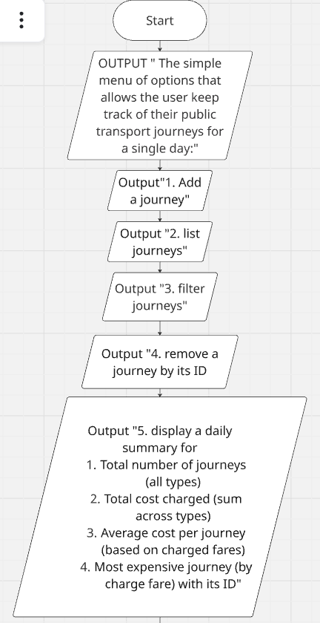

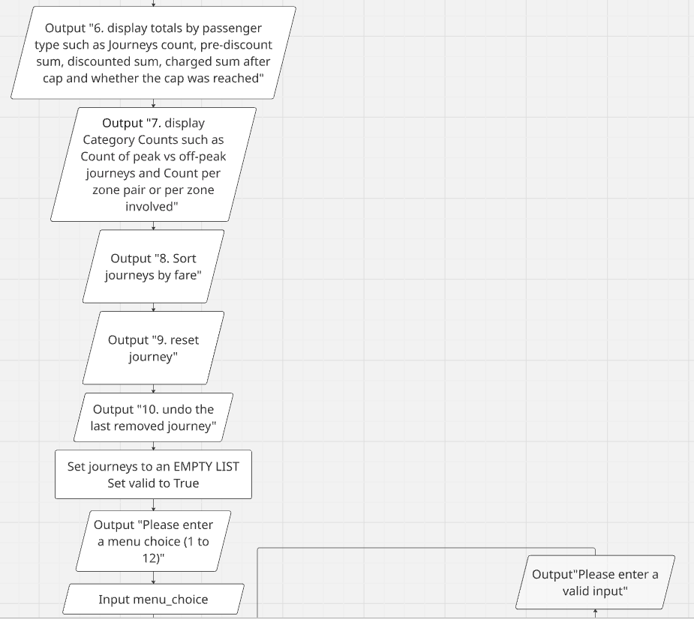

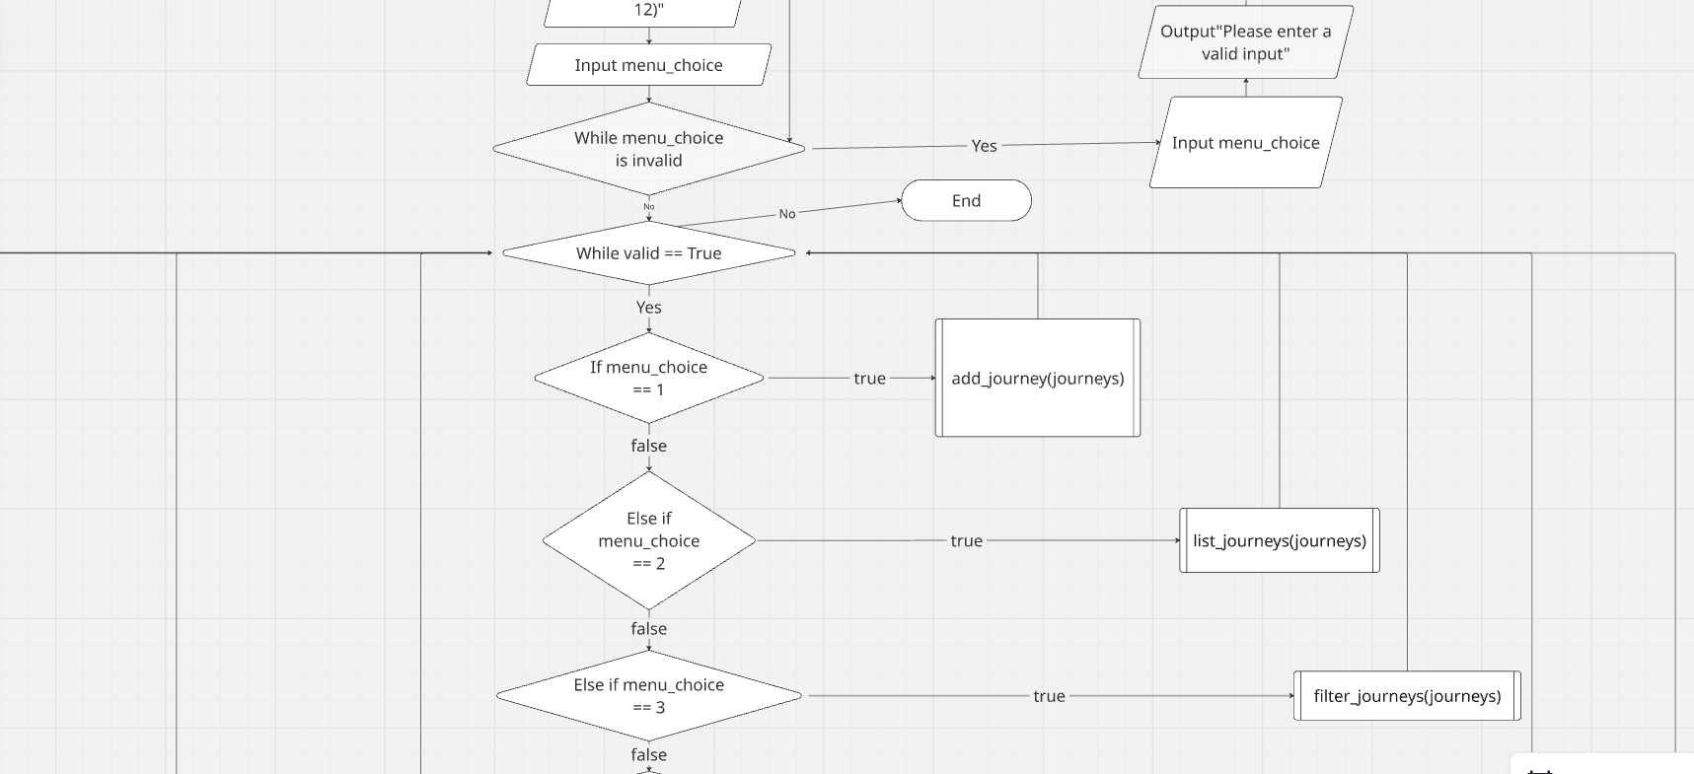

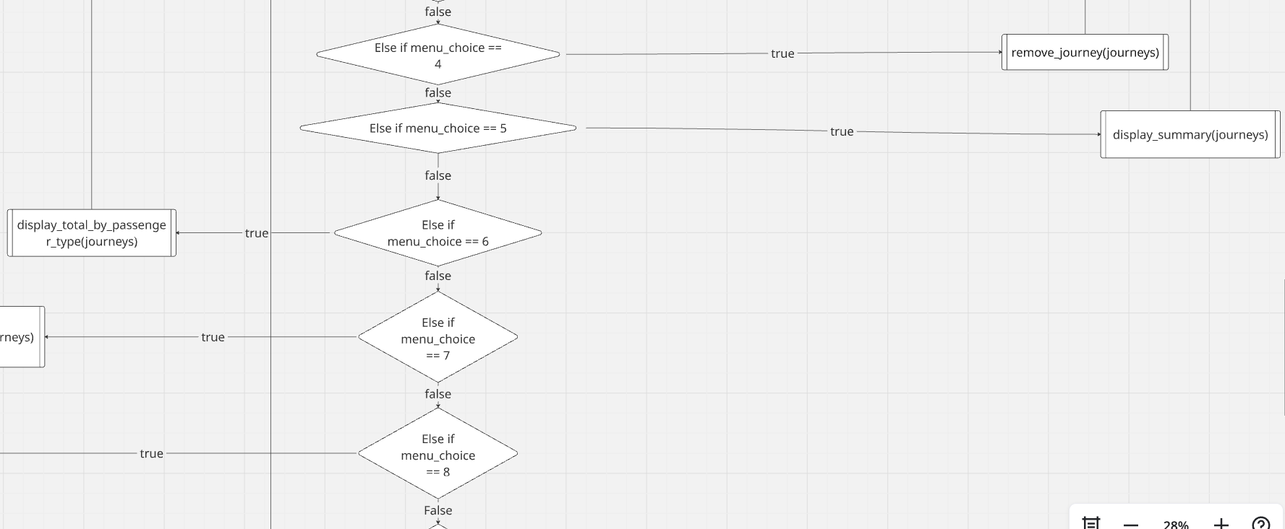

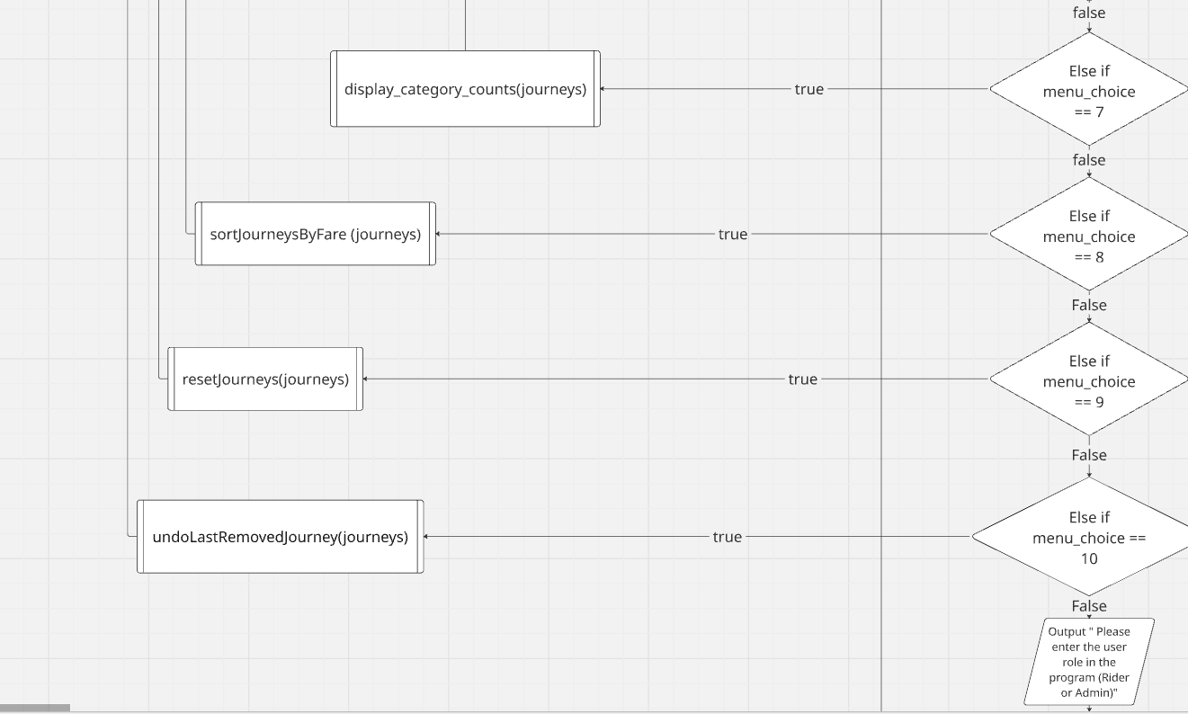

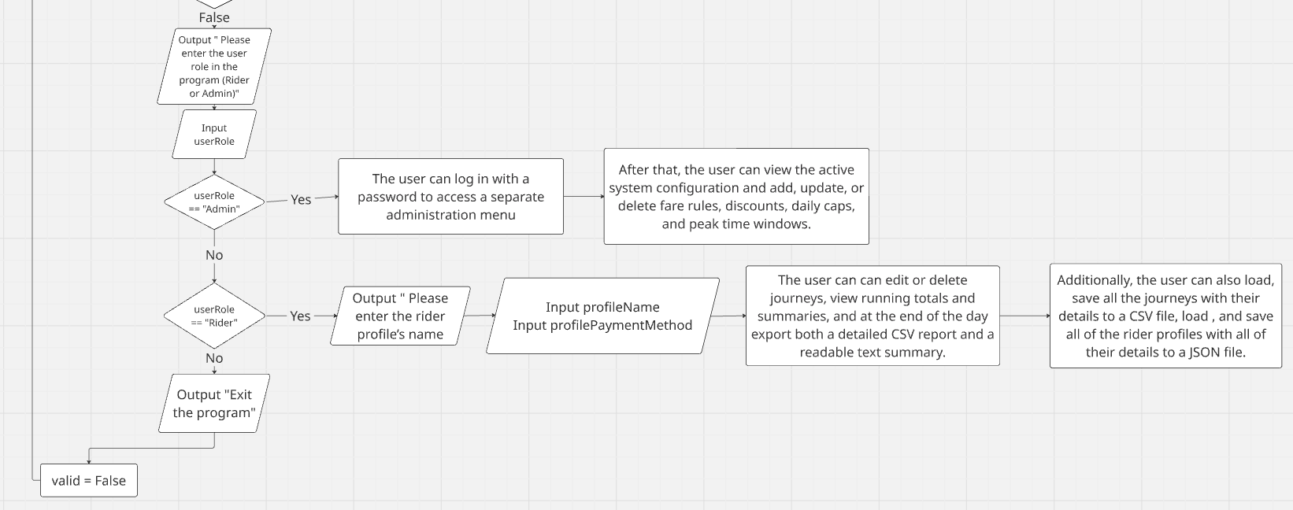

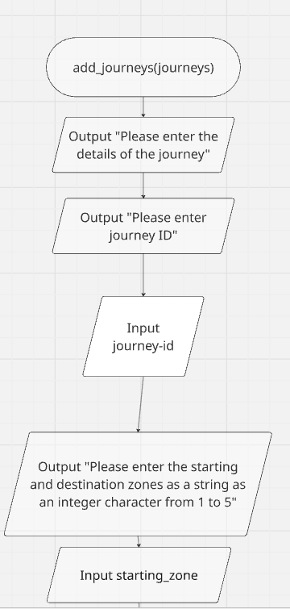

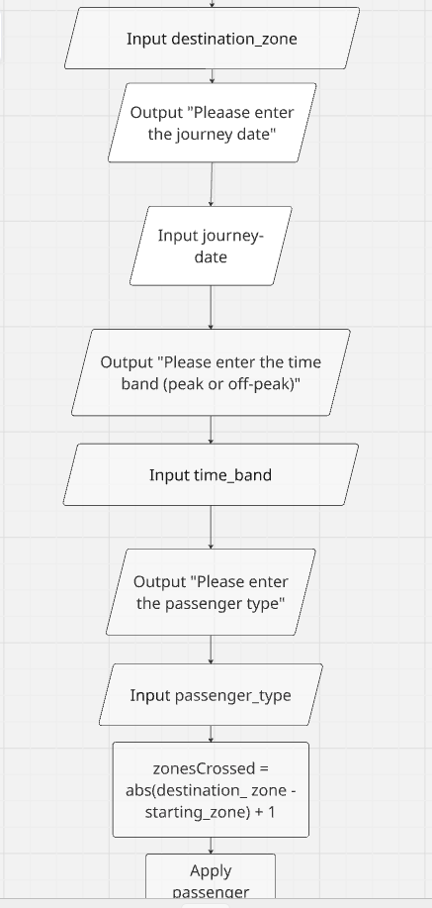
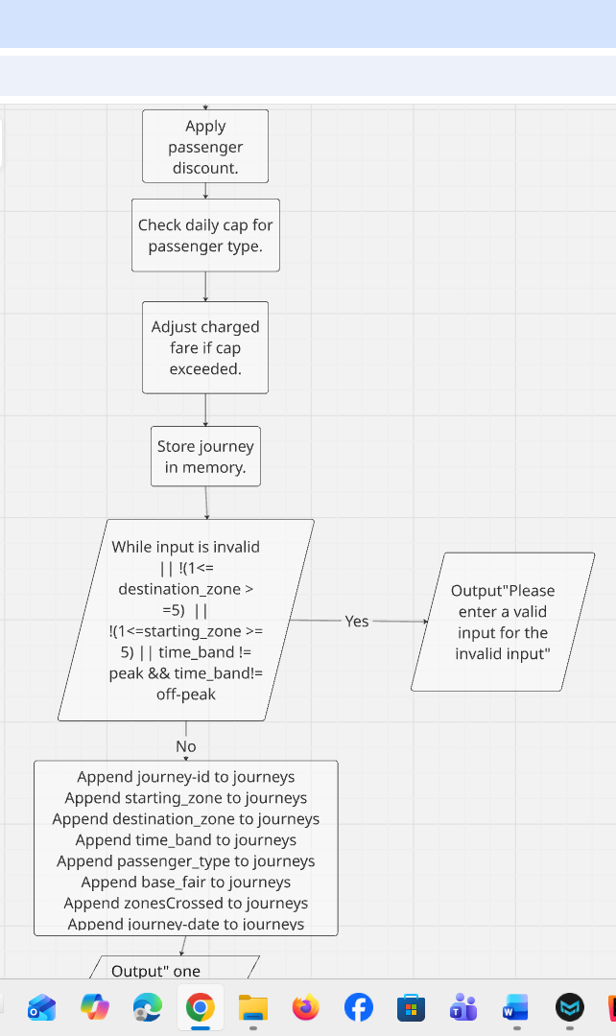
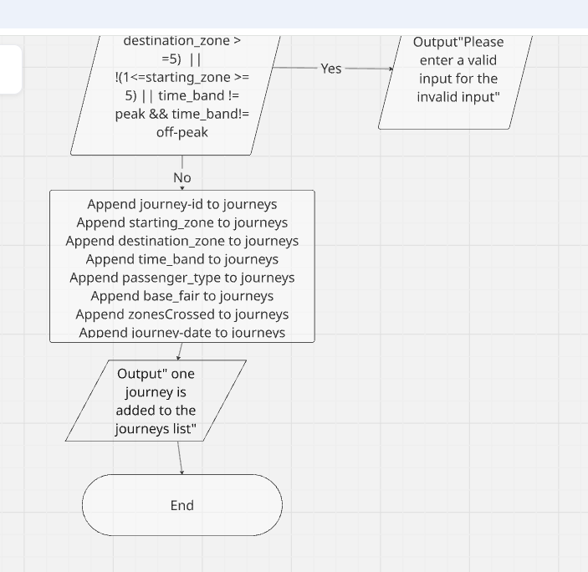

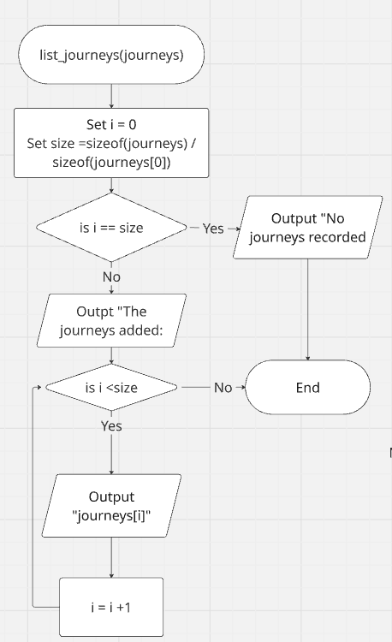

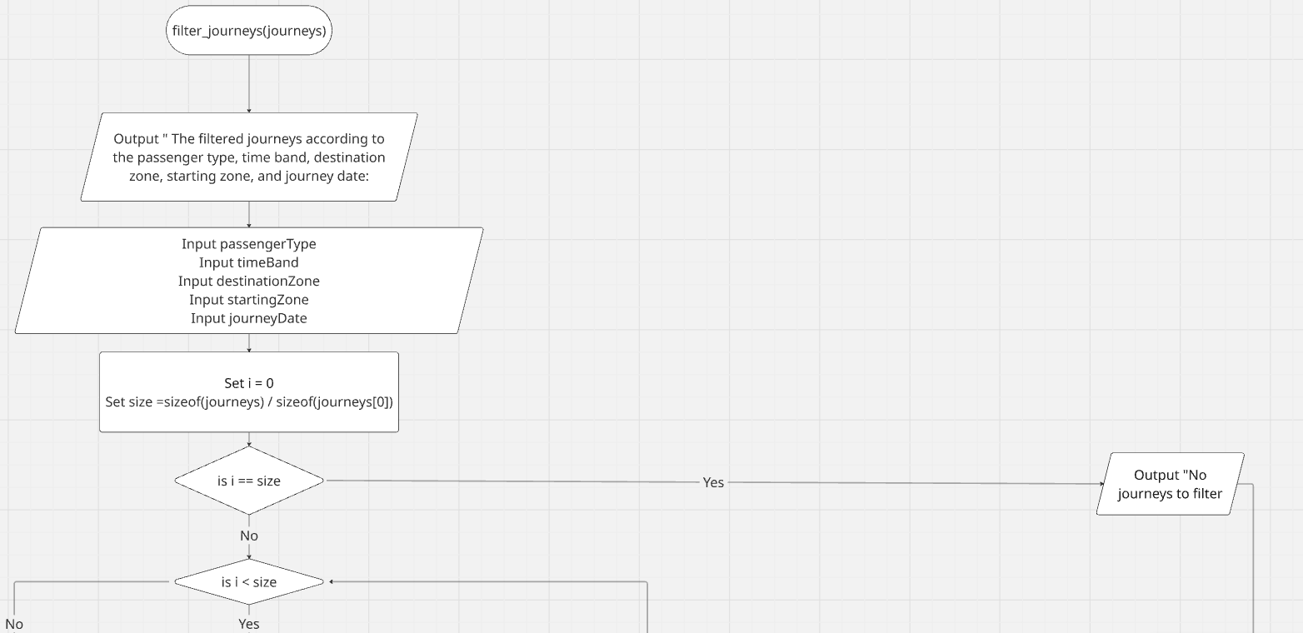

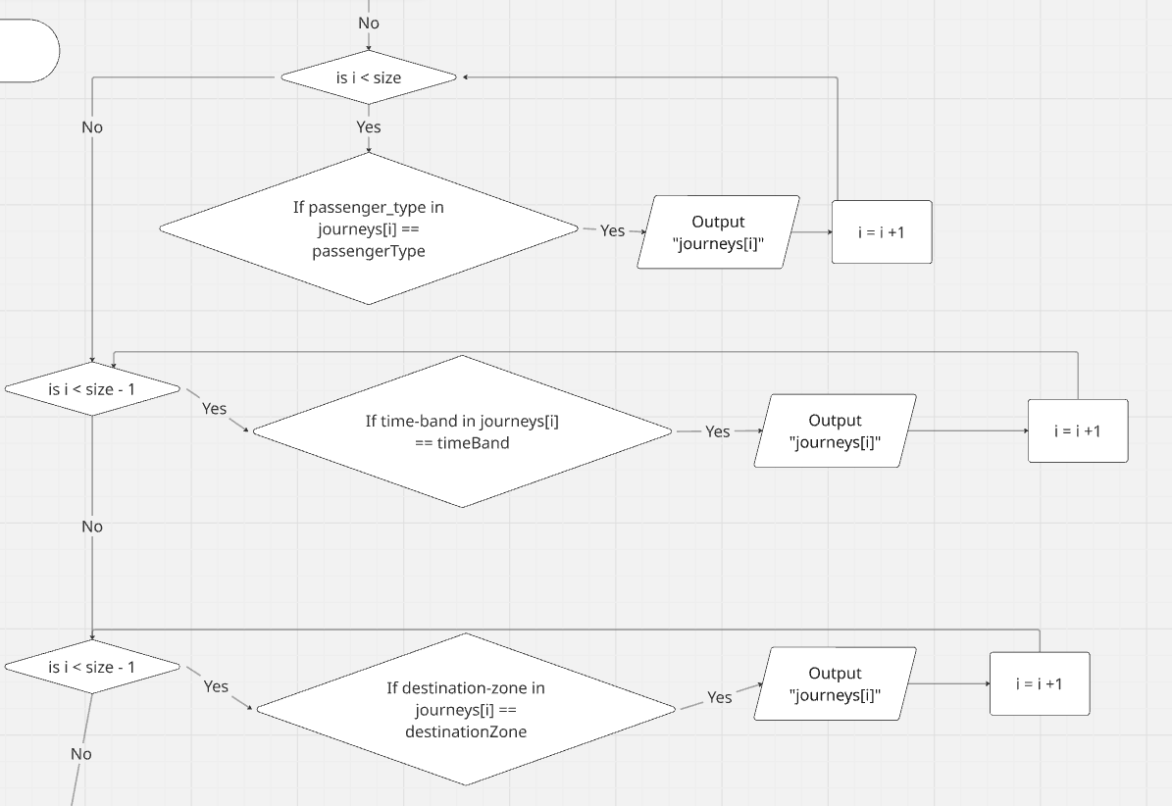

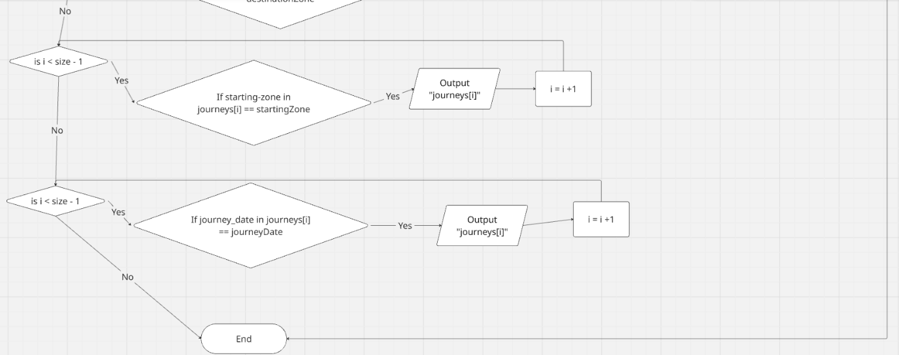

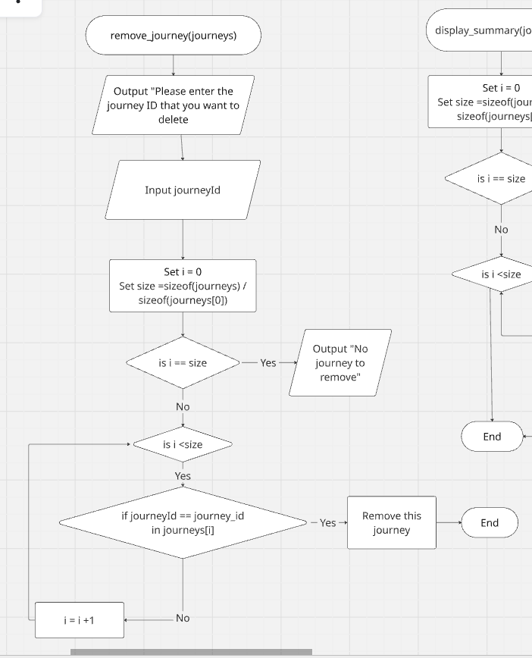

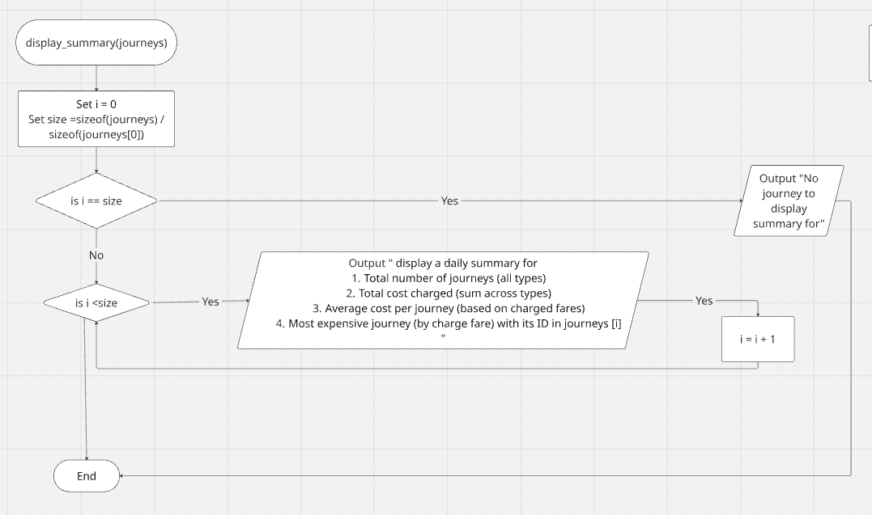

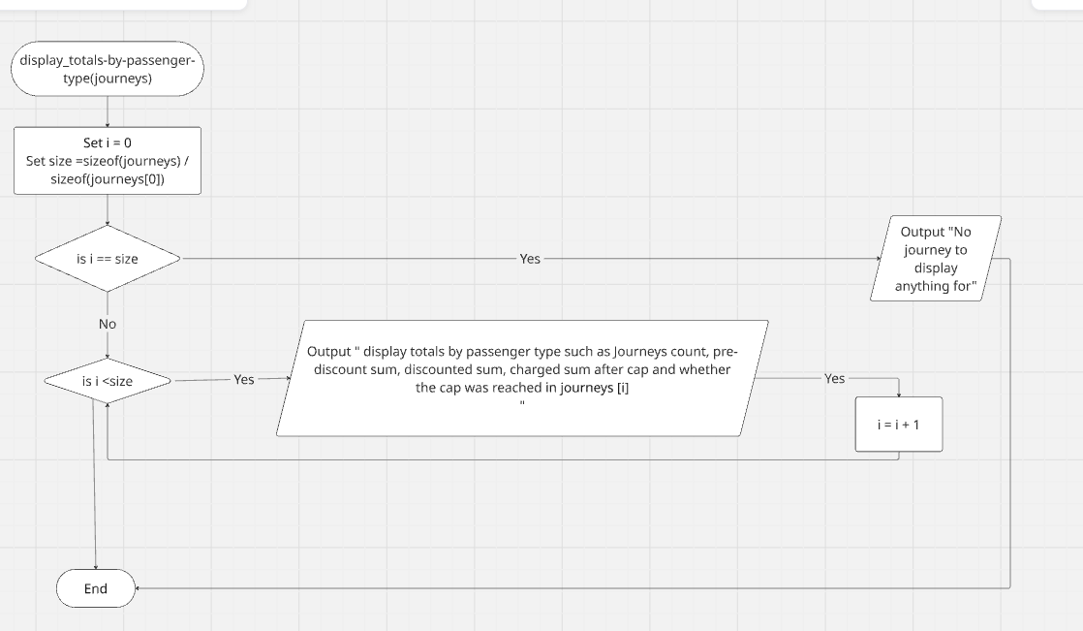

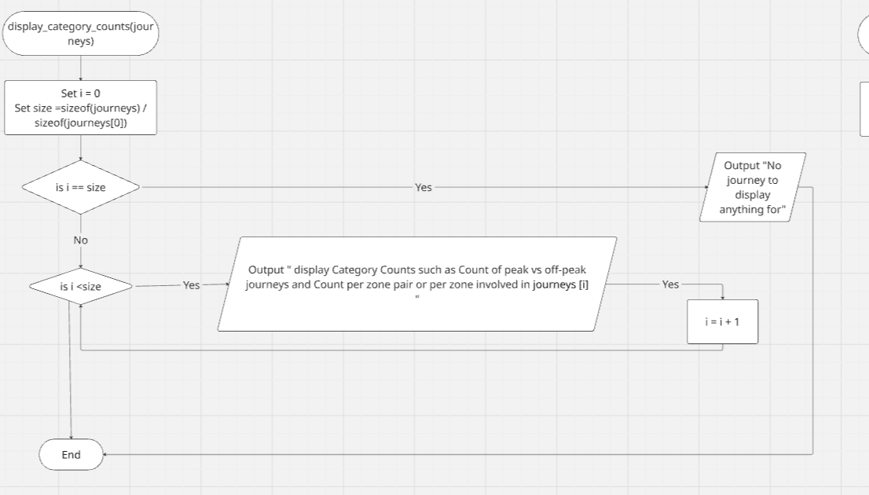

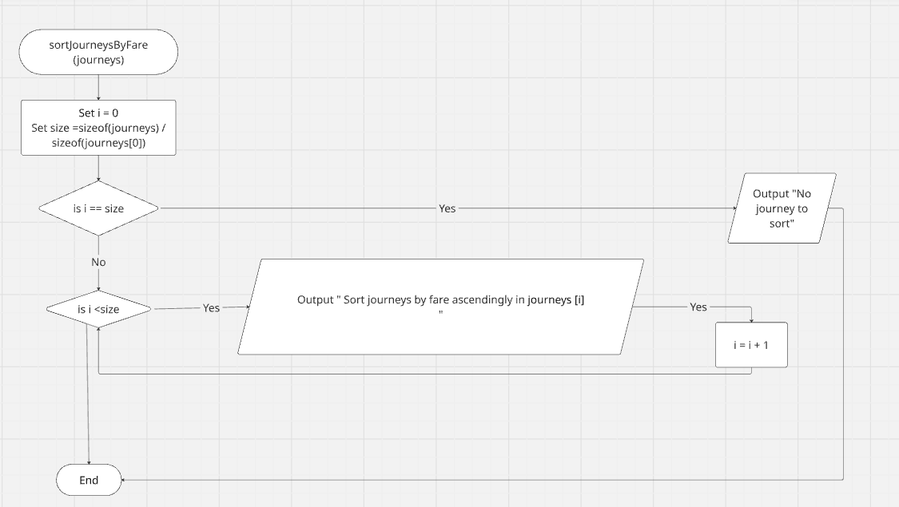

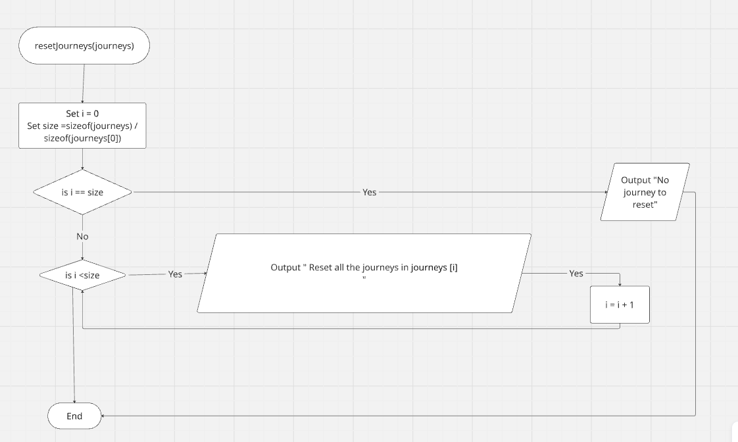

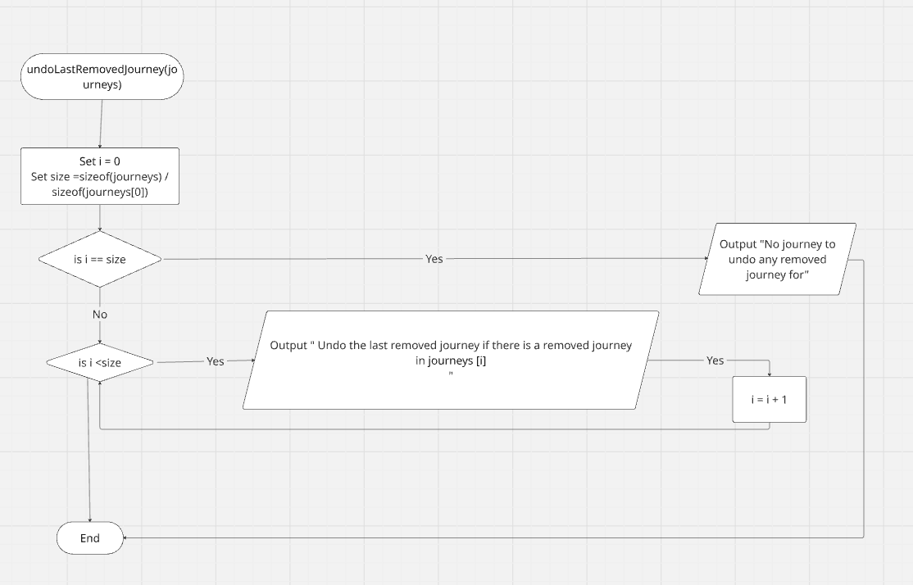
Class diagram:
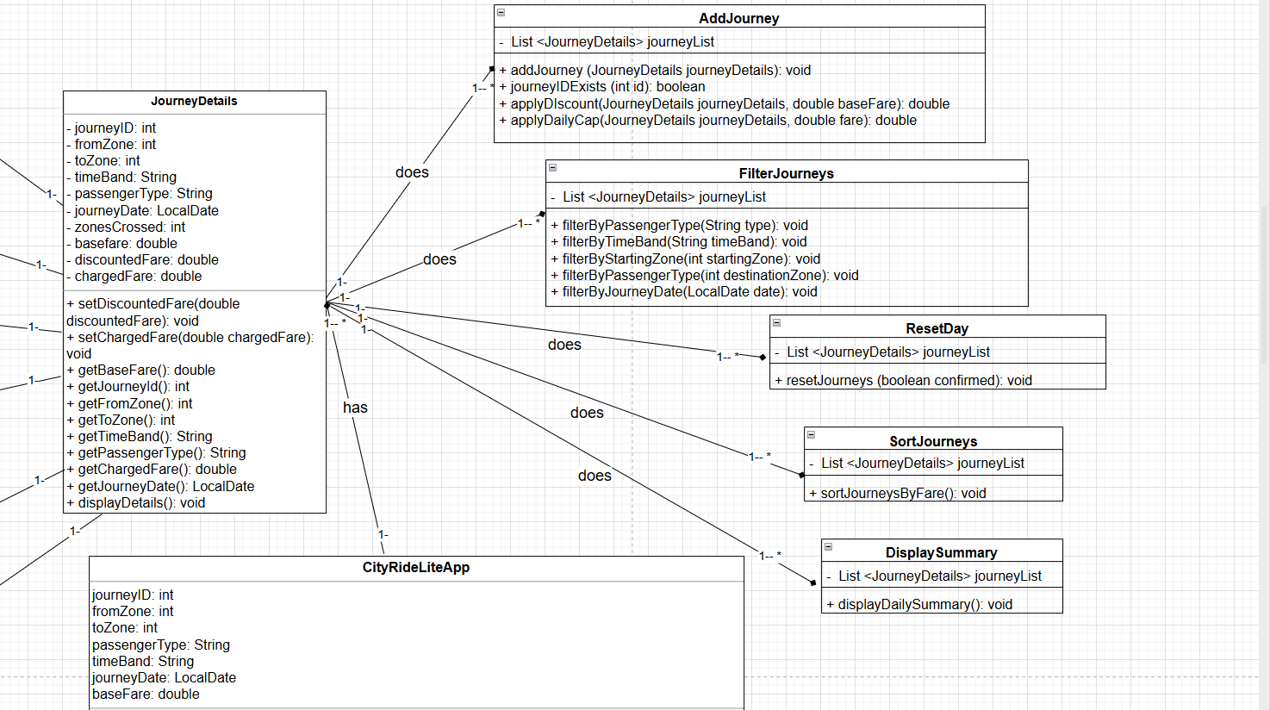
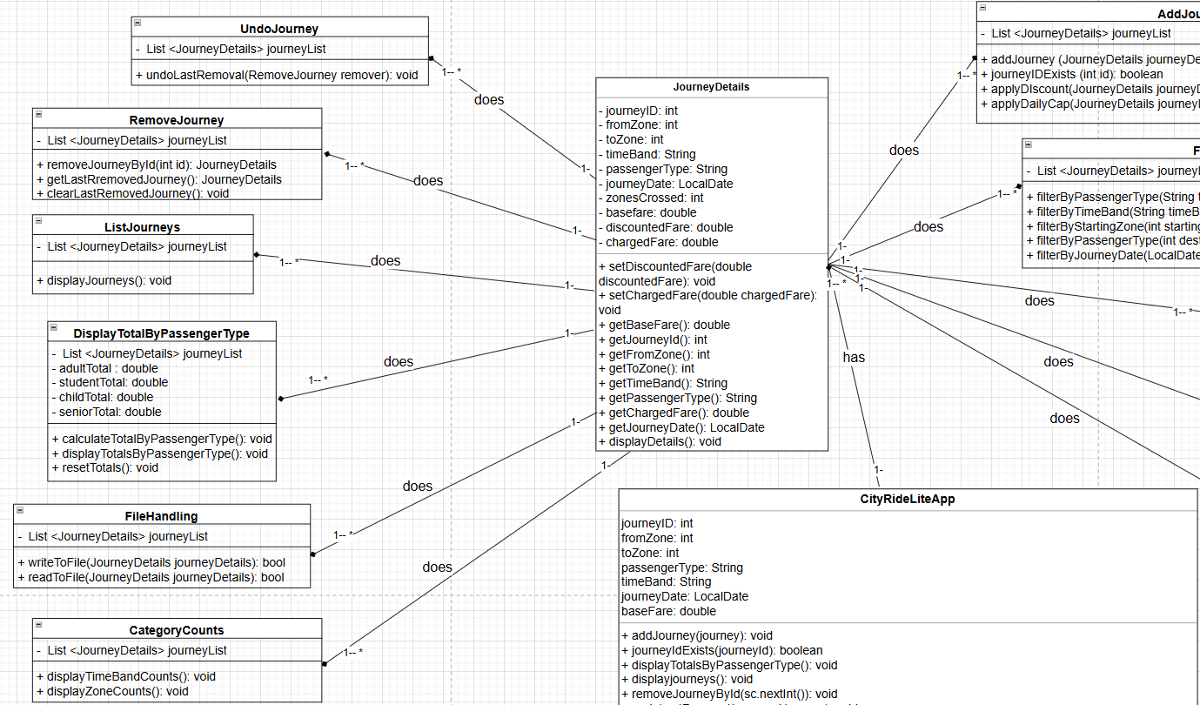
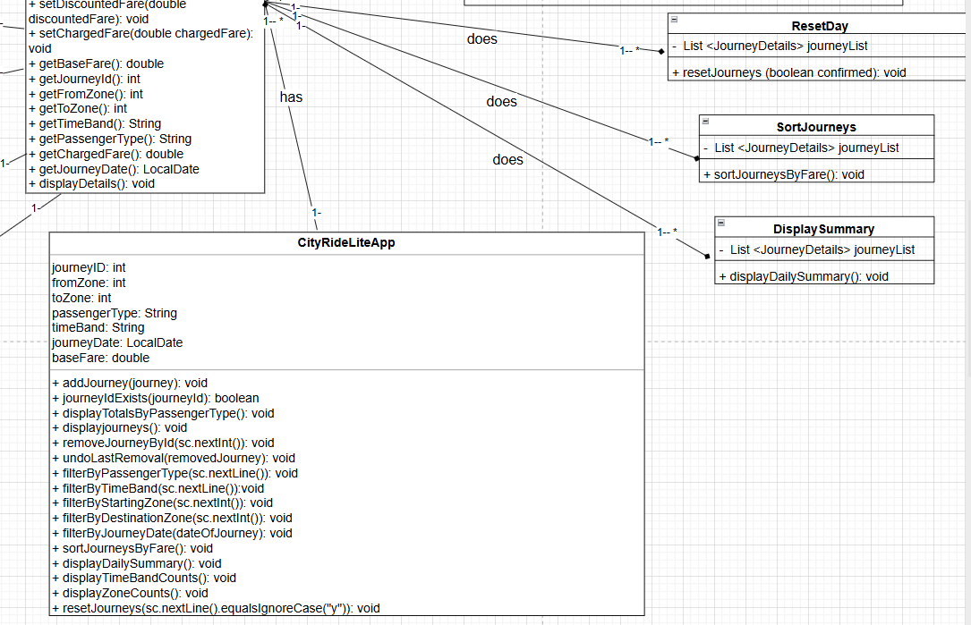
Research (minimum of 1 required, preferrebly 2)
The two research programs:
Name of the first program: Uber
Reference (link):
https://www.uber.com/
What it does well (2–3 features that work effectively):
- Provides real-time fare estimation before booking, helping users understand journey costs clearly.
- Uses a simple and intuitive interface, where users input pickup and destination with minimal steps.
- Automatically stores trip history, allowing users to review past journeys and costs.
What it does poorly (at least 1 feature):
- Pricing can be unpredictable due to surge pricing, making it harder for users to track consistent costs.
Key design ideas you could reuse:
- Clear input/output flow (enter journey → calculate fare → show breakdown).
- Use of history tracking (similar to storing journeys in your app).
- Displaying cost before confirmation, which matches your fare calculation feature.
Screenshot (showing the interface/output):
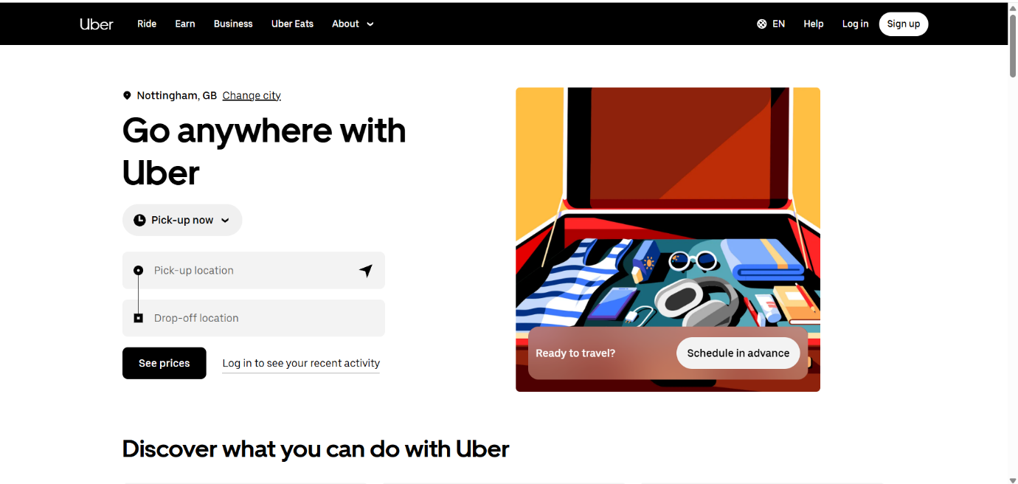
Name of the second program: Splitwise
Reference (link):
https://www.splitwise.com/
What it does well (2–3 features that work effectively):
- Tracks and stores expenses all the time, making it similar to saving journey data.
- Provides clear summaries and totals for all the journey data, including who owes what — useful model for end-of-day reports.
- Supports data persistence, meaning users can leave and return without losing data.
What it does poorly (at least 1 feature):
- The interface can become cluttered with many entries, making navigation harder for large datasets.
Key design ideas you could reuse:
- Data storage and retrieval (similar to JSON profile saving in your app).
- Generating summaries and reports (like your end-of-day summary feature for all the journeys).
- Organizing data into structured records (similar to journeys with IDs).
Screenshot (showing the interface/output):
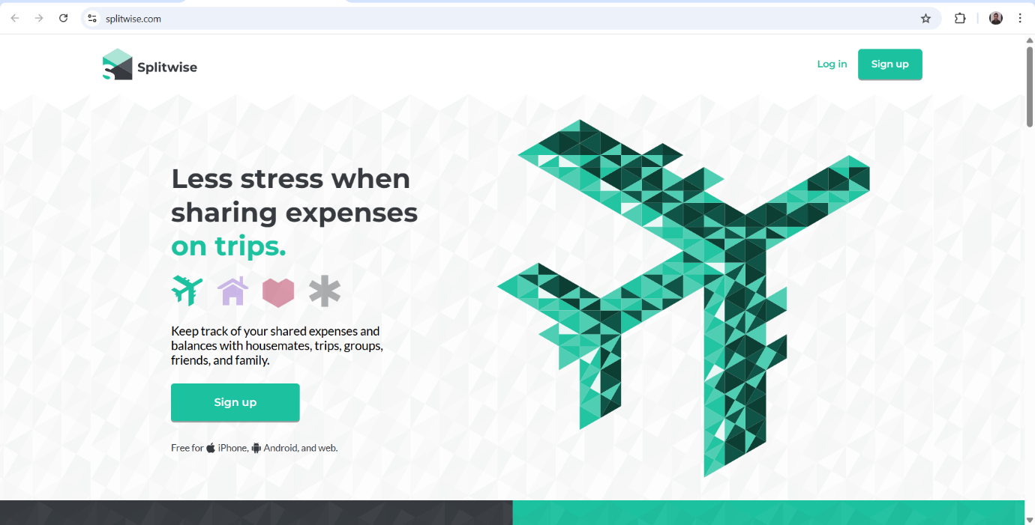
Gantt Chart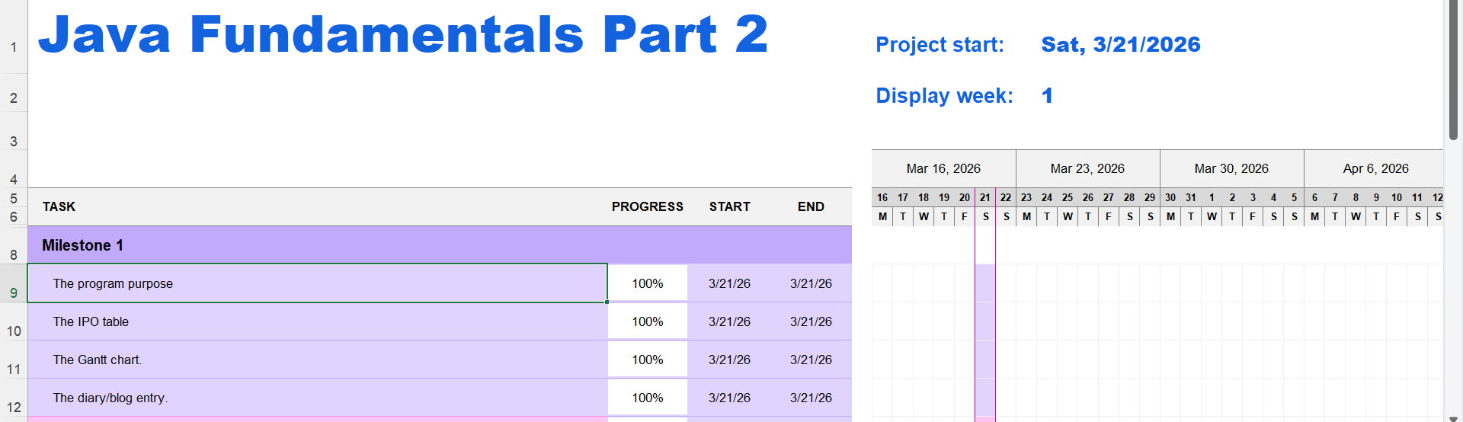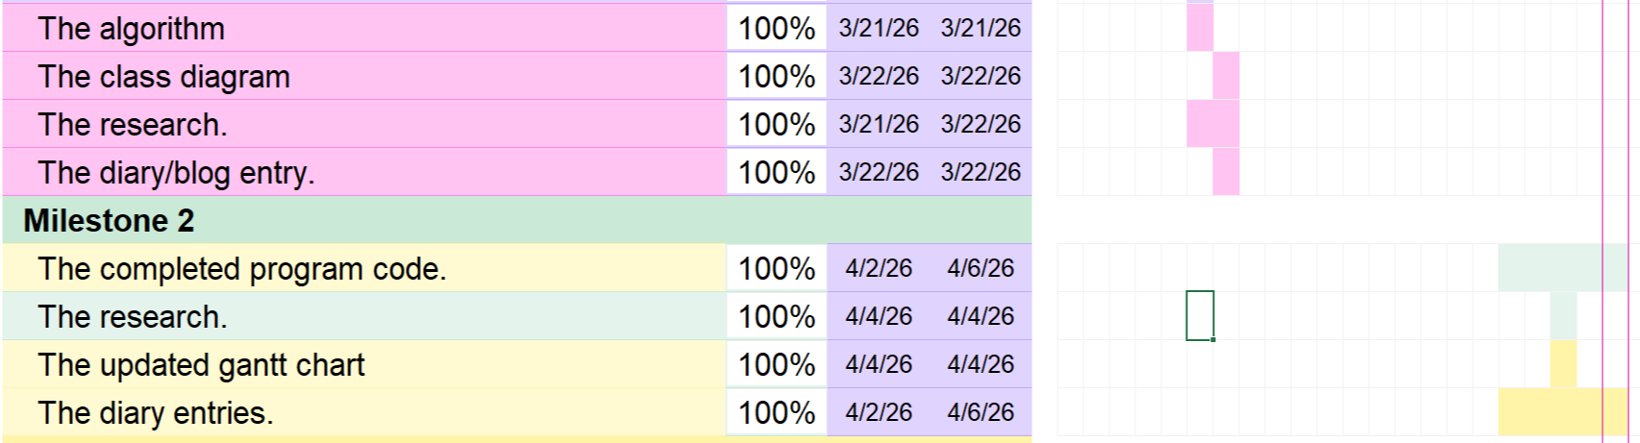
Diary Entries
16/03/2026 – Diary Entry 1 – Getting Started & Understanding the Milestone
Today I began working on Milestone 1 for Part 2 of the CityRide Lite project. The first step was to thoroughly read the new project specification and understand how much more complex this version will be compared to Part 1. The introduction of user profiles, JSON and CSV file handling, persistent storage, and an admin-level configuration system immediately stood out as major additions that significantly expand the project’s scope.
As I went through the document, I took detailed notes about how each new feature fits into the bigger system. Understanding the interaction between the rider workflows and the admin workflows was particularly important, because the program now needs to behave differently depending on the user’s role. I also made sure to identify the constraints that must not be violated, such as validating configuration changes, handling missing files perfectly, and ensuring all menus remain clear and easy to use.
By the end of the session, I had formed a complete picture of what the application needs to do in this second phase. This helped me feel more grounded and ready for the planning tasks ahead. Although no major issues arose, the scale of the requirements reinforced how important it will be to maintain clear structure and strong organisation throughout the project.

18/03/2026 – Diary Entry 2 – Building the IPO Tables
Today my main focus was constructing the IPO (Input–Process–Output) tables for the main components of the program. I started with the simpler features such as displaying main menu and adding a journey. I struggled in building these IPO tables because I was thinking about the way to implement the user role to all of the journeys that the program has, but at the end I knew the way. The way that I realised and I think is correct is by taking the user role from a variable named by userRole which should be inputted by the user. The user should input this variable to tell the system or the program what is the role that will be related to all the journeys.
Additionally, I also struggled in knowing which user role in the program writes or loads the journeys or the rider profiles. I knew later that the role of the rider is to do that and the admin is do some updates to the base fare of the journey if needed. Therefore, what I understood is that the program needs to choose a rule in each time it runs. This means that is might do this loading or writing to the needed files or it just might modify the base fares if needed. At the end, the program must know the user role and implement what is in this role after doing all the updates needed for all the journeys, like adding a journey, filtering a journey, and listing the journeys.

20/03/2026 – Diary Entry 3 – Research for Algorithms & System Structure
Today I spent time conducting research to support the next stage of the milestone. I examined examples of Java applications that make use of persistent storage, especially those that handle JSON and CSV files. This helped me understand typical approaches to parsing data, validating input, and handling exceptions. I also reviewed documentation for Java libraries commonly used for file operations, noting their strengths and potential limitations.
In addition to researching file handling, I reviewed object-oriented programming principles to ensure my system design would be clean and extensible. I examined how other applications implement user roles and considered how inheritance or interfaces could simplify the design. This was particularly useful when planning how the Rider and Admin pathways would operate separately but still share certain behaviors.
All of this research will be extremely valuable when moving into Milestone 2, as it gives me a solid technical foundation. I also recorded references for use in the written submission later on. Although comparing different approaches took some time, the research was worth it because it strengthened my confidence in the design.

21/03/2026 – Diary Entry 4 – Creating Flowcharts and JSP Diagrams
Today I focused on converting the IPO tables and system requirements into algorithm diagrams. I began with the simpler workflows, such as loading a rider profile and saving the current system state, before moving on to more complex processes like journey editing, generating daily summaries, and handling admin configuration changes. Representing the logic visually helped me better understand how users will navigate through the menu system and how different components of the program need to interact.
By the end of the session, I had produced a complete set of diagrams that accurately represent the system’s expected behavior. These diagrams will act as a roadmap for the coding phase in Milestone 2, allowing me to follow a structured and logical development process.

22/03/2026 – Diary Entry 5 – Final Review & Completing Milestone 1
Today I finalised all components of Milestone 1 and reviewed everything to ensure it meets the assessment requirements. I revisited my analysis, IPO tables, diagrams, research notes, and the Gantt chart to verify that each section was clear and logically structured. I also used the Milestone 1 template provided by the module to organise the written content properly and ensure all sections flowed smoothly.
During the review, I checked terminology to ensure consistency with the CityRideDataset.java, especially concerning zones, passenger types, and fare rules. I made minor corrections to improve precision in the presentation and documentation of my work.
With the final edits complete, I now feel confident that my Milestone 1 submission is accurate, detailed, and ready for upload. Completing this milestone has given me a solid foundation for Milestone 2, and I feel well-prepared to begin the implementation phase next.

17/03/2026 – Diary Entry 6 – The Problems I Encountered While Solving This Milestone
Today I reflected on several challenges I faced during this milestone. One of the most demanding aspects was breaking down the expanded project specification into smaller, manageable tasks. Many of the new requirements rely on each other, so it took effort to understand how everything should flow in the correct sequence. For example, journey editing can only work properly if JSON profile loading works first, and fare calculations depend on the configuration being loaded and validated.
Finally, designing the algorithm diagrams turned out to be more complex than expected. Many processes have multiple branching paths, and fitting them all into a single flowchart made them difficult to read. Splitting them into smaller linked diagrams solved the problem, but it required additional work. Although these challenges slowed my progress slightly, overcoming them greatly improved my understanding of how the system should function.

IY4113 Part 2 Milestone 2
Assessment Details | Please Complete All Details
Group | B.
Module Title | IY4113 Applied Software Engineering using Object-Orientated Programming.
Assessment Type | Java Fundamentals Part 2.
Module Tutor Name | Jonathan Shore.
Student ID Number | T0486024
Date of Submission | 06/04/2026
Word Count | 5134
GitHub Link | https://github.com/T0486024Ali/4113_Milestone_2_Part_2_T0486024
- I confirm that this assignment is my own work. Where I have referred to academic sources, I have provided in-text citations and included the sources in the final reference list.
- *Where I have used AI, I have cited and referenced appropriately.

Research (minimum of 2, at least 3)
The 3 researches:
1_
Title of research:
Role-Based Access Control
Reference link:
https://cdn-cms.f-static.net/uploads/4660132/normal_61b18ac075575.pdf?utm_source
How does the research help with coding practice?:
This book explains how systems assign roles to users and control what they can do based on those roles. In my program, when the user selects Admin or Rider, the system shows different menus and functionality. This is exactly what RBAC describes — controlling system behaviour based on roles rather than giving all users the same access.
Key coding ideas you could reuse in your program:
- Use role selection at program start
- Separate admin and user functionality
- Use if conditions to control access
Screenshot of research:
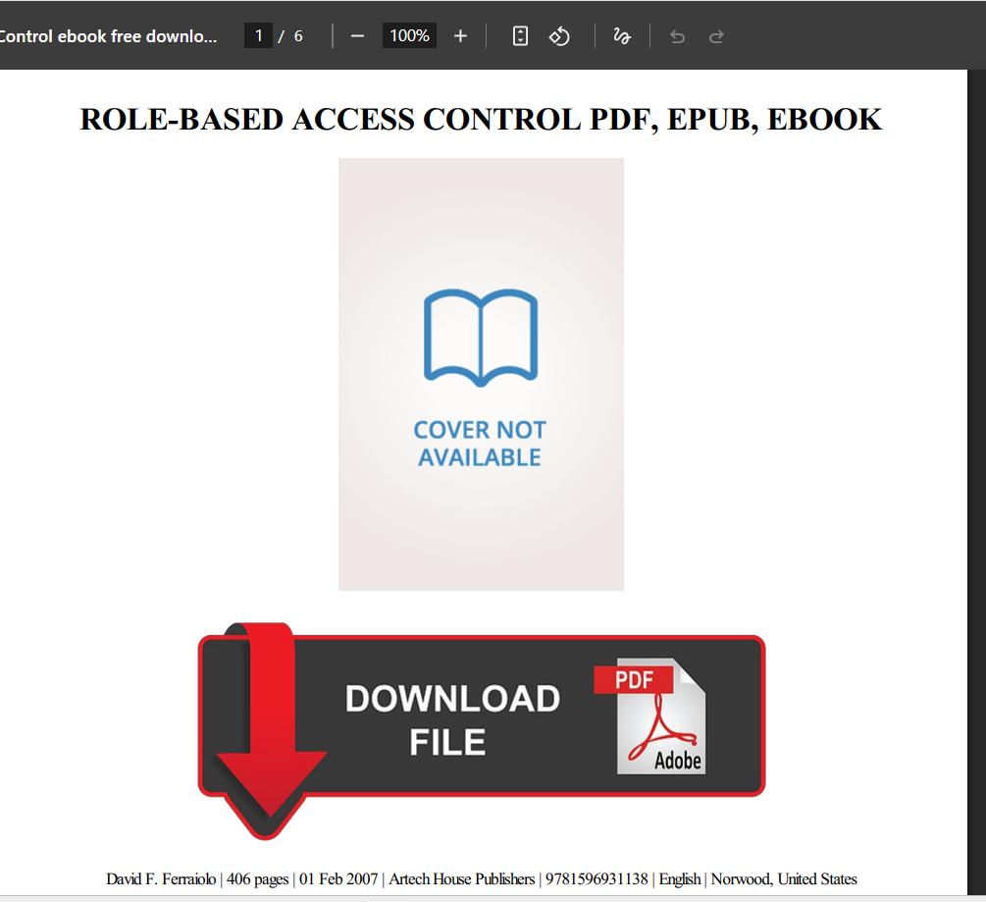
2_
Title of research:
Class Schema Evolution for Persistent Object-Oriented Software
Reference link:
https://arxiv.org/pdf/1103.0711
How does the research help with coding practice?:
This paper explains that when a core attribute changes, all dependent data must be updated to maintain consistency. In my program, when the admin changes the base fare, you correctly recalculate discounted fare and charged fare for all journeys. This ensures the system remains consistent after modification — exactly what this research supports.
Key coding ideas you could reuse in your program:
- Recalculate dependent values after updates
- Loop through all objects (e.g., journeys)
- Maintain consistency after modification
Screenshot of research:
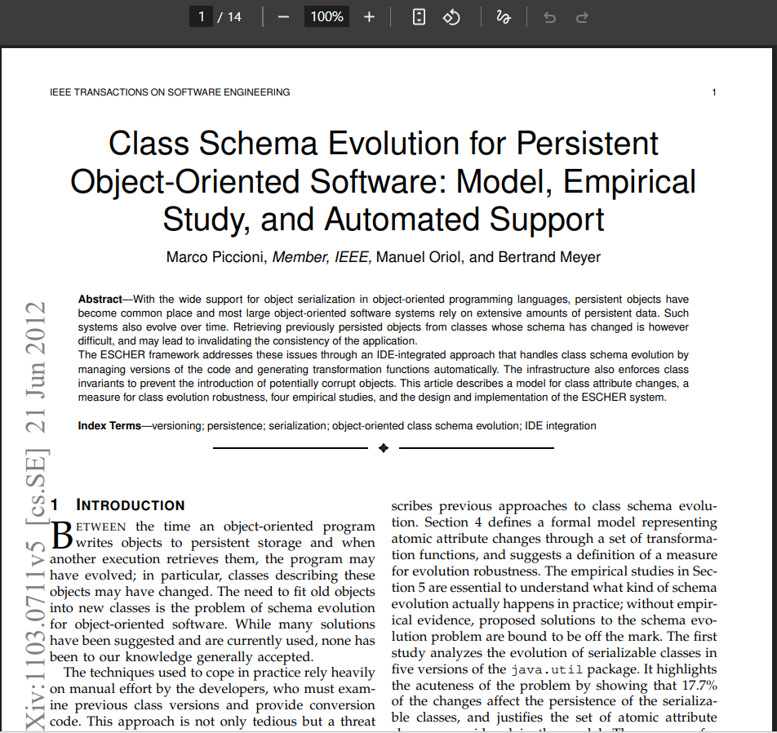
3_
Title of research:
Lambda-RBAC: Programming with Role-Based Access Control
Reference link:
https://arxiv.org/pdf/0712.1205.pdf
How does the research help with coding practice?:
This research shows how programs should check user roles before allowing access to certain functionality. In my program, the admin must enter the correct password before modifying fares. This is a direct implementation of access control — ensuring only authorized users can perform sensitive operations.
Key coding ideas you could reuse in your program:
- Authenticate user before allowing access
- Restrict sensitive operations (like modifying fares)
- Implement login checks before admin menu
Screenshot of research:
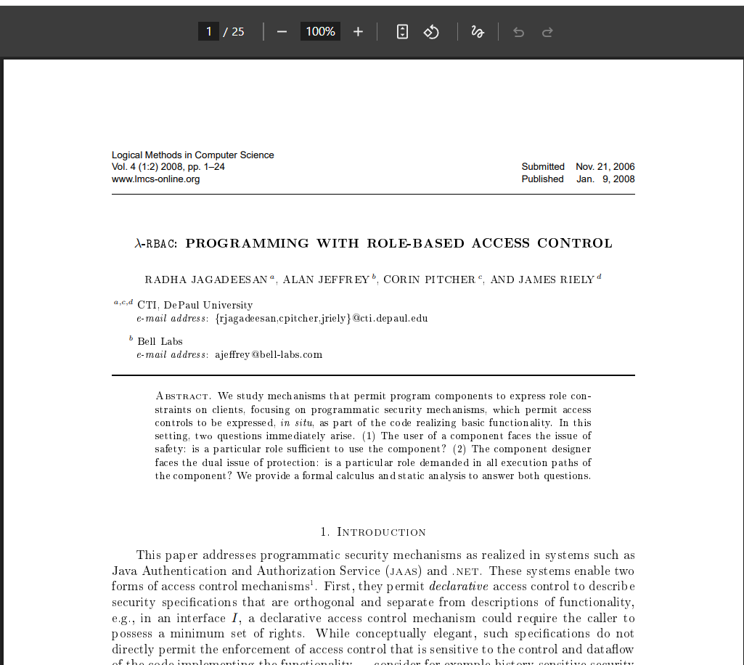

Program Code
The completed program code (The code runs):
import com.google.gson.Gson;
import com.google.gson.GsonBuilder;
import com.google.gson.reflect.TypeToken;
import java.io.*;
import java.lang.reflect.Type;
import java.util.ArrayList;
import java.util.List;
import java.util.Scanner;
import java.time.LocalDate;
import java.util.InputMismatchException;

// A class that holds data for a single journey.
class JourneyDetails {

private int journeyId;
private int fromZone;
private int toZone;
private String timeBand;
private String passengerType;
private LocalDate journeyDate;
private int zonesCrossed;
private double baseFare;
private double discountedFare;
private double chargedFare;

// Constructor only takes raw journey input.
public JourneyDetails(int journeyId, int fromZone, int toZone,
String timeBand, String passengerType, double baseFare, LocalDate journeyDate) {

this.journeyId = journeyId;
this.fromZone = fromZone;
this.toZone = toZone;
this.timeBand = timeBand;
this.passengerType = passengerType;
this.baseFare = baseFare;
this.journeyDate = journeyDate;
this.zonesCrossed = Math.abs(toZone - fromZone) + 1;
}

// Setters used internally by Journey class.
public void setDiscountedFare(double discountedFare) {
this.discountedFare = discountedFare;
}

public void setChargedFare(double chargedFare) {
this.chargedFare = chargedFare;
}

// Getters.
public double getBaseFare() {
return baseFare;
}

public double getDiscountedFare() {
return discountedFare;
}

public int getJourneyId() {
return journeyId;
}

public int getFromZone() {
return fromZone;
}

public int getToZone() {
return toZone;
}

public String getTimeBand() {
return timeBand;
}

public String getPassengerType() {
return passengerType;
}

public double getChargedFare() {
return chargedFare;
}

public LocalDate getJourneyDate() {
return journeyDate;
}

public void setBaseFare(double baseFare) {
this.baseFare = baseFare;
}

public String toCSV() {
return journeyId + "," + fromZone + "," + toZone + "," + timeBand + "," + passengerType + "," + baseFare + "," + journeyDate;
}

// Displays full journey details.
public void displayDetails() {
System.out.println("Journey ID: " + journeyId + " " +
"Starting zone: " + fromZone + " " +
"Destination zone: " + toZone + " " +
"Time band: " + timeBand + " " +
"Passenger type: " + passengerType + " " +
"Zones crossed: " + zonesCrossed + " " +
"Base fare: £" + String.format("%.2f",baseFare) + " " +
"Discounted fare: £" + String.format("%.2f",discountedFare) + " " +
"Charged fare: £" + String.format("%.2f",chargedFare) + " " +
"Journey date: " + journeyDate);
}
}

// A class that adds a journey.
class AddJourney {

private final List<JourneyDetails> journeyList;
private final DisplayTotalByPassengerType totals;

public AddJourney(List<JourneyDetails> journeyList, DisplayTotalByPassengerType totals) {
this.journeyList = journeyList;
this.totals = totals;
}

// Adds a journey object and computes all fares internally.
public void addJourney(JourneyDetails journeyDetails) {

double discountedFare = applyDiscount(journeyDetails, journeyDetails.getBaseFare());

journeyDetails.setDiscountedFare(discountedFare);

journeyList.add(journeyDetails);
totals.recalculateTotals();
System.out.println("Journey added successfully.");
}

// Ensures journey IDs are unique to avoid ambiguity when adding, removing or undoing journeys.
public boolean journeyIdExists(int id) {
for (JourneyDetails journey : journeyList) {
if (journey.getJourneyId() == id) {
return true;
}
}
return false;
}

// Applies discount based on passenger type.
public double applyDiscount(JourneyDetails journeyDetails, double baseFare) {

double discountRate = 0;

if (journeyDetails.getPassengerType().equalsIgnoreCase("student")) {
discountRate = 0.25;
} else if (journeyDetails.getPassengerType().equalsIgnoreCase("child")) {
discountRate = 0.50;
} else if (journeyDetails.getPassengerType().equalsIgnoreCase("senior citizen")) {
discountRate = 0.30;
} else if (journeyDetails.getPassengerType().equalsIgnoreCase("adult")) {
discountRate = 0.0;
} else {
System.out.println("Invalid passenger type");
}
return baseFare * (1 - discountRate);
}
}

// A class that lists all the journeys.
class ListJourneys {

private final List<JourneyDetails> journeyList;

public ListJourneys(List<JourneyDetails> journeyList) {
this.journeyList = journeyList;
}

// Displays all journeys.
public void displayJourneys() {

if (journeyList.isEmpty()) {
System.out.println("No journeys recorded.");
return;
}

for (JourneyDetails journey : journeyList) {
journey.displayDetails();
}
}
}

// A class that filters all the journeys.
class FilterJourneys {

private final List<JourneyDetails> journeyList;

public FilterJourneys(List<JourneyDetails> journeyList) {
this.journeyList = journeyList;
}

// Filters journeys by the passenger type.
public void filterByPassengerType(String type) {
for (JourneyDetails journeyDetails : journeyList) {
if (journeyDetails.getPassengerType().equalsIgnoreCase(type)) {
journeyDetails.displayDetails();
}
}
}

// Filters journeys by the time band.
public void filterByTimeBand(String timeBand) {
for (JourneyDetails journeyDetails : journeyList) {
if (journeyDetails.getTimeBand().equalsIgnoreCase(timeBand)) {
journeyDetails.displayDetails();
}
}
}

// Filters journeys by the starting zone.
public void filterByStartingZone(int startingZone) {
for (JourneyDetails journeyDetails : journeyList) {
if (journeyDetails.getFromZone() == startingZone) {
journeyDetails.displayDetails();
}
}
}

// Filters journeys by the destination zone.
public void filterByDestinationZone(int destinationZone) {
for (JourneyDetails journeyDetails : journeyList) {
if (journeyDetails.getToZone() == destinationZone) {
journeyDetails.displayDetails();
}
}
}

// Filters journeys by the journey date.
public void filterByJourneyDate(LocalDate date) {
for (JourneyDetails journeyDetails : journeyList) {
if (journeyDetails.getJourneyDate().equals(date)) {
journeyDetails.displayDetails();
}
}
}
}

// A class that removes a specific journey using the journey id.
class RemoveJourney {

private final List<JourneyDetails> journeyList;
private JourneyDetails lastRemovedJourney = null;
private final DisplayTotalByPassengerType totals;

public RemoveJourney(List<JourneyDetails> journeyList, DisplayTotalByPassengerType totals) {
this.journeyList = journeyList;
this.totals = totals;
}

public JourneyDetails removeJourneyById(int id) {

for (int i = 0; i < journeyList.size(); i++) {
if (journeyList.get(i).getJourneyId() == id) {

lastRemovedJourney = journeyList.get(i);
journeyList.remove(i);

// recalculate totals after removing
totals.recalculateTotals();

System.out.println("Journey removed successfully.");
return lastRemovedJourney;
}
}

System.out.println("No journey found with that ID.");
lastRemovedJourney = null;
return null;
}

// A method to get the last removed journey in order to help in undoing this journey later in the UndoJourney class.
public JourneyDetails getLastRemovedJourney() {
return lastRemovedJourney;
}

/* A method that clears the last removed journey to avoid undoing the same journey in the UndoJourney class
twice if the user pressed the choice of undoing this journey two times after each other. */
public void clearLastRemovedJourney() {
lastRemovedJourney = null;
}
}

// A class that undo the last removed journey in the journeys list.
class UndoJourney {

private final List<JourneyDetails> journeyList;
private final DisplayTotalByPassengerType totals;

public UndoJourney(List<JourneyDetails> journeyList, DisplayTotalByPassengerType totals) {
this.journeyList = journeyList;
this.totals = totals;
}

public void undoLastRemoval(RemoveJourney remover) {

JourneyDetails journey = remover.getLastRemovedJourney();

if (journey == null) {
System.out.println("Nothing to undo.");
return;
}

journeyList.add(journey);
remover.clearLastRemovedJourney();

// A method that recalculates all the passenger types’ totals after restoring a journey.
totals.recalculateTotals();

System.out.println("Last removed journey has been restored.");
}
}

// A class the sorts all the journeys from lowest to highest.
class SortJourneys {

private final List<JourneyDetails> journeyList;

public SortJourneys(List<JourneyDetails> journeyList) {
this.journeyList = journeyList;
}

// MANUAL SORT: compares TWO objects taken from the list.
public void sortJourneysByFare() {
for (int i = 0; i < journeyList.size() - 1; i++) {
for (int j = i + 1; j < journeyList.size(); j++) {

JourneyDetails FirstJourney = journeyList.get(i);
JourneyDetails SecondJourney = journeyList.get(j);

if (FirstJourney.getChargedFare() > SecondJourney.getChargedFare()) {
journeyList.set(i, SecondJourney);
journeyList.set(j, FirstJourney);
}
}
}
System.out.println("Journeys sorted by fare (lowest to highest).");
}
}

/* A class that displays a daily summary for all the journeys,
including the total number of journeys and the most expensive journey.
*/
class DisplaySummary {

private final List<JourneyDetails> journeyList;

public DisplaySummary(List<JourneyDetails> journeyList) {
this.journeyList = journeyList;
}

// Displays daily summary.
public void displayDailySummary() {

if (journeyList.isEmpty()) {
System.out.println("No journeys recorded today.");
return;
}

int totalJourneys = journeyList.size();
double totalCost = 0;
JourneyDetails mostExpensive = journeyList.get(0);

for (JourneyDetails journey : journeyList) {
totalCost += journey.getChargedFare();
if (journey.getChargedFare() > mostExpensive.getChargedFare()) {
mostExpensive = journey;
}
}
System.out.println("----- Daily Summary -----");
System.out.println("Total journeys: " + totalJourneys);
System.out.println("Total cost charged: £" + String.format("%.2f",totalCost));
System.out.println("Average cost per journey: £" + String.format("%.2f",(totalCost / totalJourneys)));
System.out.println("Most expensive journey ID: " +
mostExpensive.getJourneyId() +
" (£" + String.format("%.2f",mostExpensive.getChargedFare()) + ")");
}
}

// A class that counts the number of peak, offPeak journeys, and journeys involved in each zone.
class CategoryCounts {

private final List<JourneyDetails> journeyList;

public CategoryCounts(List<JourneyDetails> journeyList) {
this.journeyList = journeyList;
}

// Displays peak and off-peak counts.
public void displayTimeBandCounts() {

int peak = 0;
int offPeak = 0;

for (JourneyDetails Journey : journeyList) {
if (Journey.getTimeBand().equalsIgnoreCase("peak")) {
peak++;
} else {
offPeak++;
}
}

System.out.println("Peak journeys: " + peak);
System.out.println("Off-peak journeys: " + offPeak);
}

// Displays how many journeys involved each zone (zones 1–5 only).
public void displayZoneCounts() {

int[] zoneCounts = new int[6]; // Index 1–5 represent zones.

for (JourneyDetails Journey : journeyList) {
zoneCounts[Journey.getFromZone()]++;
zoneCounts[Journey.getToZone()]++;
}

System.out.println("Zone involvement counts:");
for (int zone = 1; zone <= 5; zone++) {
if (zoneCounts[zone] > 0) {
System.out.println("Zone " + zone + ": " + zoneCounts[zone]);
}
}
}
}

// A class that resets all the journeys in a specific day.
class ResetDay {

private final List<JourneyDetails> journeyList;
private final DisplayTotalByPassengerType totals;

public ResetDay(List<JourneyDetails> journeyList,
DisplayTotalByPassengerType totals) {
this.journeyList = journeyList;
this.totals = totals; // <-- the SAME instance used in main
}

// Resets all journeys.
public void resetJourneys(boolean Confirmed) {

if (!Confirmed) {
System.out.println("Reset cancelled.");
return;
}
totals.resetTotals();
journeyList.clear();
System.out.println("All journeys have been reset.");
}
}

// A class that displays totals by passenger type.
class DisplayTotalByPassengerType {

private final List<JourneyDetails> journeyList;

// Running totals per passenger type (for daily cap logic)
private double adultTotal = 0;
private double studentTotal = 0;
private double childTotal = 0;
private double seniorTotal = 0;

public DisplayTotalByPassengerType(List<JourneyDetails> journeyList) {
this.journeyList = journeyList;
}

// A method that helps us to get all the daily caps of all the passenger types
private double getDailyCap(String passengerType) {
switch(passengerType.toLowerCase()) {
case "student": return 6.00;
case "child": return 4.00;
case "senior citizen": return 7.00;
case "adult": return 8.00;
default: return 0;
}
}

// Recalculate totals and update each journey's charged fare
public void recalculateTotals() {

// Reset totals before recalculation
adultTotal = studentTotal = childTotal = seniorTotal = 0;

// Loop through each journey in order
for (JourneyDetails journey : journeyList) {
double discountedFare = journey.getDiscountedFare(); // Already calculated per journey
double remainingCap = getDailyCap(journey.getPassengerType()) - getRunningTotal(journey.getPassengerType());

// Charged fare = min(discountedFare, remaining cap left)
double chargedFare = Math.min(discountedFare, remainingCap);

// Set the journey's charged fare
journey.setChargedFare(chargedFare);

// Add to the running total
addToRunningTotal(journey.getPassengerType(), chargedFare);
}
}

// A method that gets the running total for a passenger type
public double getRunningTotal(String passengerType) {
switch(passengerType.toLowerCase()) {
case "student": return studentTotal;
case "child": return childTotal;
case "senior citizen": return seniorTotal;
case "adult": return adultTotal;
default: return 0;
}
}

// A method that adds the total of each student to the running total.
public void addToRunningTotal(String passengerType, double fare) {
switch(passengerType.toLowerCase()) {
case "student": studentTotal += fare; break;
case "child": childTotal += fare; break;
case "senior citizen": seniorTotal += fare; break;
case "adult": adultTotal += fare; break;
}
}

// Display totals per passenger type
public void displayTotalsByPassengerType() {
System.out.println("Adult Total: £" + String.format("%.2f", adultTotal));
System.out.println("Student Total: £" + String.format("%.2f", studentTotal));
System.out.println("Child Total: £" + String.format("%.2f", childTotal));
System.out.println("Senior citizen Total: £" + String.format("%.2f", seniorTotal));
}

// Reset all totals
public void resetTotals() {
adultTotal = studentTotal = childTotal = seniorTotal = 0;
}
}

// A class that writes all the journeys to a CSV file.
class JourneyFileWriter {
public static void writeStudentsToFile(String fileName, List<JourneyDetails> journeyList) {
try {
PrintWriter writer = new PrintWriter(new FileWriter(fileName));
writer.println("journeyID,fromZone,toZone,timeBand,passengerType,baseFare,journeyDate");
for(JourneyDetails journeyDetails: journeyList){
writer.println(journeyDetails.toCSV());
}
writer.close();
System.out.println("journeys data successfully written to file");
}
catch (IOException e){
System.out.println("Error writing to file!");
}
}
}

// A class that reads all the journeys from a CSV file.
class JourneyFileReader {
public static List<JourneyDetails> readStudentsFromFile(String fileName) {
List<JourneyDetails> journeyList = new ArrayList<>();

try{
File file = new File(fileName);
Scanner scanner = new Scanner(file);

if (scanner.hasNextLine()){
scanner.nextLine();
}

while (scanner.hasNextLine()){
String line = scanner.nextLine();
String data[] = line.split(",");

int journeyId = Integer.parseInt(data[0]);
int fromZone = Integer.parseInt(data[1]);
int toZone = Integer.parseInt(data[2]);
String timeBand = data[3];
String passengerType = data[4];
double baseFare = Double.parseDouble(data[5]);
LocalDate journeyDate = LocalDate.parse(data[6]);

JourneyDetails journeyDetails = new JourneyDetails(
journeyId,
fromZone,
toZone,
timeBand,
passengerType,
baseFare,
journeyDate
);
journeyList.add(journeyDetails);
}
scanner.close();
}
catch (FileNotFoundException e){
System.out.println("Error -> file not found!");
}
catch (NumberFormatException e){
System.out.println("Error -> Invalid number in file!");
}
return journeyList;
}
}

// A class that writes all the user profiles to a JSON file
class ProfileFileReader {
private final Gson gson;
private String fileName;
public ProfileFileReader() {
gson = new GsonBuilder().setPrettyPrinting().create();
fileName = "profiles.json";
}
public List<Profile> loadProfiles() {

List<Profile> loadProfiles = new ArrayList<>();
try {
FileReader reader = new FileReader(fileName);
Type profileListType = new TypeToken<ArrayList<Profile>>() {}.getType();
loadProfiles = gson.fromJson(reader, profileListType);
reader.close();
if (loadProfiles == null) {
loadProfiles = new ArrayList<>();
}
}
catch (Exception e) {
System.err.println("No existing file found. Starting with empty list");
}
return loadProfiles;
}
}

// A class that reads all the user profiles from a JSON file.
class ProfileFileWriter {
private final List<Profile> profiles;
private final Gson gson;
private String fileName;
public ProfileFileWriter(List<Profile> profiles) {
gson = new GsonBuilder().setPrettyPrinting().create();
this.profiles = profiles;
fileName = "profiles.json";
}
public void saveProfiles() {
try {
FileWriter writer = new FileWriter(fileName);
gson.toJson(profiles, writer);
writer.close();
System.out.println("Profiles saved to file.");
}
catch (Exception e) {
System.err.println("Error saving to file");
e.printStackTrace();
}
}
}

// A class that sets the user profile for the rider user role.
class Profile {
private String name;
private String defaultPayment;

public Profile(String name, String defaultPayment) {
this.name = name;
this.defaultPayment = defaultPayment;
}

public void showProfile() {
System.out.println("Profile name: " + name);
System.out.println("Profile default payment method: " + defaultPayment);
}
}

// A class that sets all the caps of all the passenger types.
class Config {
private final List<JourneyDetails> journeyList;

public Config(List<JourneyDetails> journeyList) {
this.journeyList = journeyList;
}

public void setBaseFare (double baseFare, AddJourney addJourney, DisplayTotalByPassengerType totals) {
if (journeyList.isEmpty()){
System.out.println("No Journeys found to modify the base fare for them by the admin!");
return;
}
for (JourneyDetails journeyDetails: journeyList){
journeyDetails.setBaseFare(baseFare);
double discounted = addJourney.applyDiscount(journeyDetails, baseFare);
journeyDetails.setDiscountedFare(discounted);
System.out.println("Base fare updated in 0 or many journeys to: " + baseFare);
}
totals.recalculateTotals();
}
}

// A class that identifies the rider user role.
class Rider {
private final List<Profile> profiles;

public Rider(List<Profile> profiles) {
this.profiles = profiles;
}

public void addProfile(Profile profile){
profiles.add(profile);
}

public void displayProfiles() {
if (profiles.isEmpty()) {
System.out.println("No profiles found!");
return;
}
for (Profile profile: profiles){
profile.showProfile();
}
}
}

// A class that identifies the admin user role.
class Admin {
private String userName;
private String password;
private Config config;

public Admin(String userName, String password, Config config) {
this.userName = userName;
this.password = password;
this.config = config;
}

/* A method that allows the admin to log in to the system with his correct username and password to access a
specific menu that allows him to add, update, or delete fare rules, discounts, daily caps, and peak time windows */
public boolean login(String inputUserName, String inputPassword) {
return userName.equals(inputUserName) && password.equals(inputPassword);
}

// A method that modifies the base fare of 1 or multiple journeys.
public void modifyBaseFare(Config config, double newFare, AddJourney addJourney, DisplayTotalByPassengerType totals) {
config.setBaseFare(newFare, addJourney, totals);
}
}

// Main application class.
public class CityRideLiteApp {

public static void main(String[] args) {

List<JourneyDetails> journeyList = new ArrayList<>();
List<Profile> profiles = new ArrayList<>();
Scanner sc = new Scanner(System.in);

Rider rider = new Rider(profiles);
int i = 0;
while (i < 10) {
String name = "";
boolean validName = false;
while (!validName) {
try {
System.out.println("Profile name: ");
name = sc.nextLine();
validName = true;
} catch (InputMismatchException e) {
System.out.println("Invalid input. Please enter a valid input for the profile name: ");
sc.nextLine();
}
}

String defaultPayment = "";
boolean validPaymentMethod = false;
while (!validPaymentMethod) {
try {
System.out.println("Profile payment method: ");
defaultPayment = sc.nextLine();
validPaymentMethod = true;
} catch (InputMismatchException e) {
System.out.println("Invalid input. Please enter a valid input for the profile payment method: ");
sc.nextLine();
}
}
i++;
Profile profile = new Profile(name,defaultPayment);
rider.addProfile(profile);
}

String userName = "";
boolean validUserName = false;
while (!validUserName) {
try {
System.out.println("Admin username: ");
userName = sc.nextLine();
validUserName = true;
} catch (InputMismatchException e) {
System.out.println("Invalid input. Please enter a valid input for the admin username: ");
sc.nextLine();
}
}

String password = "";
boolean validPassword = false;
while (!validPassword) {
try {
System.out.println("Admin password: ");
password = sc.nextLine();
validPassword = true;
} catch (InputMismatchException e) {
System.out.println("Invalid input. Please enter a valid input for the admin password: ");
sc.nextLine();
}
}

String inputUserName = "";
boolean inputValidUserName = false;
while (!inputValidUserName) {
try {
System.out.println("Admin input username: ");
inputUserName = sc.nextLine();
inputValidUserName = true;
} catch (InputMismatchException e) {
System.out.println("Invalid input. Please enter a valid input for the admin username: ");
sc.nextLine();
}
}

String inputPassword = "";
boolean inputValidPassword = false;
while (!inputValidPassword) {
try {
System.out.println("Admin input password: ");
inputPassword = sc.nextLine();
inputValidPassword = true;
} catch (InputMismatchException e) {
System.out.println("Invalid input. Please enter a valid input for the admin password: ");
sc.nextLine();
}
}

double configBaseFare = 0;
boolean validConfigBaseFare = false;
while (!validConfigBaseFare) {
try {
System.out.println("Config base fare:");
configBaseFare = sc.nextDouble();
sc.nextLine();
validConfigBaseFare = true;
} catch (InputMismatchException e) {
System.out.println("Invalid input. Please enter a valid input for the config base fare.");
sc.nextLine();
}
}

Config config = new Config(journeyList);
Admin admin = new Admin(userName,password,config);

int userRole = 0;
boolean validUserRole = false;
while (!validUserRole) {
try {
System.out.println("The user role: ");
userRole = sc.nextInt();
while (!(userRole == 1) &&
!(userRole == 2)) {
System.out.println("Please enter a valid user role: ");
userRole = sc.nextInt();
}
sc.nextLine();
validUserRole = true;
} catch (InputMismatchException e) {
System.out.println("Invalid input. User role must be an integer.");
sc.nextLine();
}
}

if (userRole == 1) {
rider.displayProfiles();
}
else if (userRole == 2) {
System.out.println("The user role of this program is admin");
}

ListJourneys journeys = new ListJourneys(journeyList);
FilterJourneys journeysFiltered = new FilterJourneys(journeyList);
SortJourneys sortedJourneys = new SortJourneys(journeyList);
DisplaySummary journeysSummary = new DisplaySummary(journeyList);
CategoryCounts count = new CategoryCounts(journeyList);
DisplayTotalByPassengerType totals = new DisplayTotalByPassengerType(journeyList);
AddJourney journey1 = new AddJourney(journeyList,totals);
RemoveJourney removedJourney = new RemoveJourney(journeyList,totals);
UndoJourney journey2 = new UndoJourney(journeyList,totals);
ResetDay journeysReset = new ResetDay(journeyList, totals);
ProfileFileWriter profileFileWriter = new ProfileFileWriter(profiles);
ProfileFileReader profileFileReader = new ProfileFileReader();

boolean running = true;

while (running) {

System.out.println("\n --- CityRide Lite ---");
System.out.println("1. Add journey");
System.out.println("2. List journeys");
System.out.println("3. Filter journeys by the passenger type");
System.out.println("4. Filter journeys by the starting zone");
System.out.println("5. Filter journeys by the destination zone");
System.out.println("6. Filter journeys by the journey date");
System.out.println("7. Filter journeys by the time band");
System.out.println("8. Remove a journey");
System.out.println("9. Undo the last removed journey");
System.out.println("10. Sort journeys by the fare");
System.out.println("11. Daily summary");
System.out.println("12. Category counts");
System.out.println("13. Reset day");
System.out.println("14. Display totals by passenger type");
System.out.println("15. write all the journeys to a CSV file");
System.out.println("16. read all the journeys from a CSV file");
System.out.println("17. write all the profiles to a JSON file");
System.out.println("18. Read all the profiles from a JSON file");
System.out.println("19. Modify the base fare of 0 or many journeys by the admin");
System.out.println("20. Exit");
System.out.println("Choose option: ");

int choice = 0;
boolean validChoice = false;
while (!validChoice) {
try {
System.out.println("The choice:");
choice = sc.nextInt();
sc.nextLine();
validChoice = true;
} catch (InputMismatchException e) {
System.out.println("Invalid input. Choice must be an integer.");
sc.nextLine();
}
}

switch (choice) {

case 1:
int journeyId = 0;
boolean validJourneyId = false;

while (!validJourneyId) {
try {
System.out.println("Journey ID:");
journeyId = sc.nextInt();
sc.nextLine();
if (journey1.journeyIdExists(journeyId)) {
System.out.println("This Journey ID already exists. Please enter a unique ID.");
} else {
validJourneyId = true;
}
} catch (InputMismatchException e) {
System.out.println("Invalid input. Journey ID must be an integer.");
sc.nextLine();
}
}

int fromZone = 0;
boolean validFromZone = false;

while (!validFromZone) {
try {
System.out.println("From zone (1–5):");
fromZone = sc.nextInt();
validFromZone = true;
} catch (InputMismatchException e) {
System.out.println("Invalid input. Please enter a number.");
sc.nextLine();
}
}

while (fromZone <= 0 || fromZone > 5) {
System.out.println("Please enter a valid input for the starting zone (1 to 5): ");
fromZone = sc.nextInt();
}

int toZone = 0;
boolean validToZone = false;

while (!validToZone) {
try {
System.out.println("To zone (1–5):");
toZone = sc.nextInt();
validToZone = true;
} catch (InputMismatchException e) {
System.out.println("Invalid input. Please enter a number.");
sc.nextLine();
}
}

while (toZone <= 0 || toZone > 5) {
System.out.println("Please enter a valid input for the destination zone (1 to 5): ");
toZone = sc.nextInt();
}

sc.nextLine();

String passengerType = "";
boolean validPassengerType = false;

while (!validPassengerType) {
try {
System.out.println("Passenger type (Adult / Student / Child / Senior Citizen):");
passengerType = sc.nextLine().trim().toLowerCase();
while (!passengerType.equalsIgnoreCase("adult") &&
!passengerType.equalsIgnoreCase("student") &&
!passengerType.equalsIgnoreCase("child") &&
!passengerType.equalsIgnoreCase("senior citizen")) {
System.out.println("Please enter a valid passenger type: ");
passengerType = sc.nextLine().trim().toLowerCase();
}
validPassengerType = true;
} catch (InputMismatchException e) {
System.out.println("Invalid input. Please enter a valid input for the passenger type: ");
sc.nextLine();
}
}

String timeBand = "";
boolean validTimeBand = false;

while (!validTimeBand) {
try {
System.out.println("Time band (Peak / Off-Peak):");
timeBand = sc.nextLine().trim().toLowerCase();
while (!timeBand.equalsIgnoreCase("peak") &&
!timeBand.equalsIgnoreCase("off-peak")) {

System.out.println("Please enter peak or off-peak: ");
timeBand = sc.nextLine();
}
validTimeBand = true;
} catch (InputMismatchException e) {
System.out.println("Invalid input. Please enter a valid time band: ");
sc.nextLine();
}
}

// Convert String → Enum
CityRideDataset.TimeBand band;

if (timeBand.equalsIgnoreCase("peak")) {
band = CityRideDataset.TimeBand.PEAK;
} else {
band = CityRideDataset.TimeBand.OFF_PEAK;
}

double baseFare = CityRideDataset
.getBaseFare(fromZone, toZone, band)
.doubleValue();

LocalDate journeyDate = null;
boolean validDate = false;

while (!validDate) {
try {
System.out.println("Journey date (YYYY-MM-DD):");
String dateInput = sc.nextLine();
journeyDate = LocalDate.parse(dateInput);
validDate = true;
} catch (InputMismatchException e) {
System.out.println("Invalid input. Please enter a valid input for the date: ");
sc.nextLine();
} catch (Exception e) {
System.out.println("Invalid date format. Use YYYY-MM-DD.");
}
}

JourneyDetails journey = new JourneyDetails(
journeyId,
fromZone,
toZone,
timeBand,
passengerType,
baseFare,
journeyDate
);

journey1.addJourney(journey);
break;

case 2:
journeys.displayJourneys();
break;

case 3:
System.out.println("Passenger type to filter: ");
journeysFiltered.filterByPassengerType(sc.nextLine());
break;

case 4:
System.out.println("Starting zone to filter: ");
journeysFiltered.filterByStartingZone(sc.nextInt());
break;
case 5:
System.out.println("Destination zone to filter: ");
journeysFiltered.filterByDestinationZone(sc.nextInt());
break;

case 6:
System.out.println("Journey date to filter: ");
String dateInput = sc.nextLine();
LocalDate dateOfJourney = LocalDate.parse(dateInput);
journeysFiltered.filterByJourneyDate(dateOfJourney);
break;
case 7:
System.out.println("Time band to filter: ");
journeysFiltered.filterByTimeBand(sc.nextLine());
break;

case 8:
System.out.println("Journey ID to remove: ");
removedJourney.removeJourneyById(sc.nextInt());
sc.nextLine();
break;

case 9:
journey2.undoLastRemoval(removedJourney);
break;

case 10:
sortedJourneys.sortJourneysByFare();
break;

case 11:
journeysSummary.displayDailySummary();
break;

case 12:
count.displayTimeBandCounts();
count.displayZoneCounts();
break;

case 13:
System.out.println("Confirm reset (y/n): ");
journeysReset.resetJourneys(sc.nextLine().equalsIgnoreCase("y"));
break;

case 14:
totals.recalculateTotals();
totals.displayTotalsByPassengerType();
break;

case 15:
if (userRole == 1) {
JourneyFileWriter.writeStudentsToFile("journeys.csv", journeyList);
}
else {
System.out.println("The user cannot write the journeys to a CSV file");
}
break;

case 16:
if (userRole == 1) {
List<JourneyDetails> imported = JourneyFileReader.readStudentsFromFile("journeys.csv");
journeyList.clear(); // Clears all the journeys in the journeyList.
journeyList.addAll(imported);
for (JourneyDetails j : journeyList) {
double discounted = journey1.applyDiscount(j, j.getBaseFare());
j.setDiscountedFare(discounted);
}
totals.recalculateTotals();
System.out.println("Journeys loaded from file.");
}
else {
System.out.println("The user cannot read the journeys from a CSV file");
}
break;

case 17:
if (userRole == 1) {
profileFileWriter.saveProfiles();
}
else {
System.out.println("The user cannot write the profiles to a JSON file");
}
break;

case 18:
if (userRole == 1) {
List<Profile> imported = profileFileReader.loadProfiles();
profiles.clear(); // Clears all the journeys in the journeyList.
profiles.addAll(imported);
for (Profile profile : profiles) {
profile.showProfile();
}
System.out.println("Journeys loaded from file.");
}
else {
System.out.println("The user cannot read the profiles from a JSON file");
}
break;

case 19:
if (userRole == 2) {
if (admin.login(inputUserName, inputPassword)) {
admin.modifyBaseFare(config, configBaseFare,journey1, totals);
} else {
System.out.println("The admin cannot log in with this password and username to modify the base fare");
}
}
else {
System.out.println("The user is not an admin");
}
break;

case 20:
running = false;
System.out.println("Exiting CityRide Lite.");
break;

default:
System.out.println("Invalid option.");
}
}
sc.close();
}
}
The references:
ChatGPT. (2026). Passing a list between classes, removing, undoing journeys, and recalculating totals for all the passenger types when adding, removing, or undoing any journeys. OpenAI. Prompt: Please help me in passing a list between classes, removing, undoing journeys, recalculating totals for all the passenger types after adding, removing, or undoing journeys as required.
Goodrich, M.T., Tamassia, R. and Goldwasser, M.H. (2014). Data Structures and Algorithms in Java. Hoboken, NJ: John Wiley & Sons. Retrieved from: https://github.com/shshankar1/ebooks/blob/master/Data%20Structures%20and%20Algorithms%20in%20Java%2C%206th%20Edition.pdf [Accessed 11 March 2024].
Updated Gantt Chart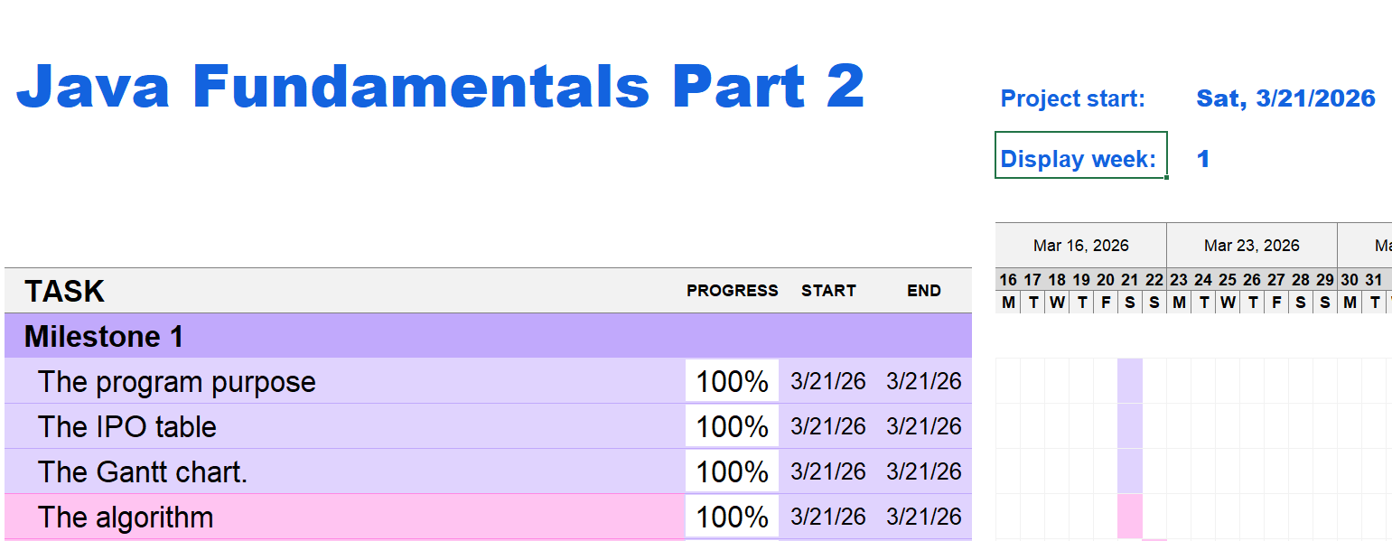
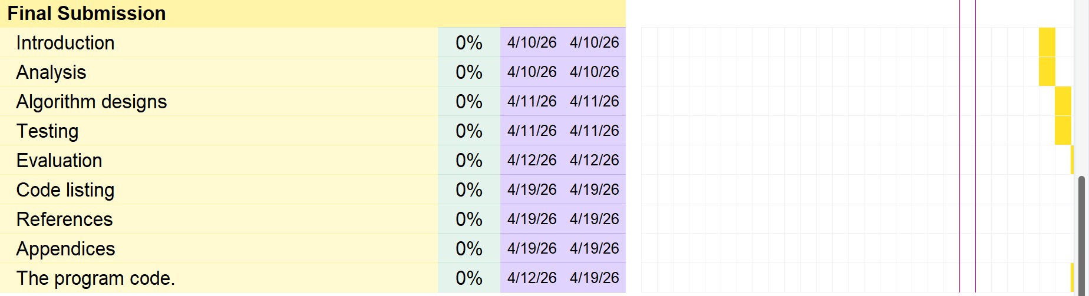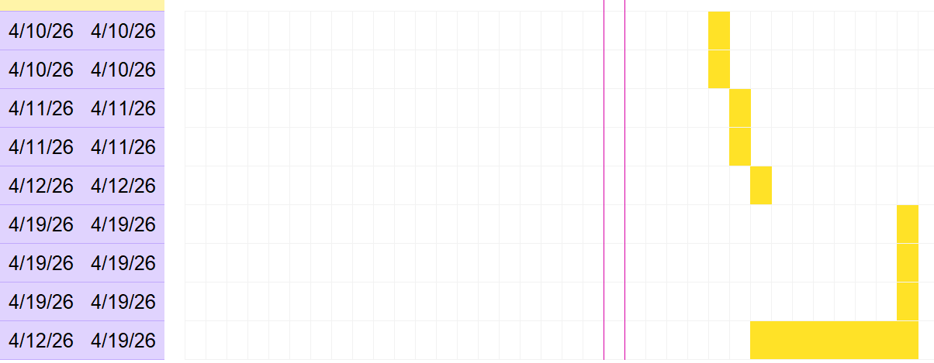
Diary Entries (at least 4)
02/04/2026 – Diary Entry 1 – Starting the Implementation Phase and Understanding Milestone 2 Requirements
Firstly, today I started focusing on understanding the Milestone 2 requirements and attempting to implement them. From my initial understanding, this milestone requires us to extend our CityRide Lite app to make it function more like a real transport fare companion application. This involves implementing several features, such as identifying the user role at the start of the program. This role can be either a rider or an admin.
The rider role is responsible for creating and loading user profiles from a JSON file, as well as creating and loading journey data from a CSV file. The admin role requires logging in with a password to access a separate administration menu, which allows modifications to the base fare rules.
Therefore, I began by researching how to allow the program to select the user role when it launches. After some research and experimentation, I successfully implemented this feature. Now, the program prompts for the user role each time it runs and continues according to the selected role until the program ends.

03/04/2026 – Diary Entry 2 – Implementing File Handling (JSON & CSV)
Today, I focused on implementing file handling, particularly working with JSON and CSV files for storing and loading data. This part was important because the system needs to maintain persistent data between program runs, which is a key requirement of the project specification.
Initially, I found this challenging because file input and output require careful attention to formatting and error handling. I worked on reading data from files and converting it into usable objects within the program. I also ensured that the program can handle cases where files may be missing or empty, which could otherwise cause runtime errors.
After several tests, I successfully managed to load and save data correctly. This step significantly improved the functionality of the program, as it now behaves more like a real-world system that preserves user data. Although it took extra time to debug small issues, completing this feature increased my confidence in the robustness of the application.

04/04/2026 – Diary Entry 3 – Implementing User Roles and Recalculating Totals
Today, I worked on implementing user roles at the beginning of the program. When the program launches, the user selects a role, which can be either a rider or an admin. I initially struggled with clearly defining the functionality of each role. For example, I found it difficult to implement the admin login system with a password and restrict access to a specific menu for modifying base fare rules.
Another challenge I faced was ensuring that totals are correctly updated after each operation, such as adding or removing journeys. For instance, when undoing an action or deleting a journey, the total daily cost for all passenger types needed to be recalculated accurately.
I realised that recalculating all totals after each change is more reliable and helps avoid logical errors. By the end of the session, I successfully implemented these features and tested them using different scenarios. This confirmed that the system behaves consistently regardless of the operations performed.

05/04/2026 – Diary Entry 4 – Admin Functionality and Fare Modification
Today, I focused on implementing admin-related functionality, which allows modification of the base fare and related values. I created a dedicated admin section that is only accessible after entering the correct login credentials. This ensures that sensitive operations are restricted, aligning with access control principles.
A key challenge in this part was handling the recalculation of fares after the base fare is modified. Since many values depend on the base fare, I needed to ensure that all journeys are updated accordingly. I solved this by iterating through all stored journeys and recalculating the discounted and charged fares based on the updated value.
This part of the implementation was particularly important because it demonstrates dynamic system behaviour. After testing, I confirmed that changes made by the admin are correctly applied throughout the program.

05/04/2026 – Diary Entry 5 – Final Integration, Testing, and Debugging
Today, I completed the final integration of all components and focused on testing and debugging the program. I ran multiple test cases to ensure that all features work together correctly, including role selection, journey management, fare calculation, and admin modifications.
During testing, I encountered minor issues related to error handling and menu navigation. For example, incorrect inputs sometimes caused unexpected behaviour. I resolved this by adding input validation and error handling to ensure the program handles invalid input gracefully.
I also reviewed the overall structure of the code to improve readability and consistency. By the end of the session, the program was fully functional and aligned with the requirements of the milestone. This final step gave me confidence that the implementation is complete and ready for submission.

